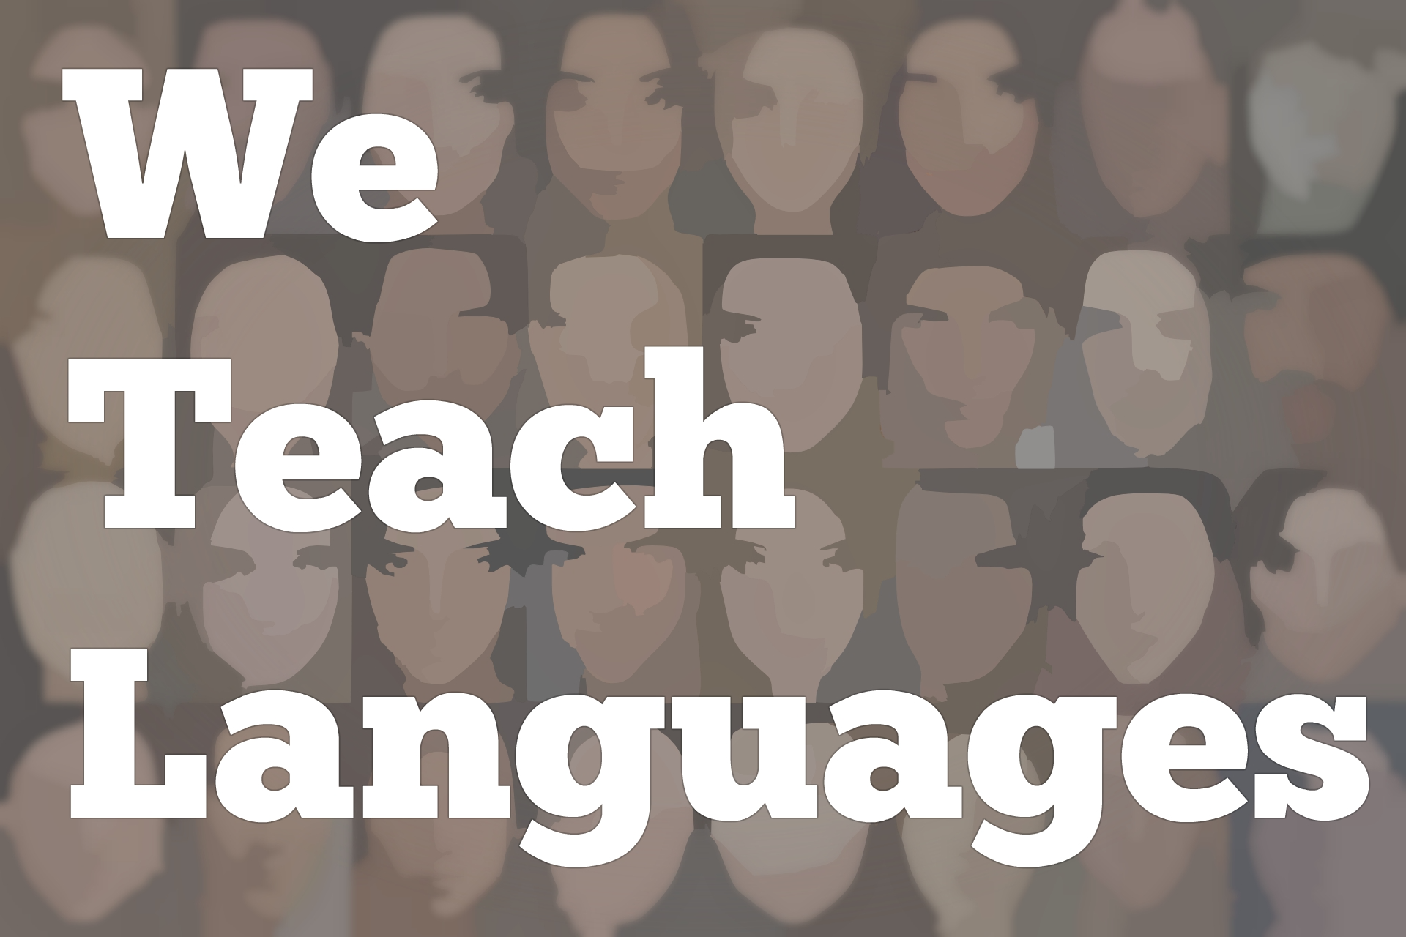
We Teach Languages Episode 104: A conversation about ESL and ASL with 2018 National Teacher of Year Mandy Manning and National Teacher of the Year finalist Amy Andersen, Part I

Stacey Margarita Johnson: [0:01] This is "We Teach Languages," a podcast about language teaching from the diverse perspectives of teachers.
[0:10] [music]
Stacey: [0:14] I'm Stacey Margarita Johnson. Today, on episode 104, I am so excited to share the first half of a conversation I recently had with two remarkable language teachers. Our first guest is Mandy Manning, the 2018 National Teacher of the Year. Over the past year, you've probably seen her interviewed on a talk show, or advocating for educators at the national level.
[0:44] Our second guest is Amy Andersen, who teaches American Sign Language, and was one of the finalists for the 2018 National Teacher of the Year. Our conversation was so high energy and informative that it couldn't all fit into one episode, so be sure to listen this week, and then check in next week to hear the rest.
[1:07] In this first half of the series, Mandy and Amy introduce their work as ESL and ASL teachers, and talk about how culture is integral to both of their work.
[1:21] [music]
Stacey: [1:24] Mandy, would you tell us a little bit about what you teach and where you teach?
Mandy Manning: [1:27] I'm Mandy Manning, and I'm the 2018 National Teacher of the Year. I teach brand-new immigrant and refugee students at the Newcomer Center in Spokane, Washington at Joel E. Ferris High School.
[1:41] Just to give you some background on the Newcomer Center, the Newcomer Center is a specialized English language development program for brand-new immigrant and refugee students.
[1:51] These are kids who have just come to our nation. They're usually been here for three months or fewer, and they speak very little English. They've scored a level one on our state language assessments.
Stacey: [2:03] Do you mind if I ask you, Mandy, how did you come to work with Newcomers?
Mandy: [2:07] This is my 20th year in education. When I first started out in education, I had a degree in filmmaking. I was very reluctant to come to being a teacher, but I found myself a job as a paraeducator in a special education classroom. Then after that, I went to the Peace Corps.
[2:26] That was my first introduction in teaching English, but it was teaching English as a foreign language, which is very, very different. When I came back to the United States, I didn't know what I was going to do because I still wasn't certified, or I didn't have a degree in education.
[2:42] Then, I was encouraged by my aunt in Texas to apply to be a teacher. That's when I got a job teaching, and I was shocked. Most people are shocked when they hear the story.
[2:55] [laughter]
Mandy: [2:55] That's when I became a teacher. Ultimately, I was certified. I was not teaching new immigrants and refugees at that time. I was teaching theater, speech and debates, and communications. Then, I moved overseas again, and I taught in Japan. I had another experience teaching English, but again as a foreign language.
[3:16] It was actually when I came to Spokane. I came to Spokane in 2008. One of the very first people that I met in Spokane, I was teaching video productions at the time, was a woman who was in the English Language Development Department, and she had also served in the Peace Corps. We had that in common.
[3:36] She said, "You know, we really need people who have experience working with kids who are not from the United States." She encouraged me to apply to the program. Very long story short, I applied and I got a position. A few years in, that teacher -- the one that I just talked about -- she became our coordinator for our program.
[3:59] She was the one that had been teaching in the Newcomer Center. I went to her at that time because she was my mentor. I asked her about the possibility of teaching in the Newcomer Center. She got really excited about it, and I got really excited about it. Now, I've been in the Newcomer Center for eight years.
Stacey: [4:18] If there are people who might be interested in working with new arrivals, new immigrants and refugees in a school setting but don't come from an educational background that prepared them for that, what advice would you give them based on your journey?
Mandy: [4:34] Well, there are a lot of opportunities to work with new immigrant and refugee students that don't have anything to do with the public school system. One of the very first things I did before I joined the Peace Corps was to volunteer at the local -- it was called Mason County Literacy -- and they provided classes for immigrants in our community.
[5:00] I volunteered there, and I got to teach a couple of hours, like three times a week. That's one way to start that journey. You can also look at your local community college because they often have adult education classes. They look at a lot of different things in terms of experience.
[5:19] You don't have to be a certified teacher to work at the community college in adult education. That's another opportunity.
[5:27] You can also, if you don't want to stay here in the United States, you can teach overseas. If you're a native English speaker, you can always find a job teaching English overseas, but it's not nearly as rewarding as teaching newly arrived immigrant and refugee kids. There's those opportunities.
[5:44] There are summer programs where you can volunteer your time, or sometimes get a job teaching in the summer language camps in many communities. Of course, you can look at your local colleges and see if they have programs that will help you get certified to be able to teach.
[6:02] Because even though it seems like we, in our nation right now, are not welcoming in as many immigrants and refugee families and their children, we do still have a huge need for English language development educators and specialists. It always is worth looking into. Those are some of the ways that you can get involved.
[6:25] There are so many. It doesn't have to be a traditional path. Obviously, I didn't take a traditional path. That just takes a little bit longer.
Stacey: [6:33] That's wonderful. Amy, would you mind introducing yourself and telling me a little bit about where you work and what you do?
Amy Andersen: [6:39] Sure. I am Amy Andersen. Originally, I was a teacher of the deaf in Massachusetts for eight years, and that's what my degree was in.
[6:51] I actually studied flute performance through my bachelor's degree and then started taking ASL classes at Indiana University doing that and just fell in love. Fell in love with the culture and sounds, how I really wanted to contribute.
[7:06] Performing on a stage was gratifying but working with children who are deaf and just using the language and being in the culture was so far beyond that. Anyway, I taught for eight years in Massachusetts at schools for the deaf and then moved back to South Jersey, where I grew up.
[7:25] I had a family at that point, my parents were still in the area, so I wanted to have my children grow up close to their grandparents.
[7:34] That is when I started working at Ocean City High School, which is a public high school with about 1,200 students. District total, I think there's like 2,500. When I moved, they had just started an American Sign Language program with 42 students.
[7:52] It was like being in the right place at the right time. The teacher who they had that had started it went out on maternity leave. Because New Jersey had set up some new stricter guidelines to be certified as a teacher of ASL, I ended up having the qualifications and background that was needed. Then the following year, I took over the program. There were 138 students.
[8:18] The former teacher went out on maternity leave in February, I took over. Then, that next year, it just exploded.
Stacey: [8:25] That's amazing.
Amy: [8:27] This year, I have 176, so it's continued to grow. We now have American Sign Language 1, 2, and 3 Honors. They're all hearing students. They're taking ASL for their foreign language requirement. Many students will then go on and have ASL as part of their career path, either majoring or minoring.
[8:53] From the minute I moved to the community, and that was 2004, I reached out to the local deaf community. I found them because the son of one of our deaf community members was in my class. After a couple of days, I'm looking at him in ASL 1 and saying, "I feel like you know ASL, Robbie"
[9:16] [laughter]
Amy: [9:18] He's like, "Yeah, I'm a CODA," which is a Child of Deaf Adults. Mom and dad, and uncle, and grandparents were all deaf. I was like, "Well, now you're my assistant," so thank you very much.
Stacey: [9:29] I have a question. Was his signing already fluent, or was he still learning?
Amy: [9:36] He was still learning. He hadn't had any formal training in the grammar, knowing the linguistic features. I mean, the cultural learning, he had learned by living it but, he was fluent. I don't know that it was native-like but close, very close.
Stacey: [9:51] Very interesting. Everything you're saying sounds exactly like other foreign language teaching.
Amy: [9:56] Yes, that's a really important distinction because, often, people will instead look at American Sign Language and the deaf community with this perspective of a disabled group and the group that needs services and accommodations.
[10:12] Where really it's just a group that's a minority culture that uses a minority language in our bigger world, which is majority hearing and spoken language-driven.
[10:24] An important piece about teaching American Sign Language that's different from other foreign languages is that the modality is completely different. Learning another spoken language is easier because you're used to learning a language in its printed form, and through spoken and auditory processing, where American Sign Language is in a visual, spatial mode.
[10:53] There's no written form. There's two things to learn at the same time as you're learning ASL, which is contrary to what a lot of people think, "All right, if you can't pass a foreign language, then take ASL because it'll be a lot easier," where that's the opposite.
Stacey: [11:09] Actually, I really latched on to what you said about falling in love with the language and culture. Also, because many of the people I know who have begun studying ASL were so enthralled by it that it became a lifelong passion to find people to sign ASL with. I interrupted your story about your student.
Amy: [11:30] [laughs]
Stacey: [11:30] He gave you an in into the local deaf community?
Amy: [11:33] Right. Because as a hearing teacher, it would be like a white teacher going into a class full of African American and Latino students and like, "Who is this person? Why are they qualified to now teach us about our culture?"
[11:52] It's the same situation as a hearing person in the deaf community. It's important to see yourself and understand your role as an ally and not a savior.
[12:02] I emphasize that so much with my students, like they are not the hearing super heroes who are going to go in and save the poor deaf person trying to order coffee at Starbucks. First, they're [inaudible] old, and they've been doing it for 40 years. They don't need you. I think no. It was very, very important to me to have that connection.
[12:23] The deaf community was thrilled to just immediately connect and collaborate, and has been a strong part of the program ever since. They come in and they coach the students. They'll do deaf panels, where students can ask questions. There are chaperones when we go to Gallaudet University in Washington, DC, which is the only college for the deaf in the world.
[12:51] It's been amazing with the deaf community. I started working with deaf babies also in the early intervention program. Then, was able to have my students connect with those babies and families, and baby sitter. They'd go to the daycares. A member of the deaf community recently started working in a daycare setting which was new. It hadn't happened before.
[13:18] It's been a nice symbiotic relationship. I've gotten so much more from them than they've gotten from me, but I try to give back.
Stacey: [13:28] That's amazing. One thing that I imagine both of you work with in different ways is trying to integrate. For Amy, it would be deaf community culture, and for Mandy, it would probably be your students' own cultures into your classroom and into your teaching. I'm wondering what that looks like for you guys?
Mandy: [13:48] Well, for me, it's really important that my students, number one, connect with one another and understand each other's cultures. Because in Spokane, we serve about 77 language groups. In my classroom, we have between 12 and 15 languages usually at one time. The kids are often from different nations and different cultures.
[14:10] I am very intentional about ensuring that they have opportunities to share that culture with one another. Whatever lesson or language we're targeting, I always have connections to students' own cultures.
[14:28] If we were doing, like time of day, let's say, we're looking at time, I would always incorporate something where they can talk about, what did morning time look like in your community? Did you wake up at the same time?
[14:43] Just little things that are fairly innocuous but things that we all, in general, take for granted because we're used to them. We find out so many interesting things about other cultures just by talking about what we would usually consider to be mundane. It also gives them an opportunity.
[15:02] If we're talking about places, we might talk about a favorite place or something like that in their home culture, so that it gives them an opportunity to share something positive and not relive any trauma that they might have experienced, and to have those positive feelings and positive memories of their homeplace, and then they gain an understanding.
[15:23] In my classroom, that's important, but it's even more important that my kids have the ability to share their culture and who they are, their humanity, with the students outside of the Newcomer Center.
[15:37] Really, it's the kids who are born in the United States that need that exposure more, so we make a concerted and intentional effort to connect our students with students outside of our class.
[15:51] Sometimes, that means connecting our class with another class to just do basic conversation so that they can get to know each other, or maybe my kids will plan some sort of a presentation about their home country and they'll share that. Then they'll have some interview or something with the kids for them to learn more.
[16:10] Recently, there was a class doing a project on modern migrations. Come to find out, they were studying like 35 cultures. 25 or 26 were represented within our English language learning community right there in our school. We were able to match a kid studying Syria, for example, with a kid who was from there. Just to grow that humanity.
[16:44] When you get right down to it, we're different but we're not that different. The more that we can connect and help kids see each other as kids, the more compassion and empathy we have as a society. We need that more than ever right now.
Stacey: [17:01] Awesome. Amy?
Amy: [17:04] In terms of learning about the culture, the first step is just helping students see that the deaf community is a culture. I usually start out the year with something called these diversity jelly beans, where the flavor doesn't match the color. Talk about assumptions and stereotypes. Then that'll lead us to diversity within the deaf community, that not all deaf people hear silence.
[17:31] There's a range of amounts of hearing, or whether it's high or low sounds or totally deaf. The diversity within the deaf community in terms of education, background, or language, or deaf or hearing parents, and how that impacts.
[17:49] Then, we'll do a lot of talking about norms of behavior within the deaf community and within deaf culture, like attention-getting techniques, what's appropriate. You don't throw a piece of paper at somebody to get their attention. You tap on the shoulder. We'll do that and practice that. The environment that's set up in the classroom, I don't have desks.
[18:12] We just have standalone chairs. They're in a U-formation so everybody can see each other. That's what you would find in a classroom with deaf students. In any foreign language, you want to be 95 percent in your target language.
[18:29] What that means in ASL is that we're not using English, we're only using ASL. That's a challenge with students, a hundred percent worth it, if you can get there.
[18:43] In that way, they're learning appropriate ways to be part of the culture. If they were in a deaf environment, if there were deaf people in the classroom with us, what is the respectful way to behave? Using ASL means you're using a shared language. It's not that we're signing because the deaf people can't hear.
[19:03] No, we're using ASL because that's the shared language that we all understand, and that's respectful to another human being.
Stacey: [19:12] That's such a wonderful way to frame it, to help students understand, also. A lot of listeners will be able to latch onto that and use that in conversation with their students.
Amy: [19:24] We have monthly Starbucks chats. We call it ASL Starbucks chats. That's popular in deaf communities. We have a Starbucks, two blocks from the high school. The deaf community has completely taken ownership of that, and hosting it, especially over this last year. A lot of times, I was not even able to go because I was doing something else.
[19:47] That's completely now run by the deaf community. It'll be the third Friday of every month from 4:00 to 7:00. Anybody is welcome. Students will go. We've got some college students from nearby programs. Parents with deaf children have started to come.
[20:05] It's just a time to be together, and sign. I say to them, "Even if you're just sitting there watching, you're organically learning about the culture and seeing the language."
[20:18] That's so beneficial. That's then an opportunity for them to put those things that they're learning about the norms and maybe understand why I say the things I say like, "You have to do this, and make sure there's nobody's behind you so everybody can see. There's not a big water bottle sticking up on the table because then that's going to block the vision."
[20:44] That's the biggest way if there's ever a time that they ask a question that I'm not sure of the answer. The other day, someone asked, "How would a deaf person call 911?" I knew that 911 centers had in the past, they had teletypewriters, which was something you just typed on it. I wasn't absolutely sure now exactly how it worked.
[21:08] There's this app. There's a Marco Polo or Glide, which are video chat. I'll just go get my phone, and I'll send out a message. I'll blast out a message to three or four people that we know in the deaf community with the student's question. I'll keep teaching, and then somebody will answer back. I'll say, "Oh look, OK, this is what it is." Or, if they ask a sign that I'm not sure.
[21:31] That models that I don't have to be the expert. I certainly am not. I'm a second language learner in this community and culture. The people that I turn to as experts are the native language and culture users.
Stacey: [21:45] That's amazing.
Mandy: [21:46] So awesome, Amy. Thanks.
[21:48] [laughter]
[21:48] [music]
Stacey: [21:54] We would love to hear your feedback on this episode. You can find us on Twitter or Facebook @weteachlang, or you can leave a comment on the episode page on our website, weteachlang.com.
[22:10] We would love to say a special thank you to the PEARLL Foreign Language Resource Center for partnering with us to provide transcripts and other professional development resources related to the episodes. You can learn more about PEARLL by going to PEARLL, pearll.nflc.umd.edu.
[22:28] Thanks so much for listening. Bye-bye

Podcast transcripts are provided through a partnership with PEARLL (Professionals in Education Advancing Research and Language Learning), a Title VI Language Resource Center at the National Foreign Language Center at the University of Maryland. Find additional transcripts: www.pearll.nflc.umd.edu/podcast

Transcription by CastingWords

