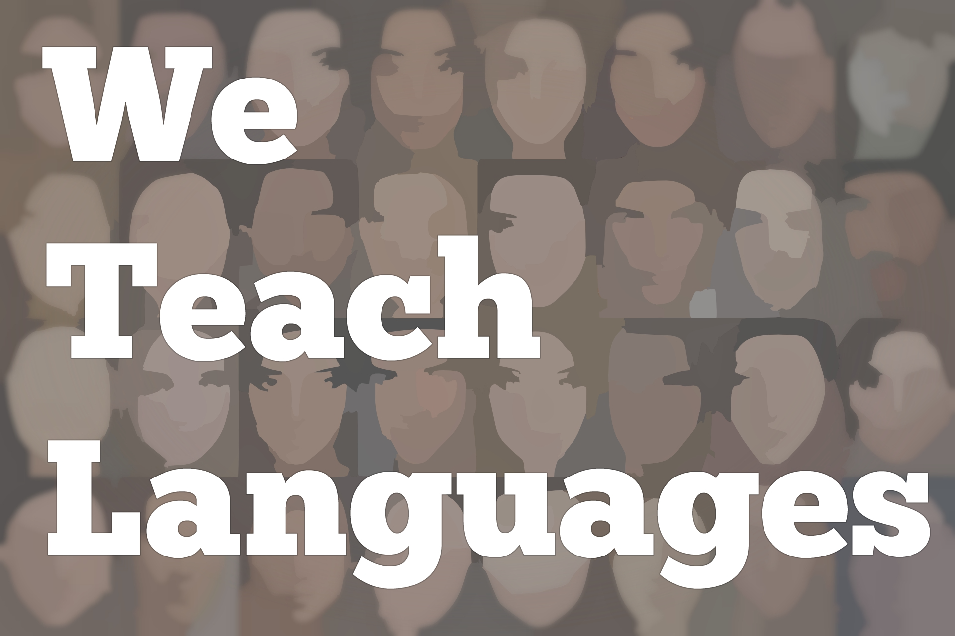
We Teach Languages Episode 109: Multilitercies and Digital Social Reading with Carl Blythe

Stacey Margarita Johnson: [00:00] This is "We Teach Languages," a podcast about language teaching from the diverse perspectives of teachers.
[00:09] [background music]
Stacey: [00:12] I'm Stacey Margarita Johnson. Today, on Episode 109, Abby Broughton interviews Dr. Carl Blythe, director of the Center for Open Educational Resources and Language Learning, or COERLL, and associate professor of French Linguistics in the Department of French and Italian at the University of Texas, Austin.
[00:36] Abby and Carl discuss multiliteracies, digital social reading, and how they center the interpretive mode of communication in language instruction. I'm sure very few listeners will be new to the idea of centering texts and meaning-making in the language classroom, in particular since that topic has been something of a theme in the last handful of episodes.
[01:03] I do suspect that multiliteracies pedagogy and digital social reading, which are both topics that they explore in some depth in this episode, are not going to be common knowledge.
[01:16] I thought I'd give a little bit of an introduction. Multiliteracies pedagogy is a framework for instruction that requires students to engage with texts in different ways and make different kinds of meaning from those texts.
[01:32] Last year, I interviewed Dr. Kate Pezzani about multiliteracies. I will link to the episode and a few other resources in the show notes for those of you who want to know more.
[01:45] Digital social reading is a technology-driven way of approaching reading. Using a tool like eComma, Hypothesis, or Perusall, students can collectively read the same text online. Each student can add their own margin notes, type in their reactions to specific things, add highlights or links to things on the Internet. Each student can do that directly on the text.
[02:13] All the students in the course can see everything everyone else is adding onto the same text. Does that makes sense? It turns the solitary experience of reading into an online and social experience of reading, which is pretty cool.
[02:31] Since this is a fairly new technology, it's not really being used extensively yet, so it's really exciting that we have Carl and Abby here today, two people who both have significant experience and expertise incorporating digital social reading in civil language classroom.
[02:49] After you listen, if you want to know more about digital social reading, I'm going to give a plug to a video that Abby put together. It's an online video presentation on the topic of digital social reading. It's aimed at language teachers. The link to it will be in the show notes along with a few other resources that you might find interesting.
[03:11] There's some cool knowledge out there available online. The really fun thing is most of those online resources were created by Carl Blythe. We have two people who I'm excited to learn from on the show today. With all that said, here is Abby and Carl.
[03:32] [background music]
Abby Broughton: [03:32] I would like to start with a brief overview of your academic career. I notice that you began teaching secondary school before going to graduate school.
Dr. Carl Blythe: [03:42] I did. I got a master's of arts of teaching and then taught. It actually started before then. I was in Washington, DC, right after I finished college and was working in different language schools, teaching ESL, and in French at these different institutes. I met a lot of people who call themselves applied linguists.
[04:05] I had never heard of an applied linguist before. A lot of them were from Georgetown since that is a big university in the area in Washington. They had this knowledge of language that I thought was really fascinating. They were so meta-linguistically aware, and they also knew a lot about language learning.
[04:24] I thought that kind of intersection of this deep knowledge of language, and then how to talk about it to others, was interesting. Then I applied to this program at the University of North Carolina and got in.
[04:38] Then I taught for a year in high school, but even then, I knew at that time that I wanted to go on and pursue a PhD. The four years in the classroom had given me the idea that I wanted to pursue this more.
Abby: [04:54] Tying into that, how do you manage your role today, and how have you managed it throughout your career as both teacher and researcher?
Dr. Blythe: [05:03] They always talk about -- I talk about it too to my students -- an ideal world that your research should influence your teaching. Your teaching should influence your research. In my world, I have a third hat, and that's administration. I'm also running COERLL and that's a little bit different of these two.
[05:21] But yes, I definitely think those categories go together. In my mind, I call them scholarship, because teaching is a scholarly activity. Two have gone hand in hand. Probably, that's not at all unusual for an applied linguist, because the orientation of an applied linguist is more problem-solver.
[05:43] A lot of people think of applied linguistics as language teaching, but the field is bigger than that. If you go to AAAL, the American Association of Applied Linguistics, there are people who are doing all kinds of cool things that have nothing to do with language teaching.
[06:00] Not that anything is wrong with that, but there are all kinds of problems to be solved with language. That's the orientation that I approach, like, "What problem are we solving?"
Abby: [06:10] Maybe we could talk about your upcoming book project first, which I know is "Understanding Languaculture -- A Multiliteracies Approach." We see that your research and your teaching combine.
Dr. Blythe: [06:24] Right, that's a great example of putting those two things together. Actually, I don't know which first. I was reading in this particular area and my teaching, particularly, I was teaching a linguistics course that I thought was really getting stale.
[06:39] I had been teaching it for uptenth years and years. I thought, "I don't want to teach it like this anymore. I'm not the same teacher that I was and my interests, even in linguistics, have changed, and I need to upgrade my syllabus. I need to update this course."
[06:58] It was focused on a pedagogical and curricular change, my own personal change, then thinking about how to find some theoretical basis for making different changes. Those things are very much of a piece.
Abby: [07:13] How are you using the multiliteracies approach in your language classrooms to develop this languaculture?
Dr. Blythe: [07:21] Meaning is problematic. The reason why people avoid it is because it is slippery and it is highly contextual, and it can be individual, idiosyncratic. It's all of those things. It is basically disordered.
[07:38] If language, like the formal properties of language, are highly ordered, which is why we teach them, why it's safe, and why young teachers like grammar. It makes them feel like there is a right answer, but the meaning, there's never a right answer. Then you just have to accept that and deal with that.
[07:56] There has to be a pedagogy that accepts disorder. One of the things that I like about multiliteracies it's approach. I was looking for a pedagogy, which is just a way of doing things in the classroom that reflected then my concept of language or my conceptualization of language.
[08:21] I think of language as having different kinds of meanings in it. This comes in the work of Karen Risager, who was an educational linguist in Denmark. Her work is just amazing. She talks about three main areas. There is linguistic meanings. She talks about it. Semantic, pragmatic meaning, and there is this interpersonal, the identity part.
[08:46] Then there is the poetic part. Let me talk, real quickly, about that because I can get into this and talk for hours and hours, but the linguistic meaning is usually what we focus on in language classes. That's the conventional words.
[09:01] Those are the meanings that are fairly easy to get that, and there's not too much disagreement about, so it's often called denotation, the dictionary meanings of things, but then language is always parasitic. You're talking about something, like I can be talking about this pen or this piece of paper, but as I'm talking about it, I'm also giving you information about me.
[09:28] The words I use, my inflection, my accent, that's basically social linguistics. We're actually negotiating our identities.
[09:40] The third area is the aesthetic or the poetic. It's the realm that language teachers don't touch, because they think, "Oh, that's for somebody else to do." The thing is that all these meanings are always traveling together.
[09:58] In what we call communicative language teaching, that's definitely on that first area. That takes all the messiness and fun of language and puts it in a box. It's basically reductionist. It reduces language to the ordered parts of it like, "No, no." So coming back to your question, I had to give that little overview of languaculture to answer the question.
[10:27] What I like about multiliteracies is it's a complex approach for a complex object. Language is complex and you need to have different perspectives on it. That's what multiliteracy does better than just about any kind of pedagogy out there right now.
[10:51] In the book, I talk about the concept of parallax, which is from astronomy. It's a concept used in astronomy. Apparently, when astronomers look at a planet or a star, how they see the object depends very much on where they are located on the earth.
[11:12] It's basically that idea of your perspective on the object. Where you are, changes what you see. That's true of anything, really. From my vantage point, as a language teacher or as a linguist, those are two very different perspectives, by the way. I see things that are very different than, say, a literary critic or a semanticist and I could go on and on. Everybody has a different perspective.
[11:40] I also like multiliteracies because you take a text and you're analyzing a text. It's very text-based. From the text, you can extrapolate the larger system, so we work from text to the larger system. Rather than, say, in French, we have gender, and therefore we start from the linguistic system and then go to the text.
Abby: [12:06] I'm personally doing digital social reading in my classroom, and as part of my dissertation project. Doing it, if you're still using it, and then that you all work with eComma and you're using digital social reading in your multiliteracies work currently?
Dr. Blythe: [12:25] This semester, we will do an experiment, an activity on digital social reading. We'll do a scholarly academic work and then we'll read it together and talk about it, so we're not using it in the language classroom, but more in the second language acquisition classroom, so in graduate school, but you can do a social reading for anything.
Abby: [12:47] When you use it, how do you usually design your tasks?
Dr. Blythe: [12:51] That depends on the context. I have done it in many different ways. Going back to multiliteracies, one way I like to do it is to get them a text to explore as an initial activity.
[13:09] I tell them, instead of interpreting the text and commenting on the text and trying to sound smart, I don't want them to do that. I want them to read through it and simply free associate. The reason, in the French context, it's called écriture automatique, which has been used a lot as a linguistic process just to get you to get your mind going.
[13:32] I tell them that what I want them to do, rather than think about the text, is to simply trigger something, a reaction, and to write their reaction, so highlight part of the text and say, "This made me think of this."
[13:48] It's much more like free association. I said, "Sometimes, your associations will be imagistic. It may not be language. I don't know if it can make you think of a song. Just whatever, put that down."
[14:02] One of the things I found is that sometimes, since my students are multilingual here, being in Texas, I have a lot of Hispanic students. Their associations are in different languages which is, "That's fine." One of the things that happened in doing this activity, and we were free-associating with a poem. I like using a lot of poetry.
[14:24] They started putting in pictures. I hadn't told them that, but instead of glossing a text with more text, they were actually using different kinds of linguistic signs. Then they started seeing from each other, like, "Wow, I could do anything." I said, "Mm-hmm."
[14:39] It became much more of a multi-modal reading, but so that activity is what I would classify as an activity that's really about experiencing the text and we're developing the notion of critical feeling. You're paying attention to your feelings as a way of analyzing a text.
[15:00] That's something that, to me, is part of language. That's part of the idea that this is just ordered excitement that I want them to get at. I want then to feel also that that's part of meaning, absolutely part of meaning. Part of meaning is also related to those silly little definitions in your bilingual dictionary. You just don't know that yet.
Abby: [15:23] When you're working on this platform, how are you assessing the students? One thing I think about a lot is I'm working on developing the interpretive mode. At the end of the day, how do you assess student growth?
Dr. Blythe: [15:40] That's a big question. I don't have a whole lot of great things to say. [laughs] The problem, of course, is that there are a lot of assessments and we don't know what we're doing very well, that we fall back on quantitative measures, because it's easier to measure how many times people annotate.
[15:58] Let's say, eComma, one of the functions in eComma is after a session, I can go back and I can look at the list of participants and look at each individual and, "Wow, Abby did 36 annotations. Carl only did three. Abby's made progress. Carl needs to work harder." That kind of thing, but it's always problematic. It's just apples and oranges.
[16:25] First of all, it's one activity in a series of activities. The multiliteracies pedagogy, or constantly I look at it, it's like a kaleidoscope. You're constantly taking the text and looking at it from different perspectives.
[16:37] I do have participation grades. I also assess by co-acting with them, so they're not just participating in doing the social reading. The whole point is to be doing it with them. That's really hard because most approaches to assessment, you're external and outside the activity. You're not participating, but how do you assess and participate at the same time?
[17:05] That's tricky, but I do actually have, like it's talked about in terms of transform practice. There I do give a grade. I do do more of a formal assessment. The whole point of a transform practice activity is to show some kind of creative application of what they have learned in all these other activities.
[17:30] One activity I have done that followed up from that one activity, the digital social reading activity I just talked about, where you're just feeling and creating, that's to fire the imagination, but then we go through and we look at translations of the poem. After we work through the poem and they start to understand it in different ways, then I give them translations of the poem.
[17:58] I say, "So, is it good? Is it bad? What did you like about it?" Then their final activity is to write their own translation. I find that it gives them enough wiggle room so that they can interpret for themselves.
[18:17] Just going back to your question about assessment, what I find hard to do when we're talking about creativity, we usually think of that as meaning there are no parameters, that you have to have some kind of parameters to assess.
[18:33] I'm looking for creativity within some kind of a boundary. That's why that particular activity works well and I was able to assess it. People can have different versions of what constitutes an effective translation. If they can execute it and then explain it to me, that's great. That's their interpretive mode that's brought out.
[18:56] [background music]
Abby: [18:56] Thank you so much, Carl.
Dr. Blythe: [18:58] Glad to meet you.
Stacey: [19:01] We would love to hear your feedback on this topic. You can reach out to us on our website, weteachlang.com. We want to especially thank the PEARLL Foreign Language Resource Center who has partnered with the podcast to provide transcripts and other resources for the episodes. You can learn more about PEARLL and see everything they have to offer by going to pearll.nflc.umd.edu.
[19:30] Thanks so much for listening. Bye-bye.
Podcast transcripts are provided through a partnership with PEARLL (Professionals in Education Advancing Research and Language Learning), a Title VI Language Resource Center at the National Foreign Language Center at the University of Maryland. Find additional transcripts: www.pearll.nflc.umd.edu/podcast
Transcription by CastingWords

