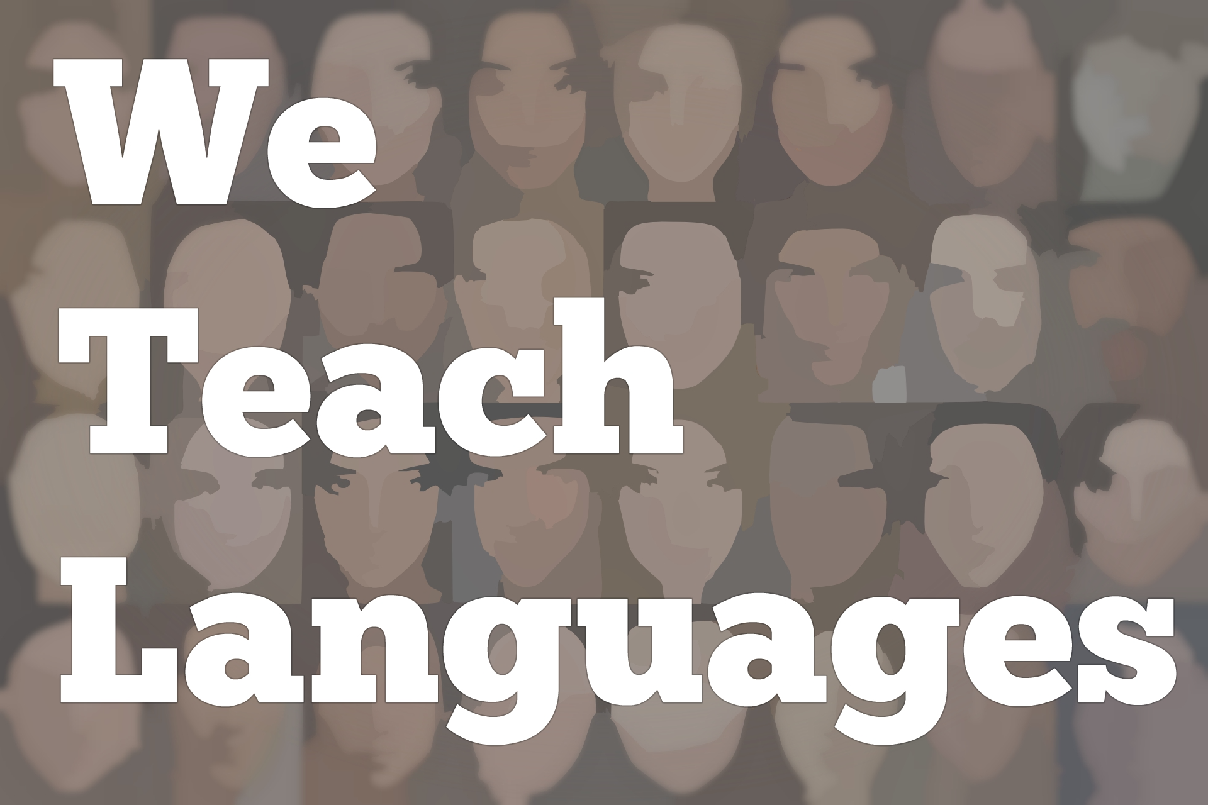
We Teach Languages Episode 110: A Fulbright Award and Afro-Mexican Stories with Michelle Nicola

Stacey Johnson: [00:00] This is "We Teach Languages", a podcast about language teaching from the diverse perspectives of teachers.
[00:09] [music]
Stacey: [00:12] I'm Stacey Johnson. Today, on episode 110 I'm sharing an interview I conducted with Michelle Nicola, a Spanish teacher who spent some time in Mexico last year, getting to know and interviewing Mexican people of African descent.
[00:31] In this interview, Michelle discusses the Fulbright Award that funded her research project to Mexico, as well as the people she met and some of the stories she heard while she was in Mexico.
[00:44] Michelle is back home now with lots of notes and interviews from her time abroad. The last thing we talk about is how Spanish students everywhere might be able to benefit from the work she did and continues to do to make these stories accessible and comprehensible for novice Spanish speakers.
[01:05] [music]
Stacey: [01:08] Michelle, thank you so much for speaking with me today.
Michelle Nicola: [01:11] Thank you, Stacey. It's so nice to be here.
Stacey: [01:14] Would you mind starting by telling us a little bit about who you are and the work you do?
Michelle: [01:22] My name is Michelle Nicola. I teach Spanish. I'm also an instructional specialist at a high school in Portland, Oregon. I've been teaching for about 10 years, 10 years in the K through 12 system in Portland. I had some teaching experience when I lived abroad in Spain.
[01:38] I've always been a Spanish teacher. I've always been passionate about social justice issues and about really figuring myself out so that I can give my kids what they need.
Stacey: [01:49] Awesome. Today we're going to talk a little bit about the Fulbright Award that you won and the time you spent in Mexico doing a Fulbright project. The Fulbright Award actually isn't the first prestigious award that you have won.
Michelle: [02:07] No, it's not. In 2014, I was one of five awardees for Teaching Tolerance, Educator of Excellence Award. That award was really special. It was a true honor. I feel that award I share with my students who I was teaching at the time, a shout-out to all the students at De La Salle. It was a really special time in my teaching career.
Stacey: [02:35] It was really fun for me to see that because I know you through the ACTFL Critical and Social Justice Approaches special interest group. We met, I think, in Nashville two years ago, right?
Michelle: [02:47] Yes, we did.
Stacey: [02:48] It was fun for me to see your long history of working in this area and the recognition you've gotten along the way. I'm really excited today to talk about your Fulbright award because getting a Fulbright is on my bucket list. I would love to get a Fulbright. I would love to travel around and do research.
[03:10] I was hoping you would start by just telling us a little bit about what a Fulbright is, and how teachers get them.
Michelle: [03:17] Sure. A Fulbright award, it was started by Senator Fulbright. He really believed that one of the ways that we can make the world a more peaceful, better place is through this intercultural exchange. People from other countries can apply for the award to come study in the US, and US citizens can apply for the award to study in other countries.
[03:43] Stacey, all I did was, I had a friend from high school who had been awarded a Fulbright. It was always in the back of my mind, as well. All I did was I googled Fulbright award for teachers or Fulbright distinguished award in teaching, and up pops the first link.
[04:00] It takes you to the application and the process. Generally, applications are due around mid-December for the following year. What I needed to do was I needed to propose a project. Part of the Fulbright application process for teachers is to create a proposal.
[04:21] This proposal is a professional inquiry question, something that you want to know that's going to help you be a better teacher. A lot of my peers...Like, there's somebody right now in Singapore, she's a special education teacher. In Singapore, they do special education really well. She is there studying that.
[04:41] There was a woman who wanted to find math theories that weren't designed by white dead guys. She went to Botswana, and she did her Fulbright project on that. For me, my question was, what are Afro-Mexican stories, and how can I incorporate those into my Spanish novice language learner curriculum?
Stacey: [05:07] Awesome. I really want to know that, as well. The first thing that pops into my head when you say that is, "Can you please share the answer with all of us?"
Michelle: [05:18] Sure. I learned so much. I lived in Xalapa, in Veracruz, Mexico, for about three-and-a-half months. It was amazing. I collected so many stories. Right outside of Xalapa is a town called Coyolillo. Coyolillo is known as a town of Afromestizos.
[05:38] I say Afromestizos because that is what is on the sign when you enter Coyolillo. One of the interesting things that I've found in my research is that just like in the US, in Mexico, there's this debate around, what word should we be using? They talk about, "Should we use negro, black? Should we use afrodescendiente, afro-descendant?"
[06:04] There's tension there. There's tension around who gets to decide what words people use to describe themselves. Anyway, in Coyolillo, I met an incredible, incredible young woman. Her name is Daniella Lopez Carreto. Daniella, along with her friends, Karen, Kelly, Enrique, Maestro Hugo, Elvis, and many other folks, they have started a collective called Casa Coyolillo.
[06:31] Casa Coyolillo works to strengthen the town's Afro-Mexican identity, and strengthen the identity in the people. They do that through...They have a lot of plans but right now, what's happening is they have an African dance troupe led by Maestro Gaby. They also have Enrique who teaches theater classes to children.
[06:58] Daniella, Karen, and Kelly go into the schools, and they give presentations about the town's African ancestry. One of the things that happened is the people in Coyolillo, they'll say, "Yeah, [Spanish] . They tell us that we're black." One of the things that happened with this history is that it just disappeared. It became silenced.
[07:23] A lot of Mexican citizens, A, don't know that there's Afro-Mexicans, and, B, that history or that lineage was lost. They don't know if they can identify it's that. When I went to Mexico, one of the things that I learned is that it is a legitimate question to ask someone who identifies as Afro-Mexican, "When did you find out that you were black?"
[07:47] That's one area. Then there's different pockets of Afro-Mexicans throughout Mexico. Another really powerful story that I learned was about Dona Gertrudes. Dona Gertrudes is the matriarch...Well, she was, she's since passed but she was the matriarch of a town called El Nacimiento, which is outside of Muzquiz in the state of Coahuila. That's up North.
[08:10] The Afro-Mexican population, they call themselves Los Negros Mascogos. People don't really know where the term, Mascogos, came from.
[08:21] What's really beautiful about this story is that this is a population of people who are the descendants of escaped African slaves and escaped Native Americans from the US, who came to settle in the North of Mexico when Spain and France and England were fighting their border wars along the, what is now, Texas-Mexican border. Instead of escaping North, these folks escaped South.
[08:52] There's a beautiful documentary called, "Gertrude's Blues," which documents Dona Gertrudes. Her legacy were these songs that she left for her town, and that came from her mother and her ancestors. Stacey, these songs are sung in English. They are spirituals. They are songs like, [sings] "My mother is gone, and she's ready to go. My mother is gone, and she's ready to go."
[09:23] I'm sitting there, and I'm watching this documentary. I'm thinking, "Oh my gosh, I've heard those songs in my history." It's this beautiful combination of African, Kickapoo, Mexico, all combined into one population, whose songs come from one area, and whose food come from another area, and is a mix.
[09:46] For me, that story was just really powerful because it teaches us to really understand that who we are is so complex and so diverse. It's not really about coming from one particular place but the path that we've traveled to get where we are, and the people that have shaped that path along the way.
Stacey: [10:11] It's a really powerful reminder of our shared history and our shared destiny also. We think of Mexico as being a different place, but we share ancestors, we share history.
Michelle: [10:24] We do. A lot of my students think of Mexico and they think of Mariachi. They think of tamales and tacos. All of those things are Mexico. It's not that those things aren't Mexico. It's just that it's much more complex, just like the United States is much more complex.
[10:47] Just really briefly, one last story that I want to share is of the third main pocket of Afro-Mexicans, they live along the Costa Chica in the states of Guerrero and Oaxaca. I was able to visit a small town called Lagunilla.
[11:04] In Lagunilla -- here's another amazing story -- the people have come together and they recognize the needs of their community. Their community needed food, and so they are trying to teach...They have a garden and a greenhouse system that they've developed so that they're growing their own food.
[11:25] Another problem that the Afro-Mexican communities have is they usually don't have easy access to schools or to medical attention. This town of Lagunilla, the people really came together. From how I understand the story, it was a series of events like some people from the news came and they wanted to interview them.
[11:48] Then the people from the town were able to use that as leverage to go to the government and apply pressure and say, "Hey, we do not have a clinic for our town. Our people, when they get sick, they have to travel a long way to get medical attention." Now this town, for a town this size, it has a state-of-the-art clinic.
[12:08] I went and I really tried to find stories like that. Stories of empowerment and stories of people who are making a difference in their community.
Stacey: [12:16] That's amazing. You told me a story earlier about a young woman who was a dancer who discovered her own hair power. I was wondering if you would tell us that one as well.
Michelle: [12:28] Yes, of course. That's Daniella. My friend, Daniella. Daniella is from Coyolillo. This is the town where I spent the most time. Daniella, I talked to her for two hours then I was invited to spend the weekend with her in Coyolillo and invited into her home and meet her grandma and her mother and her brother.
[12:50] Over the course of our friendship, she told me the story about...She has a story about finding out that she was Black, and then she has a story about accepting that she's Black and feeling proud, orgullosa. Proud about her Afro-Mexican identity.
[13:09] Daniella was one of the founders of a dance troupe in Coyolillo. Daniella and her friends wanted to do something for Carnaval. Carnaval is very important in Coyolillo. They decided they wanted to create an African dance troupe.
[13:24] They started the African dance troupe. Maestro Gaby came in and taught African dance to them. They go and they perform at different towns in the area on a regular basis, not just in their own town for Carnaval.
[13:37] One day, Daniella was pressed for time. She didn't have time to do her hair normally. The girls that I taught in Coyolillo, a lot of them, if they had really curly Afro-style hair, they try to straighten it. The men, if they have that hair, they cut it really short.
[13:57] Daniella, her hair's long and it's gorgeous. She didn't have time to do any of that. She runs out the door and she goes and she dances. Then later, she watches the video of herself dancing. She notices that her hair is dancing too. That just brings her so much joy that she decides from then on that she is going to start wearing her hair natural. It was just this beautiful story.
[14:23] Also, a testament to Daniella because even still she's told me other stories of professors who...She went to school one day. She was wearing her hair natural, and the professor said, "Hey, what's wrong? You didn't have time to brush your hair today?" Daniella responded, "Actually, when you see my hair like this, it's because I had time. When I pull it back, it's that I didn't have any time."
[14:49] Those are still maybe seemingly little things, but actually really important, really big messages that we send to ourselves about self-love.
Stacey: [14:58] Just so many connections to what our own students are experiencing in their own schools where maybe the majority culture is not recognizing and disrespecting aspects of their identity and they have to fight against that. Wonderful.
[15:15] Obviously, I think so many of our students would get so much out of learning these stories. My next question is, what are you going to do with them?
Michelle: [15:23] My plan is to use the summer to review my notes, review my interviews -- I recorded several interviews -- and to publish those on my blog. From there, what I would like to do is, I think I would like to write a mini-novel along the lines of the TPR storytelling mini-novels. Those novels are amazing. I use them in my classroom at least one or two every year.
[15:53] I'd like to use stories like Daniella's and create a novel that novice students could read. One of the things that I really struggled with, Stacey, when I was there was how to get these stories in the hands of novice Spanish language learners.
[16:10] Really, one of the big impetuses for my project for seeking out this Fulbright was that I learned about Afro-Mexicans 10 years ago when I student asked me, a Black student, he looked at me and he said, "Maestra, you mean Black people speak Spanish?" He's a seventh grade student. He didn't know. I was like, "Yes, of course. There are Black people who speak Spanish."
[16:35] Then I started researching. I was thinking, OK, we're going to talk about Afro-Cubans, Afro-Puerto Ricans. Through my research, I came across Henry Louis Gates' documentaries, "Black in Latin America." My mind was blown because I learned that there are Afro-Mexicans as well.
[16:53] From there, I took that information and I created a unit for my World Language Class. I created another unit for heritage Spanish speakers. But I was always living in this very tense space of the researches that I had were either in English or they were in a Spanish that was too difficult for my students to access.
[17:15] Originally, when I submitted my Fulbright proposal, my project was totally different. I was going to go and I was going to have a novice level interview, and an intermediate level interview, and an advance level interview.
[17:30] The problem is that I teach novice students, and in a novice-level interview, you can't exactly ask the question, "What does it mean for you to be Black in Mexico?" Which is really the question that I want my students to wrestle with.
[17:44] At this point in time, my thinking is that a mini-novel might be the best way to address that. But I'm really open to collaboration and to ideas from other teachers and I'm open to seeing where this information goes.
Stacey: [18:01] That's wonderful. I hope people listening to this are as inspired by your work as I am, and reach out to you and offer different ways that they can collaborate. Thank you so much for sharing all of this, and for eventually putting it on your blog and turning it into stories we can use in our classrooms.
Michelle: [18:20] Yes, you're welcome. Thank you.
Stacey: [18:22] One last question. If there are teachers who want their students to be more aware of diverse experiences in not just the Spanish speaking world but in the target culture of whatever language they teach, do you have any advice or any hard-earned lessons that you could share? If I want to do a better job of teaching about target culture diversity, what should I be doing in my classroom?
Michelle: [18:49] My biggest piece of advice would be to tell empowering stories, and to make sure that you are telling multiple stories. As an instructional specialist, I've been doing a lot of work with reading educators such as Elena Aguilar and Zaretta Hammond.
[19:06] One of the things that Zaretta Hammond points out is that, as teachers, when we're selecting books for our classroom, are we telling the same civil rights story again and again? Are we telling the Rosa Park's best story? Are we telling about the family that overcame against all odds? Or, are we telling the story about a kid who's a word collector? That's referencing the book, "Word Collector."
[19:32] Who's a word collector...He's this black kid, he's really into words, and he just goes searching for them. I think the challenge, as educators, is to...Especially depending upon which students you're teaching, you have to know your own kids, as well. If you're teaching in a predominantly white community, the last thing you want to do is to promote a narrative that revolves around pity.
[19:59] You want to promote a narrative that is diverse in its stories and that is empowering, and that shows people owning their own stories and writing their lives.
Stacey: [20:11] I love that. Thank you so much. I'm excited to see how your work unfolds. I hope that people will go to the show notes and find how to contact you and reach out to offer their collaborations.
Michelle: [20:25] Yes, I would love that. Thank you, Stacey, very much.
[20:29] [music]
Stacey: [20:31] We would love to hear your feedback on this topic. You can reach out to us on our website, weteachlang.com. We want to especially thank the PEARLL Foreign Language Resource Center, who has partnered with the podcast to provide transcripts and other resources for the episodes.
[20:53] You can learn more about PEARLL, and see everything they have to offer by going to pearll.nflc.umd.edu. Thanks so much for listening. Bye bye.

Podcast transcripts are provided through a partnership with PEARLL (Professionals in Education Advancing Research and Language Learning), a Title VI Language Resource Center at the National Foreign Language Center at the University of Maryland. Find additional transcripts: www.pearll.nflc.umd.edu/podcast

Transcription by CastingWords

