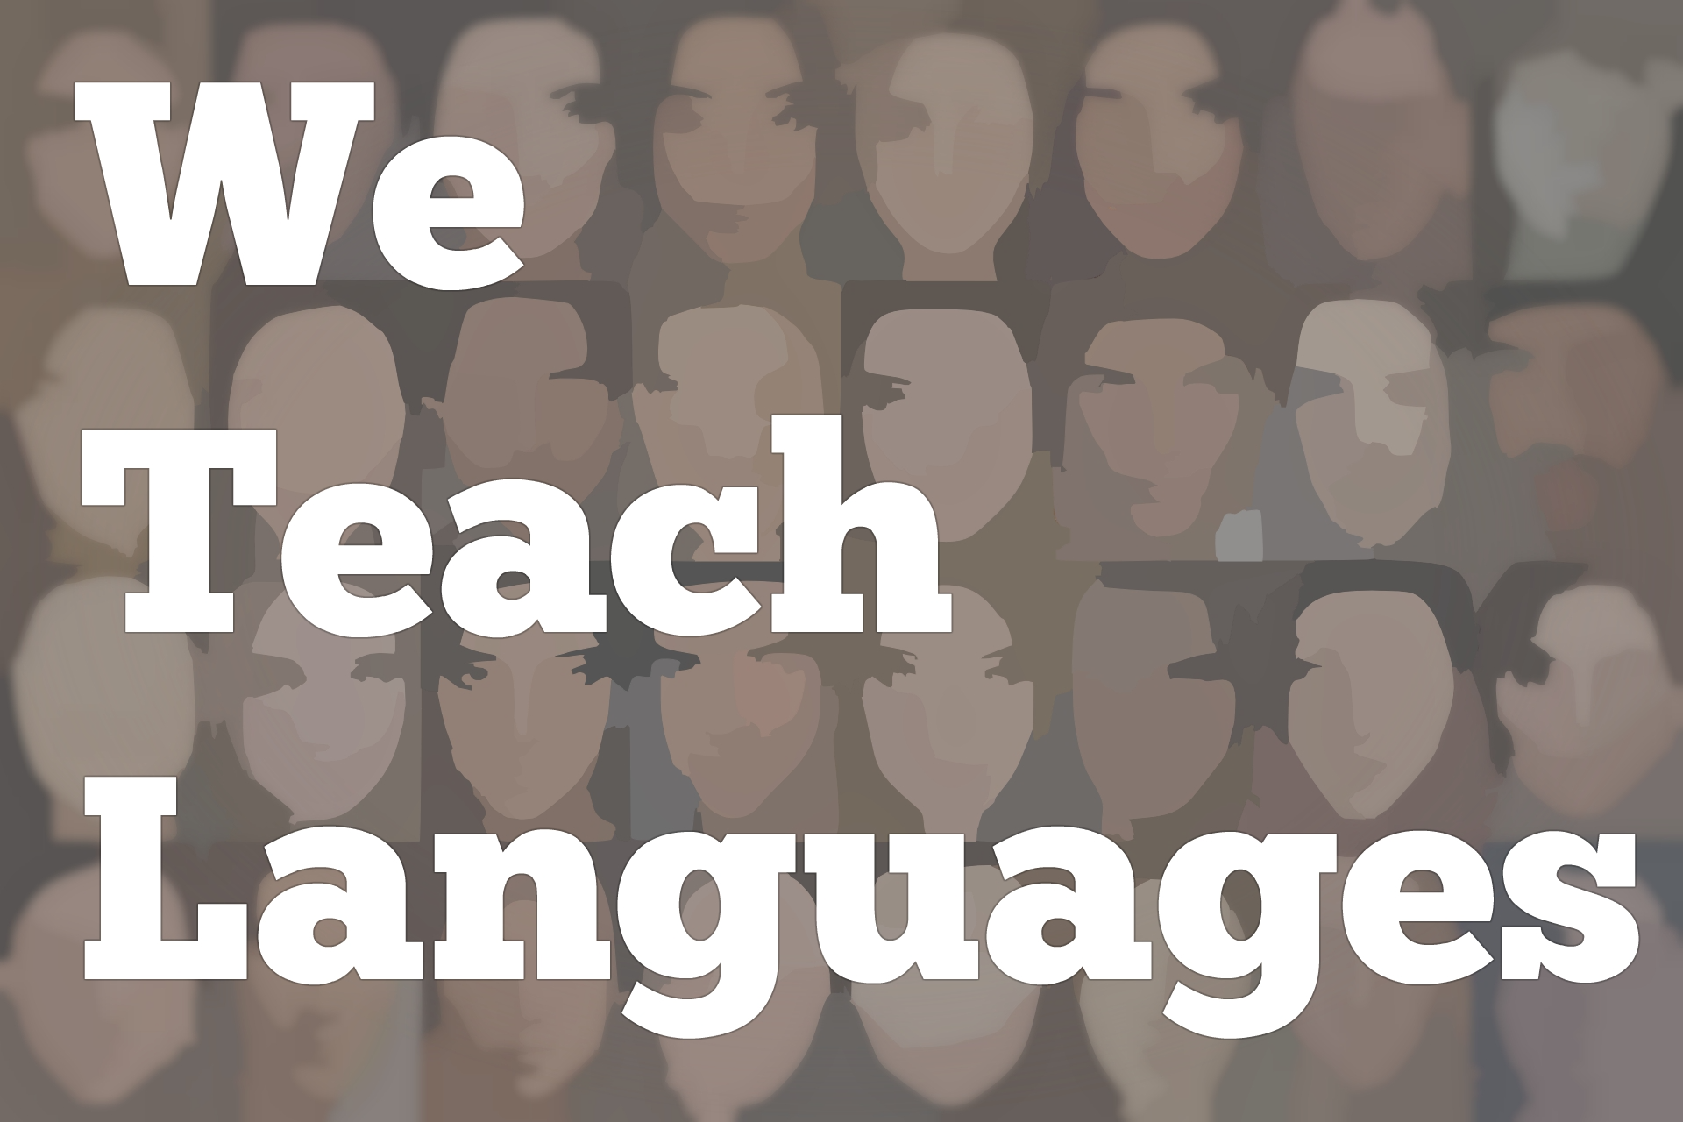
We Teach Languages Episode 111: Teaching Listening with Gianfranco Conti, Part I
[00:00] [background music]
Stacey Margarita Johnson: [00:00] This is "We Teach Languages", a podcast about language teaching from the diverse perspective of teachers.
[00:06] I'm Stacey Margarita Johnson. Today on episode 111, we get to hear Part I of my recent interview with Dr. Gianfranco Conti. As we will mention in the interview, Gianfranco was on the podcast for the first time about two years ago back in episode 16 and 17 to talk about error correction, working memory, and a few other topics.
[00:41] Well, he's back now in another two-part episode in which he asks if our students are really listening or just coping. I'm so excited to share this interview with all of you. It's just jam-packed with good stuff. You're going to want to listen, rewind and then listen again. So, go get your notepad, get your pen, settle in, [laughs] and enjoy.
[01:10] If you have any questions or comments, please do follow-up on Twitter or Facebook and tag "We Teach Lang" and Gianfranco Conti. You can find all of our contact information in the show notes or you can leave a message in the comment section of the episode on our website.
[01:28] [music]
Stacey: [01:28] It's been two years since the last time we talked. Can you believe that?
Gianfranco Conti: [01:36] Long time, yeah. You, folks, don't mind.
Stacey: [01:38] [laughs] I think you should be the one recording the podcast episodes, not me because you meet interesting language teachers all the time.
Gianfranco: [01:45] I tell you, I learn a lot during the workshops. The kind of ideas I get from teachers are shocking. They're beautiful version of, for instance, we're talking about listening. When I show them some of my listening activities, they come back to me a week later showing me how they tweaked them or changed them, or they improved them.
[02:07] I often then asked them if I can steal their idea and put it on my slides. It's amazing.
Stacey: [02:14] That's fantastic. How much of what you are sharing with teachers and getting back from teachers is going on your blog?
Gianfranco: [02:18] Quite a lot, I would say. I've been a bit silent in terms of blogging at the moment.
Stacey: [02:23] I figure that's because you were so busy with your world tour of workshops. I see that you have dates everywhere all the time. I don't know how you would have time for blogging too.
Gianfranco: [02:33] I must say that very often, coming out of a workshop, and I intend to write about what I heard. Unfortunately, it's a willpower issue. I'm too knackered after the workshop to do it. I tell you, there is so much that I heard that needs to be written.
[02:52] The teachers are amazing. The ones I've met, they've all been inspiring, inventive. The amount of challenges that they get, day in, day out, in the state sector are huge. To see them so energetic and keen is very touching at times, to tell you.
Stacey: [03:13] Let's jump in. You have a book coming out about listening that you've co-authored with Steve Smith, who...
[03:19] [crosstalk]
Gianfranco: [03:20] A legend.
Stacey: [03:20] is one of our podcast favorites here, too. He's been on before. When is your book coming out, by the way?
Gianfranco: [03:26] I'd say by second week of August at the latest, 10th of August or something like that.
Stacey: [03:33] That is amazing. Depending on when people are listening, your book might be on the shelves of Amazon, ready to be purchased?
Gianfranco: [03:40] Right.
Stacey: [03:41] What's the title of the book? Tell us what it's about.
Gianfranco: [03:43] I love the title. It's "Breaking the Sound Barrier -- Teaching Learners How to Listen." I love the title because, apart from the coolness of "breaking the sound barrier," it's the second bit that is the most important bit -- teaching students how to listen.
[04:05] Very often, teaching students how to pass the exam, the Proficiency, Cambridge, GCSE, or whatever you call it exam. This is more focused on process than product. The key theme, the leitmotif of the book is how you get students ready for the big match, which is, unfortunately, usually true or false or mentioned kind of a test.
[04:34] When I do my workshop, it's really funny because you've got people who immediately want to know how they can prepare students for the exams so that they get A stars or As. Students who are failing, how you get them in the last two years of the course to a decent grade or above the predicted grade. In England, there's this obsession with predicted grades.
[04:58] I say to them, "No, this is not about that. The book is not about that." The book is about building capacity, so how, in the formative years of learning a language, you teach them how to listen not for a test, but listen to understand.
[05:18] We use the model by a leading researcher called John Field, a model of listening. We identified the main skills or micro-skills of listening. We devised or borrowed, from other researchers, quite a wide set because we came out with 160 tasks, some of which are original, some, of course, recycled or adapted.
[05:42] We'll have a set of tasks for each micro-listening skill. The idea is, use the analogy of a football coach, how would a football coach approach training the players? He would focus on passing, focusing on heading, focusing on shooting, focusing on diving if he's an Italian coach.
Stacey: [06:04] [laughs]
Gianfranco: [06:04] The idea is try to build capacity rather than, as we often do in England...I say we because I was a teacher in England, in the English system for 25 years. The last two years of the course, panicking because half of them or more can't listen. Then basically give them a daily or weekly dose of exam strategies and pass paper after pass paper after pass paper.
[06:31] This is what led me when I was a younger teacher to ditch these strategies, which made lessons dull and about passing exams, and tried to become the teacher-coach, teacher-nurturer, as we say in the book, who, from the very beginning, is trying to create students who are confident listeners, who don't fear listening and, most importantly, who take on listening head-on by not refraining from trying to understand each word.
[07:09] We always said, "Oh, no. They shouldn't understand each and every word." The point is you either listen or you cope. The message to the average teacher is, "Imagine you are a maths teacher. Would you explain a square root by pressing a button and getting someone else on a audio recorder to explain the lessons instead of you?"
[07:37] You are the expert. You are the father and the mother of these children, linguistically. At the end of the day, use your skills and your competence, which happens to be language, and nurture the most important skill in the world, which is listening.
[07:53] The book is about celebrating listening and telling the reader, hopefully, keen teachers, "You are the nurturer. You are there to model language, number one. They should learn languages through listening, to start with." That's one aspect of our approach, a big strand. We call it listening as modeling.
[08:14] The second strand is about training them in the micro-skills of listening, which are the ability to decode. During the first 500 milliseconds of listening, what the brain does is focus on decoding form. Before the brain, working memory, actually decides to focus on meaning, during the first 400-500 milliseconds, the brain processes all the physical aspects, extracting cues from each level.
[08:44] The brain is an amazing machine. First, you would extract cues from sound. We tend to work a syllabic level, syllable by syllable, each syllable activating probabilities of what may come after. Then the brain segments words, making sure that you've identified the beginning and endings of words.
[09:07] Then move to the next level, which is understanding the meaning of word, matching each word to its meaning. Then the next level, which is applying knowledge of grammar. For instance, is the word an adjective or is it a noun? Is it a function word or is it a content word?
[09:27] When the brain has got the cues from each level, already built a picture of the meaning, then you move to the next level, which is understanding a sentence.
[09:38] Only when this system -- which we call bottom-up processing -- fails, only then does the brain use the other system, which is top-down processing using background knowledge, a coping strategy which nature, God, or evolution gave us for one purpose, which is to help us when we don't understand each and every word or most words.
[10:07] What's really happened in many, many, many years of modern language instruction has been that we focused on coping strategies, which is a system that ironically God gave us when we failed to understand.
[10:22] We make that the core business of teaching listening, which is almost like saying, "You know what? For the next five years, you're not going to understand. So use prediction and all the rest to cope." It's paradoxical, really.
Stacey: [10:40] That was amazing. [laughs] I wish I could sit through one of your workshops, Gianfranco. I had never heard that before about the phases that we go through when we parse sounds.
Gianfranco: [10:57] Cool.
Stacey: [10:57] I'm inspired to go look at some of the research and get more background knowledge about that. I understood that we mapped meaning onto the sounds first, and then mapped grammar on second. I had never thought about how we parse syllables and words. That was amazing.
Gianfranco: [11:16] I'll tell you something, Stacey, which is really interesting because you said that about mapping meaning. It's interesting because, of course, the first thing they tell you on your PTC, which is that teacher training course in England, but also on my MA TEFL, which was quite a while ago. That's possibly why they told me this.
[11:34] They told me a little lie. They said, "You know what? You shouldn't focus your students on the details of what you hear. You should focus them on keywords," which is a very vague term. What's a keyword? By that, I understood content words. For instance, dog or beautiful or I went, as opposed to things like the or with or how or because.
[12:03] Normally, most words in the mental lexicon are actually content words. We did a search with Steve. We found some contradictory answers to this question. What we found is that much less than one percent of total words in the lexicon of a language is function words.
[12:28] In other words, 99 percent-plus of the words are content words. However, what is really interesting is that in every single text that you hear, about 50 percent of the words are function words. This minority of words are so essential for communication because they are the glue.
[12:51] If you are a teacher of French, Spanish, or any other language which is highly inflected, has genders, and cases, like German, you'll understand that le or la, for instance in French, gives you quite a lot of expectations about what comes next. It tells you that there is a noun and, of course, it's going to be a feminine noun if it's la.
[13:17] Imagine that you don't understand the word that came after le or la, but you got context. You've got what came before and is going to come after to help you, and you've got another very important clue. It's going to be a feminine noun. If you don't recognize le or la or, as often kids do, think that they are the same thing, you're missing out on a very important clue.
[13:43] These are just small examples of how things like determiners like mon, ma, le, la, au, un, une, [French] can help you. Yet, we've always been taught, "Ah, don't worry. You don't need to understand every single word. The most important thing is gist." It's questionable.
Stacey: [14:06] I see this happen with reading texts a lot. I think some of it is because my professional organization in the US says that, at a certain level, students should only be able to understand the main idea of a text, which is that top-down processing.
[14:21] My understanding of literacy is that we actually start by picking up on details, and then we cobble those details together to create a main idea. Main idea is actually a much more challenging skill than details.
Gianfranco: [14:34] Absolutely.
Stacey: [14:35] I think, unintentionally, we sometimes give teachers the mistaken belief that it's OK to present students with listening texts that are super challenging, and then allow students to pick out a few words they know and extrapolate meaning from that.
[14:54] Let's say I'm that teacher. I'm using a textbook. It comes with certain listening texts embedded that I'm supposed to play for my students. What would be your recommendation to me to move into a better way of doing it rather than having my students grapple in the dark to try and get a few words' worth of meaning out of a challenging text?
Gianfranco: [15:13] It's interesting that you ask me this question. I think it's the most important part of teaching listening. As you know, we, as teachers -- I think we mentioned that in the first podcast -- what happens is that very often we teach the way we've been taught. This means something that community language teaching brought upon us, that we had to focus only on gist.
[15:37] The idea was you might be at an airport one day or talking to a native speaker one day asking for directions. The most important thing is that you cope, which is a very noble principle. It's not something I dispute. The problem is, unfortunately, always thinking about the exam.
[15:56] When you asked me that question, the answer to the question depends on your purpose. If you are giving them a task simply because you want them to become versed or better at inferring meaning from cues -- survival skills, examination strategies, trying to get the gist of the meaning -- fine. Do that.
[16:23] At least make sure that you prepare them from the task. Because, as we discussed in a previous podcast, sound stays in the brain only a few seconds, give them a sense afterwards of achievement by working on the text in other ways so that information list is consolidated somehow. What's in their vocabulary, the culture?
[16:49] Any relevant information you want them to actually learn is consolidated afterwards. Have what I call a triadic approach. Prepare them linguistically as much as you can to minimize overload during phase two. Phase two is the listening set of activities. Notice I say set not activity. Normally, unfortunately, it is only eight questions on the text.
[17:12] Finally, after that phase two, have a phase three. Phase two means you listen, and sound only stays in your brain for two seconds. If you just move on to the next activity, which has nothing to do with that text, kids will have listened two or three times to a text without learning absolutely anything. Their attention will have been only on picking details from a text.
[17:43] In other words, they're going to get to phase three thinking, "OK, I got my grade, 5 out of 10, but what have I done that for? Because all the information is gone. I've done an activity which means absolutely nothing."
[17:58] And in my research, I found that kids who were defeated day in day out by listening, in phase three, they thought, "OK, I'm getting a score which is crap. It just reinforces my idea that I can't do listening on top of that. What have I done? I just heard something that went really fast, made no sense, punished me by giving me a 3 out of 10. It just doesn't make sense because I've learned nothing. What is language-learning about?"
Stacey: [18:28] That is my worst fear as a parent, that my kids are going to end up in that class where they can't understand what's being played for them. Then, they're punished for not understanding what was played for them. That can't the best way to do it.
Gianfranco: [18:45] Exactly. What's really funny is that, you find that when I say this to and I spoke to, I think between March and June, about 5,000 teachers, every single one of them told me that this idea of getting a text, playing the text, and giving them the grade, mark, or score, whatever you want to call it, and then move on to an activity which is not often recycling what they just heard is very, extremely common.
[19:19] We knew that from research, the famous big research by a guy called Chambers in 1996. We found this by 1996 so I was hoping that things that moved on a bit but every single teacher tells me that the status quo, "In fact, you tend to tick the box, do the text, the listening task because it's there in the textbook."
[19:42] Every single one of them had told me exactly what I find out from my students which is, in textbooks, the oral texts are either too easy or too difficult. They never find something in the middle. By in the middle, I believe they made something between 90-95 percent comprehensible.
[20:02] Inside it's super easy because you want to secure that every learner succeed. Then, it goes straight to the semi-impossible or if I'm a strict, smart kid, I can do it. If I'm anxious, worried, low in self-confidence, self-efficacy kids are unfortunately fail once again.
[20:25] The purpose of the book is not to get there. If on the other hand, you really want the students to learn from listening, then you make sure that you minimize cognitive load. In other words, we know that the brain can cope only with about 95 percent to 98 percent comprehensible input.
[20:42] In other words, input that the students do not have to decode using textbooks, experts, or dictionaries. 95 percent to 98 percent comprehensible is what scholars from all over the world agree on as the ideal figure. I tend to believe it's more like 98 percent because 95 percent is what normal is found for reading. Listening, we know is much more difficult.
[21:11] [background music]
Stacey: [21:11] As I said, this is just Part I of a two-part episode. Please check back in next week to continue this conversation. We would love to hear your feedback on this episode. You can find us on Twitter or Facebook at weteachlang or you can leave a comment on the episode page on our website at weteachlang.com.
[21:35] We would like to say a special thank you to the PEARLL Foreign Language Resource Center for partnering with us to provide transcripts and other professional development-resources related to the episodes. You can learn more about PEARLL by going to pearll.nflc.umd.edu. Thanks so much for listening. Bye-bye.
Podcast transcripts are provided through a partnership with PEARLL (Professionals in Education Advancing Research and Language Learning), a Title VI Language Resource Center at the National Foreign Language Center at the University of Maryland. Find additional transcripts: www.pearll.nflc.umd.edu/podcast

Transcription by CastingWords

