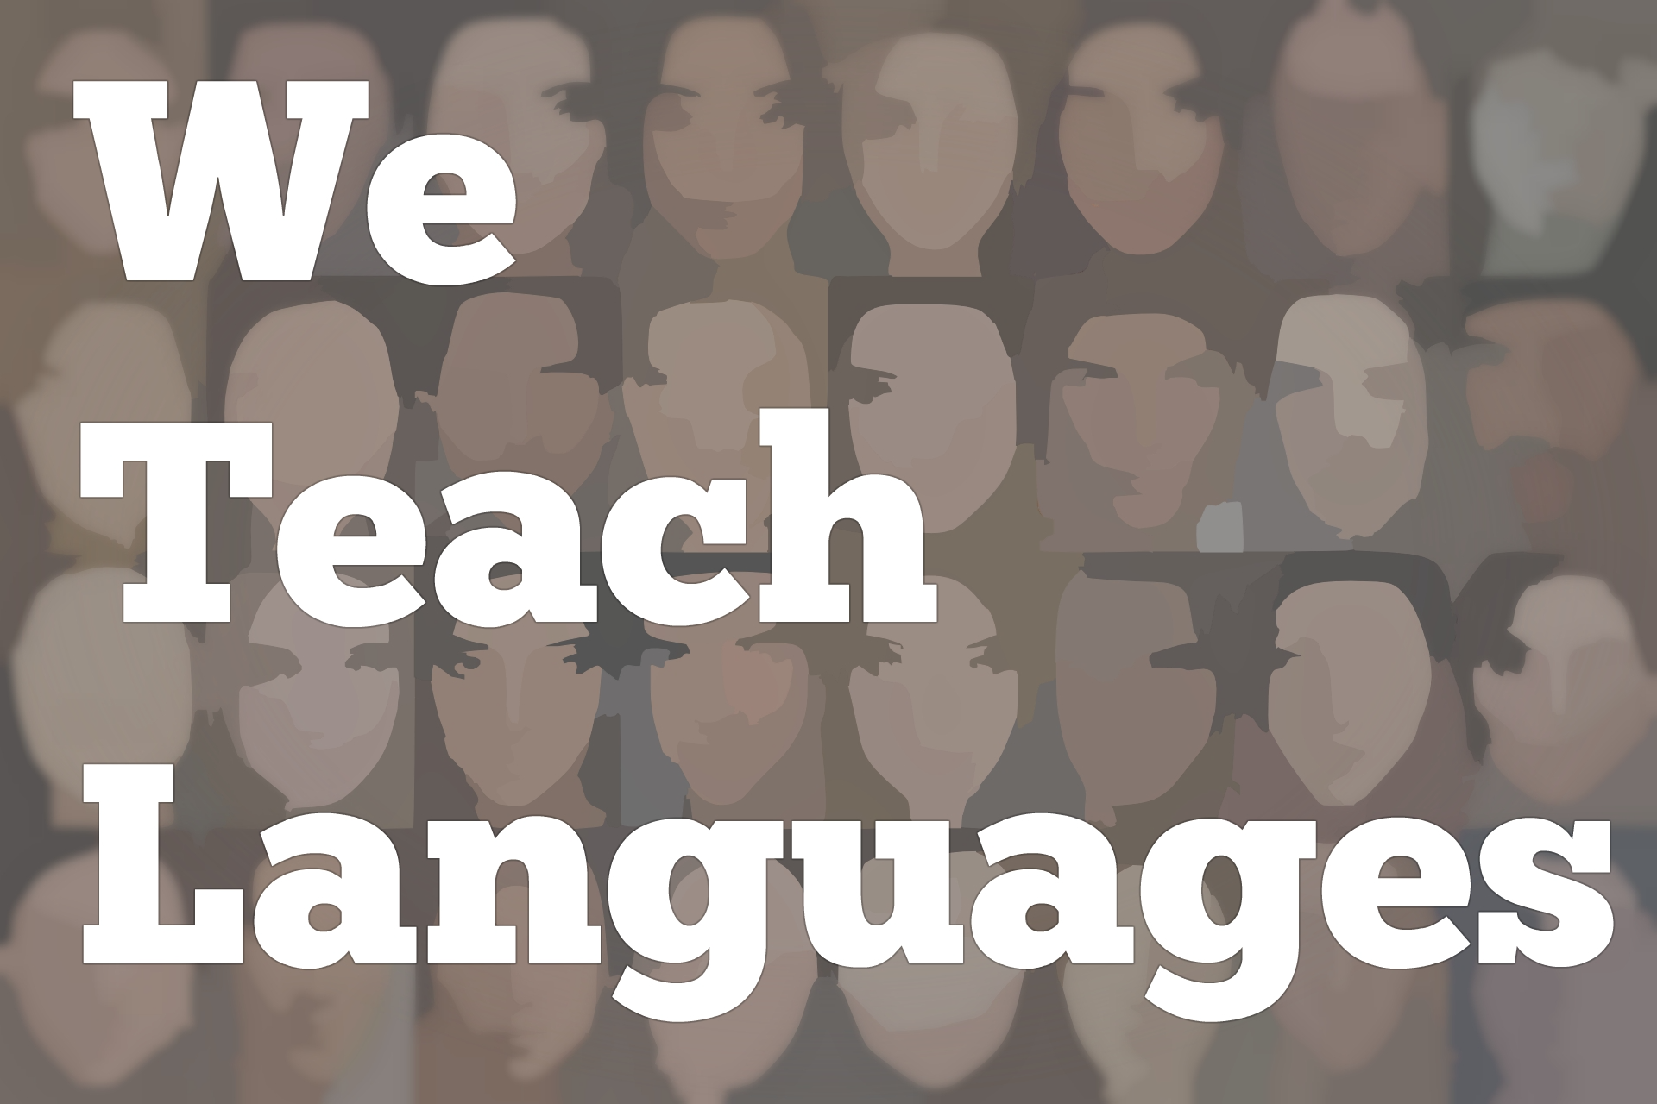
We Teach Languages Episode 112: Teaching Listening with Gianfranco Conti, Part II

Stacey Johnson: [0:00] This is, "We Teach Languages," a podcast about language teaching from the diverse perspectives of teachers.
[0:07] [background music]
Stacey: [0:07] I'm Stacey Johnson. Today, on Episode 112, Dr. Gianfranco Conti is going to continue his discussion of how to teach listening. You are going to get to hear Gianfranco's take on how failure and anxiety negatively affect student outcomes when it comes to listening in particular.
[0:35] He's also going to break down in more detail his process for making sure you're really getting the most out of a listening text. If you hear something you like and you want to know more, please check out the links in the show notes. There's a link to his recently released book that he co-authored with Steve Smith, and also some links to his blog that he mentioned in the episode.
[0:57] If you have any questions, comments or feedback, we would love to continue this conversation with you on social media or in the comments section of the episode on our website. Now let's jump right in, and listen to Gianfranco talk about one of the big barriers for our students to listening proficiency.
[1:20] [music]
Gianfranco Conti: [1:23] We need to take into account a very important issue which we tend to ignore because we are language teachers -- anxiety. We know for a fact, from our own experience and I'm sure, Stacey, you had the same issue I had -- what is the worst thing for a language learners? Even the more advanced of advanced learners. Talking to somebody on the phone in the target language, everyone hates that.
Stacey: [1:49] I don't even like to talk to people on the phone in English. When I have to speak on the phone in Spanish, I can't sleep the night before. [laughs] It's really anxiety-causing.
Gianfranco: [1:58] You know what? It's interesting, because when you listen to somebody on the phone, at least you can ask them to repeat. When we get students to listen to an audio track on tape, or whatever you call it, you can't.
[2:14] We have this stupid magic number two which comes from publishers because of course it's much more expensive to have an actor say it three of four times because it's going to take more space on the CD than to just say two. You tell me how it's possible if you speak at native speaker's speed, you might know this. The listener is behind you, .25 seconds. .25 seconds.
[2:46] In a working memory, sound only lingers for about two seconds. To make things worse, any new incoming sound erases the previous one.
[2:57] Now, tell me how on earth when the brain is not equipped...because as a mother, you will know that it takes much more to model. You use your face, your body language on top of lots of repetition, and the most important thing that a teacher does when she or he models, which is input enhancement.
[3:19] You may want to make sure that the endings of words -- especially if it's Spanish -- are more pronounced. The E and the A as opposed to the O in learning Spanish. All these things already go out of the window when you listen to a CD or an auditory track.
[3:38] To make things worse, of course, most of these in the end, they just pick a speed and the kids cannot stop. I always say to the people that I talk to about listening, "You are the teacher nurturer. You're modeling. You can do lots of things with your face and your speech that some professional actor hired for that purpose, who is not a teacher, won't do."
[4:06] Inevitably, in every single group that I've done, you'll have one person putting their hand up, saying, "Gianfranco, don't they need to hear loads of voices other than yours?" The answer is when you're building capacity, you don't.
[4:25] What are the chances of an 11-year-old, a 12-year-old having to cope with that in the real life? Maybe if they travel to France or Spain often, but will they? The other answer I gave is, on top of that, how many mothers did you have?
[4:44] If you only had one and it worked really well for you, when you're building capacity, as far as your accent is decent, that's not native speaker quality but fairly good. Maybe 80 percent, 70 percent as far as the sounds are pretty distinct. You don't say nu when you're supposed to say new in French and the other way around.
[5:06] As far as that you have that and you should, let's face it, if you have a language degree you should be able to, then it's sufficient. This mind shift is something that is not easy for every teacher to actually do. Let's face it, if you've been teaching or you're being taught listening that way for many, many years, it suddenly puts you into a different role, which is all about listening.
[5:39] If you become the nurturer, then you're the provider of input. By rights you should be, because you are an expert. Also, you need to find ways for students to do the most natural thing, which is interpersonal listening, because most listening doesn't happen in a vacuum or listening to a source. It's between two people.
Stacey: [6:00] All right, this has been amazing. I'm going to recap what I heard you say and you correct me if I got any of it wrong. I need to prepare my students linguistically for what they're going to hear. If I can do the audio texts myself with my own voice as an interpersonal listening, that's ideal. If I have to use a text, I want it to be 98 percent comprehensible so that my students actually have a chance of understanding.
[6:28] I have to understand the limitations of the human brain for being able to parse that text and give them a set of different activities to do with it, instead of a few comprehension questions?
Gianfranco: [6:40] That's key, yes.
Stacey: [6:40] Afterwards, I need to do follow-up activities to make sure they're really getting all the benefit from the text. One question. With those follow-up activities, would you suggest I move to a written transcript of the text instead of using the audio? How should I do the follow-up?
Gianfranco: [6:56] Fantastic. I love this question, because when you're a teacher-nurturer in the way that Steve and I envisage them, you are using listening to model, right? When you're thinking of listening as modeling, and you ask yourself, "What am I doing listening for?" it's because it's leading hopefully at some point to production.
[7:23] If it's not leading to production, it's leading at least to building self-efficacy -- in other words, expectancy of success. How can a student learn in either dimension from what they heard? That third phase could be, if you are trying to learn about their problems, it could be putting the transcript, for instance, on the screen, the classroom screen, reading it aloud, and start to ask the students what their problems were.
[7:59] Imagine a student saying, "Sir, you just said a 't' there." Imagine he's French. "There's a 't' there, but the 't' is not on the text. That is called 'liaison' in French."
"[8:11] Well spotted, Johnny." "Miss (or Sir), is that why you said the 's' there, because it's normally silent?" "Yes."
[8:19] There's a lot of things there. You know what's really interesting, and always, always baffled me? In Year 10 and 11 if you're in England, which are the last two years before the exams, normally there's quite a lot of work like that being done.
[8:34] My question is, since this requires zero preparation, why is it not done in Year 7, the first year? If you get a student to start reflecting on these little problems, even for five minutes a day, you're focusing on the process. You're getting students to think about their learning, which is meta-cognition, number one. Two, when you get to Year 10 and 11, it means that you have to do much less of that because they've already been reflecting on that.
[9:01] The other dimension is leading to production. Imagine texts, listening texts, where already there's been what I call "EP," Extensive Processing. My approach is called EPI, Extensive Processing Instruction, because of this.
[9:18] The idea is that when you exploit the text at different levels, you would be ideally, hitting all the different levels of processing that I described earlier -- phonemic, syllabic, segmenting, lexis, and of course, grammar and syntax. Already, that language has been recycled many times over.
[9:41] As you might know, because I even wrote an article for that on my blog, I love narrow listening. Imagine the same text being exploited many times over, but with the students thinking they're actually hitting a different text.
[9:58] Let me say, they're important. Beginners, but humans in general, don't like long texts. They don't.
[10:06] We know that, as humans, when we interact with another human, after 20 seconds of listening to somebody -- that's why you've been so heroic right now -- after 20 seconds there's already a red light. After 40 seconds, the brain of the other person who's listening disengages already.
[10:22] I suggest, for younger learners, to keep it short and sweet, packed with flooded input, with repetitions and the same kind of frames many times over with absolute beginners.
[10:35] Make sure they understand that it's not true what some ladders, rubrics, say -- that the fact that the text is longer, it means that the more fluent the learner is, because you can have a short text which is much more difficult than a longer text. It's a stupid assumption that nobody gains from.
[10:53] The whole idea is, once the students already extensively process the text, if you have done your job well, the final phase that you are inquiring about could easily be production, because now that kids are constantly...
[11:09] A beautiful piece of research that I came across three days ago -- too late for the book, so you won't find in the book -- said something really smart. We always thought that speaking mirrors listening. We always thought that you listen to somebody, as a child for instance you listen to your mom, and you mirror that.
[11:31] We found something much more magical about the brain -- that when we process listening, we activate exactly the same neuronal circuits used in speech. Do you know how massive that is? Except for the motor bit, so their motor skills are not engaged at all -- because of course you're not speaking -- but apart from that, everything else is identical.
[11:59] It's like the brain is already speaking what you hear. Imagine doing that many times over, like narrow listening does. You then get to a point where you get to the end, where technically, if you harness the skills properly, you can actually have a speaking activity.
[12:21] What's easier than speaking, which is kind of similar? Writing. You could have a phase immediately after the listening, where the kids prepare for the speaking task through some writing tasks, highly scaffolded with less able kids, and then the culmination would be listening.
[12:39] Gianfranco, the usual guy that asked me about "Shouldn't they listen to many other accents?" will ask me, "Are you suggesting that we should spend so much time just on a few narrow listenings?" I always answer the same way.
[12:57] In my research, I always found that most teachers spend about an hour on 5 to 10 or 12 words. That's normally, from what I got from teachers in my questionnaires and surveys, they always say they spend.
[13:15] I ask them, "How many words do you teach per lesson?" "5 to 12, 15." That's the average answer. A lot of people say five, which is kind of worrying because I think you can actually teach more.
[13:27] What's really interesting is, if you spend an hour on 10 words, how many words the students don't understand are found in a typical text you give your students? They always say, "Many more than that."
[13:42] If those words in those texts are useful words, why would you only spend five minutes, do the scores and then move on? Isn't that unfair to the students? Do you see the imbalance? Five minutes for a text which contained 20 really fine words you know, and one hour on 10 words.
[14:02] At least those are in context for God's sake. [laughs] Those are not. The idea is that if you spend more time...It's true that this overlapping rather than mirroring between speaking and listening is happening. It means that when you're doing listening, you're doing speaking.
[14:21] We know from research that you should only go to production once the knowledge and skill is consolidated receptively. One of the most flouted rules ever in language learning. Kids go to production too soon and then what happens, teachers complain about errors, of course.
[14:45] The whole idea is taking listening seriously, modeling those skills consciously when you exploit the text so that it doesn't just become a box-ticking exercise, but it develops into the most important part of the language process. Where listening is not this chore that you have to go through with kids are rolling their eyes, but become something the students' enjoy.
[15:14] Of course, we need to think of listening as fun. Playing with sounds is listening. Fun dictation is listening. And reading aloud, masses and masses of it, reading aloud games which the students do, purely enjoying when listening to each other.
Stacey: [15:35] One thing that I know just from reading your blog and getting to chart with you is that you are incredibly focused on making meaning with your students in the classroom, but understanding also that it's OK to carve out time to only work on phonemic awareness and training students to listen carefully.
Gianfranco: [15:56] The time is ripe with this kind of talk. I don't know about America, but in England the concept of cognitive load has become very important. Now that we know that working memory cannot focus on meaning a form at the same time, you have a game changer.
[16:14] If I can only do one of the two right unless I'm very gifted and talented in languages, it makes only sense that at the beginning of the process, I focus only on sound because that is the basis of being able to communicate. Meaning is learnt at a later stage because it's more important in terms of communication. It's higher order.
[16:41] Nothing in life which is higher order can be done properly unless you have routinized lower order skills. This is the biggest lesson I got from cognitive load theory. We need to understand that we have very finite cognitive resources. We need to be mindful of that.
[17:03] Before cognitive load theory, I think people were a bit arrogant in expectations in the sense that, "Everyone has to be like me. I'm a language teacher. I'm an expert. I manage to cope with paradigms and conjugations and pronunciation. Why shouldn't you?"
[17:21] We were always false reassured by the four or five people in the first row putting their hand up until we realized in year nine in England three years on, when children are starting to play up and misbehave, that for two years they had enough.
[17:34] Now that they got to year nine and they are more rebellious, they think, "You know what? I can't be bothered to do languages." The minute you give that, you give them failure. You set them up for failure. They going to come up with that and say "Languages are useless."
[17:50] Not because they really believe they're useless, it's because they failed. Let's be mindful of the fact that language shouldn't be an intellectual endeavor just for the few, but it should be for anyone and everyone.
[18:06] We feel respect for children by being educationally fair, something which in listening, we never do, or we rarely do. We would actually guarantee that students will be happier with languages.
[18:24] There's one thing that we know for certain, is that the brain is wired to learn through listening. We've been hardwired by nature. Because of evolution, the way we learn has always been through listening. It's a primary instinct. Reading and writing isn't. We learned to write because we realized that what people were telling us only stay in your brain for two seconds.
[18:49] We had to write it down to teach languages in any other way, especially at the early stages by not remembering there are 65 to 45 percent of communication occurs through listening, we are failing our students because we are tapping in a biological root for acquiring languages which is not the natural one.
Stacey: [19:13] Well, thank you so much [laughs] for sharing that with us. I can't wait to get a hold of your book.
Gianfranco: [19:18] If you really are keen on getting our book, do remember that it's been written by teachers for teachers. If you are really applied linguistic scholar you'll find loads of evidence, loads of references to research. While there are some bits which tend to be a little bit researchy, most of it is written with the teacher in mind.
[19:43] If you are an applied linguistic scholar here trying to find the typical essay written by Rod Ellis, or Michael Long, or all the rest, this is a practical book with a lot of theory. The idea is, we first tell you the theory, break it down and make it easier for you, plenty of pictures, plenty of tables to help you.
[20:07] Then it's going to be a massive chunk of activity. We're talking about 30, 40 per section. It's all meant for classroom practitioners. It's not the Michael Ross to John Field book for applied linguistics commerce. It's meant for teachers. Don't come with the expectations of the book to quote in your university PhD thesis.
Stacey: [20:33] I'm sure our listeners, who are overwhelmingly teachers, will appreciate that.
Gianfranco: [20:38] Brilliant. Then I'm happy too.
Stacey: [20:40] Thank you so much.
Gianfranco: [20:40] Thank you, Stacey, for having me on. Always a pleasure to meet you, so interesting.
[20:44] [background music]
Stacey: [20:46] We would love to hear your feedback on this episode. You can find us on Twitter or Facebook @weteachlang, or you can leave a comment on the episode page on our website at weteachlang.com.
[21:01] We would like to say a special thank you to the PEARLL Foreign Language Resource Center for partnering with us to provide transcripts and other professional development resources related to the episodes. You can learn more about PEARLL by going to pearll.nflc.umd.edu. Thanks so much for listening. Bye-bye.

Podcast transcripts are provided through a partnership with PEARLL (Professionals in Education Advancing Research and Language Learning), a Title VI Language Resource Center at the National Foreign Language Center at the University of Maryland. Find additional transcripts: www.pearll.nflc.umd.edu/podcast

Transcription by CastingWords

