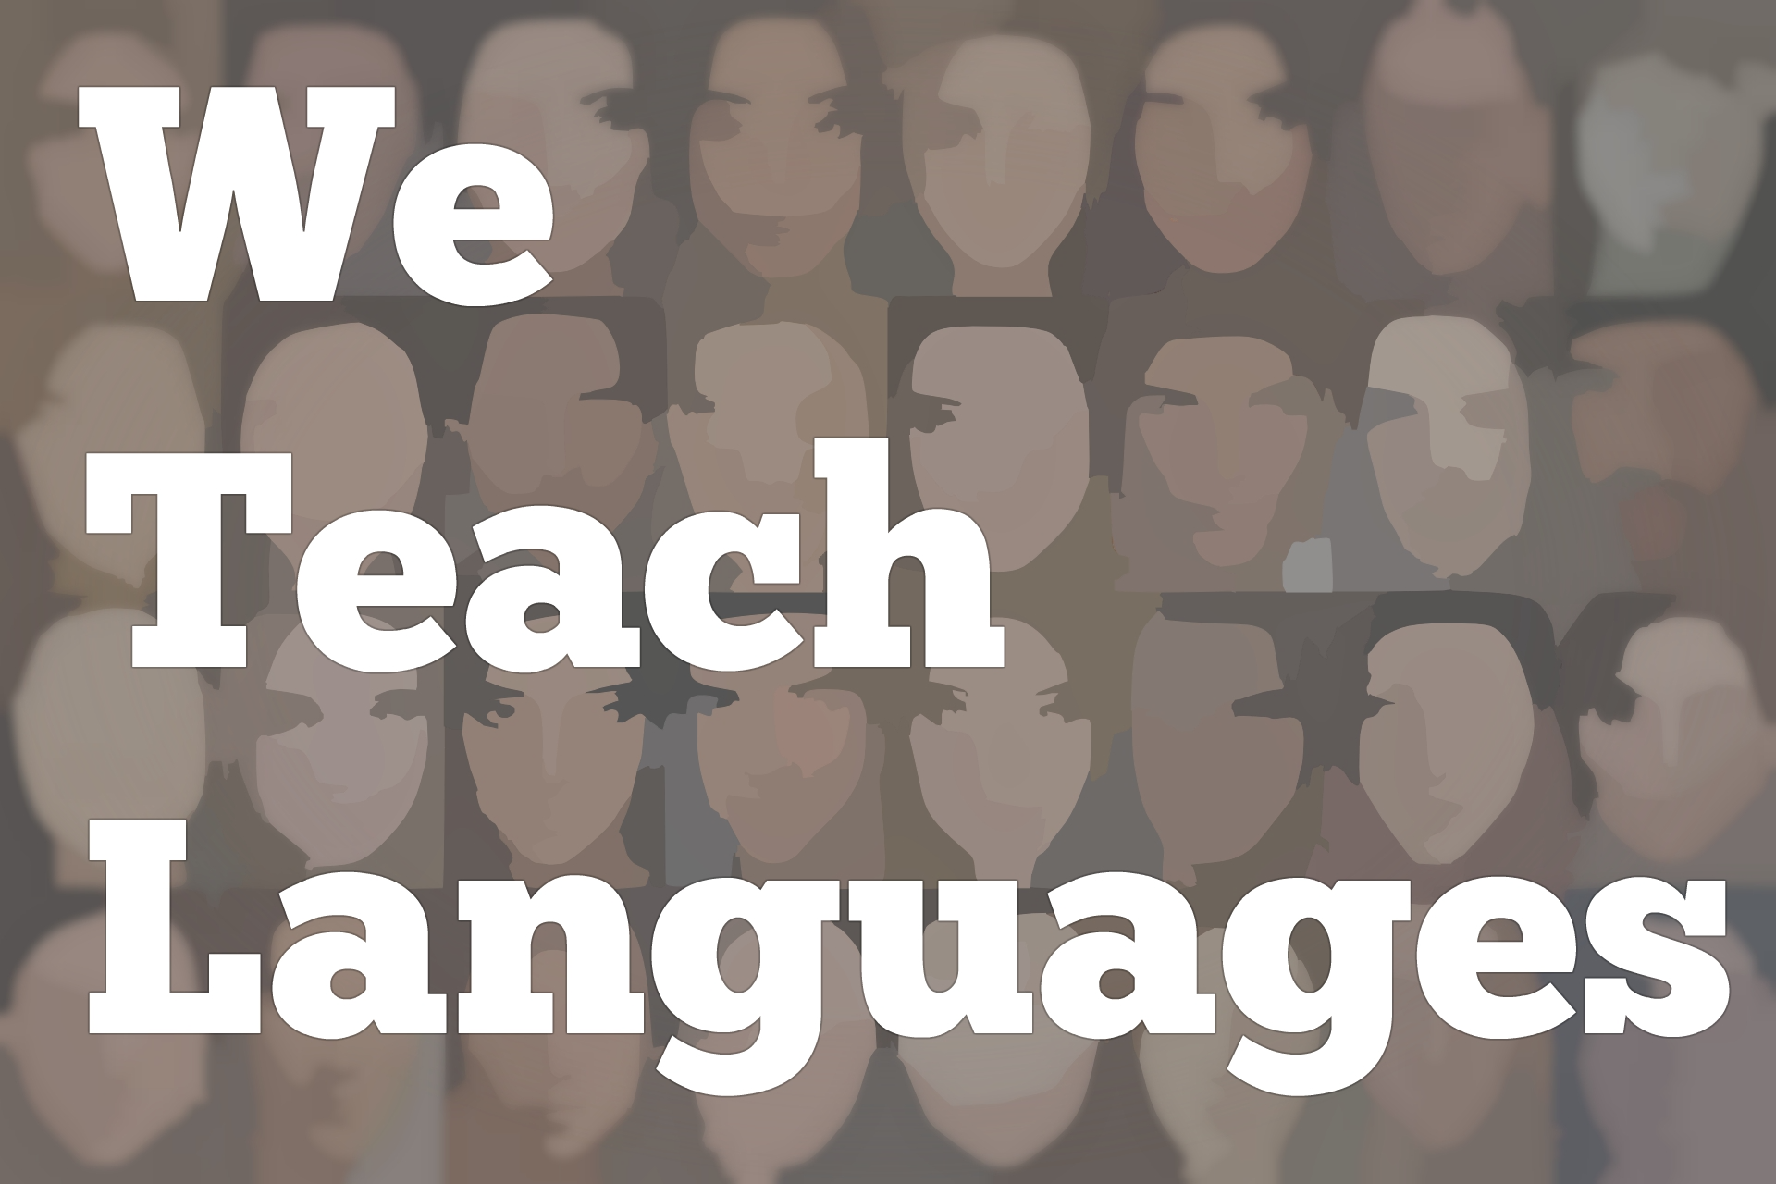
We Teach Languages Episode 116: Linguistic Variation and Serving Diverse Heritage Learners with Damian Vergara Wilson
[00:00] [background music]
Announcer: [00:00] This is "We Teach Languages," a podcast about language teaching from the diverse perspectives of teachers.
Carolyn Siegel: [00:11] Hello, this is Carolyn Siegel of We Teach Languages. I'm here today with Damian Vergara Wilson, Associate Professor and Coordinator of the Spanish as a Heritage Language program at the University of New Mexico.
[00:24] Damian, welcome.
Dr. Damian Vergara Wilson: [00:25] [Spanish]
Carolyn: [00:25] I'm so glad to have you today. Just to get us started, I'd like to ask you if you could describe your learner community.
Dr. Wilson: [00:35] Our learner community is very diverse. If we talk about the Spanish as a Heritage Language program that I direct, we are in Albuquerque, New Mexico, which is the largest city in the state of New Mexico, and of course, this is a border state in the American southwest with a very unique history.
[00:56] We really bring to bear in the present day, a lot. In Albuquerque, you will find in the Heritage Language program not only a great deal of diversity in terms of the heritage language communities, but also in heritage language learner abilities.
[01:14] To begin with, we are one of the first and few programs that really makes concerted efforts to serve beginning level Spanish as a Heritage Language learners. What that means is that a lot of these students really are at the beginning level as far as their productive skills, so speech and writing.
[01:40] At the same time, a lot of our beginners are characterized by having deceptive skills. In other words, when I'm recruiting students, one of the ways I can discover my potential beginning heritage language students is by asking them, "Can you understand your grandma? Can you understand what relatives are saying?"
[02:00] You will typically get students who will say, "Yeah, you know, I can understand almost everything. I can understand a great deal, but I just don't like to speak it. People make fun of me when I talk or it is just doesn't come out." It's kind of an incredible thing if you think about it.
[02:14] A lot of the programs overlook these students or they'll send them to their L2, their second language program until their skills improve. These students have, to me, represented an enormous resource.
[02:29] Beginning heritage language students here, well a great body of them, comes from the portion of the population that has been here since colonial times. However, at the same time, mixed in with that are waves of immigration that have occurred here in New Mexico, really, since the beginning of the state as an area that was settled by Europeans.
Carolyn: [02:55] Do you have classes then that are specific for heritage language learners with high receptive skills?
Dr. Wilson: [03:01] Absolutely. We have beginning level heritage language courses. The sequence right now is Spanish as a Heritage Language one, two, three, and four. In days of better enrollment, we also had upper division heritage language courses as a writing course for heritage language learners and just a general topics course that changed according to who was teaching the class.
[03:26] We get a lot of variation. We get a lot of diversity in terms of the students' abilities with the language when they come in, which is mixed in with them being from the colonial group of New Mexicans as compared to a lot of recent immigrants.
[03:42] You'll get people who might be second or third generation immigrants most commonly from Mexico, but also we get a lot of people who come from an immigrant tradition that stems from South America and even Spain, oddly enough, once in a while, and, as you can guess, many, many Central Americans.
[04:00] There's a lot of diversity here.
Carolyn: [04:03] I'm curious to know when you have these two, let's say, bodies of heritage language learners in the class, those that have this many generation sense of identity around their families and their personal identity in the same classroom with heritage language learners that are recent immigrants, can you give an example of what that looks like in, for example, a level one or level two heritage class?
Dr. Wilson: [04:27] Yeah, it's an interesting thing. I'm writing about it as we speak. I'm working on a couple of articles that deal with that in different ways. Really, I think that you focus on the things that unite the students. We teach from a sociolinguistic perspective that is also informed by critical pedagogies.
[04:50] Really, a lot of the work that happens is a teacher attempting to position all students as resources, as all students of speakers of legitimate varieties of Spanish that deserve to be recognized as completing the functions of the community to which they belong, and just generally pushing the notion that nobody inherently speaks a dialect that is superior to another.
[05:17] When you start looking for commonalities, you erase some of the natural kind of competitions that might happen at a societal level.
[05:27] You can imagine as we look at the situation with immigration in the border at a national level, on a more micro scale, there's been tension in New Mexico for many, many decades, where people who believe themselves to come from a colonial past, with more direct European roots, often view or position more recent immigrants as a possible threat, as people who might be taking their jobs.
[05:57] You'll find it really in the high schools, I believe that this still happens, you'll have some division between the groups. When you get them into a heritage language classroom and start focusing on the commonalities, I think young people, especially these days, are much more willing to embrace that and explore that.
[06:14] What you get is a lot of students will come in and they'll say, "My grandma says something this way." Another student with a different background will say, "Oh, my grandmother says it that way." Really, the students do a lot of the teaching. One of the biggest things that I try to teach my TAs who work for me is never get in the way of student learning.
[06:39] As teachers, we have this intuitive drive to insert ourselves into everything, into shape and guide conversations, but sometimes you have to step out of the way and let the students [indecipherable] . A lot of times, the students will rally around the fact that language attrition, language loss, lack of language transmission is one of the thing that unites them.
[07:04] It doesn't matter if your grandparents are from New Mexico or from Mexico. We're all united by the fact that the societal language, English, is really pushed on us to the detriment of us maintaining our heritage language, which brings in notions of critical pedagogy or critical language awareness, where the idea is...
[07:25] Teaching heritage language learners is much more than just having students fill out verb charts and memorize a great deal of vocabulary, instead...
[07:35] One of the things that really facilitates language acquisition is to look at language issues, to develop a critical language awareness, to examine the societal forces that have promoted language abandonment, keep issues facing all people who come from Spanish speaking backgrounds, the way they were positioned by the dominant society.
[07:59] A lot of times, we start looking at those issues. Once again, students who have very diverse background will feel united. They'll be able to share. Also, when you come from a Latinx community, be it New Mexican, Latin American, wherever, when you come from one of these communities, you realize that society positions you in the same way regardless of where you came from.
[08:26] Once again, there's a lot of commonalities. You can highlight them. That's one of the big things we do. I can't even talk about specific things we do with our beginner. In the program that I coordinate or direct, we focus on the final project as an element that defines the class.
[08:49] For our beginning level heritage language learners, we are currently doing a project that focuses on lexical variation. The students going to the communities and do many dialectology objects, where they...Often, the students come up with this.
[09:08] We will show them the basics. Like in class, we come in with a variety of images. Of course, the Turkey is an image that provokes a great deal of lexical variation. We'll ask students, "How many words do you know for this animal?" In New Mexico, you are going to get [Spanish] .
[09:31] You are going to get [Spanish] , you are going to get [Spanish], etc. Some might even call it [Spanish]. In all of these words bring a history with them. It's very fascinating. You show this to the students within the classroom. Just the students amongst themselves will come up with a great deal of lexical variety.
[09:58] What you do is you have them brainstorm. What other images do you think we can show? Because, guess what, you guys are about to go out into the communities and do this. A lot of times, the students will come up with really interesting images.
[10:12] As the students go through these projects, they go to their communities and they learn these words, and they document them by showing members of the community various images of, say turkey, underway, a hose, bring some pretty interesting variance -- cars, trucks. Whatever the students think they want to focus on, because they are aware of language variation.
[10:36] They come back into the classroom and they present their results, and it's just fascinating because every word tells a story. The students talk about not just what they find, but the process of finding it, and the conversation that these started in. I say this, but my grandma said that. She was from here. They say this that way, but my other relatives are from there. You get these amazing stories.
[10:57] Really what happens too, at the same time you're validating a lot of different speech communities and the way that they talk, but also you are combating the standard language ideology that many people internalize, which manifests itself as what is the right word? My dad says [non-English speech] , but that's Spanglish. It can't be the right word. What's the right word?
[11:23] Once again, the students learn a bunch of vocabulary, and then they find ways to combat these language ideologies to really shine light outside of these ideologies. It's a great project. It brings in critical language awareness, notions of sociolinguistics, and along the way augments vocabulary.
Carolyn: [11:43] I noticed when you were speaking about your student community, you used the pronoun we. I assume that you include yourself in this heritage speaker narrative. Can you correct me if I'm wrong? [laughs]
Dr. Wilson: [11:53] I'm glad that you noticed that. I don't do it on purpose. To begin with, I was actually a student in the program that I now direct. I was a student in the '90s. This program has been in continuous existence since the mid '60s at the University of New Mexico.
[12:15] As a student, I was in a million different departments. I started off in the art department. I went to sociology. I tried out English, history. I was just lost. Then I got recruited into the Spanish as a Heritage Language Program. It was so cool so cool because language loss is isolating.
[12:34] A lot of students feel this isolation. They think, "I'm the only one." My uncles and aunt called me a gringo because I can't speak perfectly. They feel isolated. They feel like they're somehow defective. When you're suddenly in a room with a bunch of people that share that same experience, you realize that it's not an individual characteristic.
[12:52] This is not an individual deficiency. It is something larger. It is something that is the result of ideologies at the societal level being pushed upon us. I am part of a growing number of practitioners of Spanish as a Heritage Language who were also students in these programs. Like I said, there's a growing number of us.
[13:21] I think that using the pronoun "we" is important because when I go to a lot of conferences, the researcher is always talking about "they." They do this. They do that. They're using the third person because they don't belong to the same communities. What we're seeing is a lot of people going from the heritage language classroom into graduate level education now. Taking up the baton. Picking up the torch.
Carolyn: [13:46] How long have you been teaching in this program?
Dr. Wilson: [13:51] My history is a little bit idiosyncratic, as you could guess. I graduated in 1999 with a bachelor's degree from UNM in University Studies. Held a job as a social worker for a few years, which connects to my love for sociolinguistics of course. I ended up in a master's program by 2001. I got to teach in a heritage language program as a master's student. Ended up doing my PhD at the same institution.
[14:27] Because of my focus on New Mexican Spanish and heritage language learners, and just the very good fortune of being in the right place at the right time, the position opened rather suddenly [inaudible] . There I was with the right credentials. I had just graduated with my doctoral degree.
[14:52] I began as a lecturer. The circumstances at the time were very friendly towards the program and the chair. People at dean's office worked to get my position converted to tenure track in about 2011.
Carolyn: [15:08] Therein comes my follow-up question. Over the course of these 19 years teaching heritage language learners in New Mexico, how has your approach, and maybe your department's approach changed towards these learners?
Dr. Wilson: [15:24] It's a lot more visible now. As far as my own approach over the years, a lot of it has become we're now including a lot more delivery, including a lot more task-based teaching, and also teaching that draws upon communicative language teaching.
[15:43] Back in the day, if you look at a lot of what some of the more prominent scholars in heritage language teaching were doing in their early writings, like [indecipherable] , Sanchez, it's interesting because they were talking about including notions of sociolinguistics back in the 1970s. I think it's really easy to say that, but how do you do it?
[16:12] Since I've been there, there has been a much more, over the years, become a lot more deliberate about how we do it. One of my missions right now is that...
[16:22] As an educator, you always get these fancy terms. Like critical language teaching, critical pedagogy, sociolinguistically informed pedagogy. It sounds great. You go to these conferences and it's awesome. You're totally inspired. You get back home and you're like, "I'm going to do it." But how?
[16:43] I've done a couple of workshops over the last couple of years. I'm working on a publication right now that addresses how do you do this? How do you incorporate sociolinguistic oriented pedagogy in the classroom in a way that you can be confident that it's rooted in sociolinguistics, even though you might not have a PhD focused strictly on sociolinguistics? That's one of the things that's changed.
[17:08] The previous coordinator promoted a lot more mechanical work, a lot more time in class doing things like filling in the blanks and verb paradigms, and less speaking activities. Over the last 19 years, we've found a lot of different ways to get students out of the classroom and into the communities and bringing great information back. I think that would be the biggest way that it's changed.
[17:37] But also the field has exploded. When I got into teaching in heritage languages at the Spanish as a Heritage Language at University of New Mexico, as a master's student trying to write term papers, there were scant citations that you could draw upon. There was no literature. There were a few things. Everybody was citing the same 10, 12 papers. Well, there was of course more than that.
[18:02] There was really just a small core set of publications from which you could draw and formulate new ideas. Now, it's just exploded. I'm putting together a seminar on teaching Spanish as a heritage language now, and there is just so much out there that it's hard to narrow it down. The field itself has exploded.
Carolyn: [18:23] To end our conversation on a high note, hopefully, inspiring our listeners to think more critically, I like when you said it's easy to say that we incorporate sociolinguistics, but it's harder to do. My final question for you is what resources do you recommend to help teachers do it?
Dr. Wilson: [18:42] Just to start with, people have been writing about it for a while. A good place to start is with two scholars I'll name, Jennifer Leeman and Glenn Martinez, one publication in particular called "Innovative Approaches to Heritage Language Teaching".
[19:01] These are good places to start. There are a number of articles out there that lay the groundwork, that talk about that framework, but, OK, and here's the key and this is one of the things that has fueled some of my recent writings, there's no guide on the specifics.
[19:21] Once again, you go to these presentations and you read these articles, and they're great. They're very inspiring. All of these scholars I just mentioned do very inspiring work. Yet, the specifics are not discussed. I think one of the few scholars to discuss specifics is Glenn Martinez who in an article in the mid-2000s in the "Heritage Language Journal", I believe it was, talked about specific activities to do with students.
[19:51] While we never used those activities in our program, we drew from them and kind of recast them, modified them to fit our needs.
Carolyn: [20:03] Last inspiring words for our listeners as they move forward teaching heritage language learns both at the university and high school level?
Dr. Wilson: [20:12] To somebody who's entering into the field of teaching Spanish as a Heritage Language or really, any heritage languages, don't be afraid to take risks. You'll have great rewards, and you'll also have occasional disasters, but look to your students. Try to set the stage for your students to show you who they are for your students to feel valued.
[20:35] Try to find ways to serve the vision that the students have for their own learning, which can sometimes be a little bit different from what we think that their learning goals are. In other words, you might go in thinking that they want all this critical pedagogy in sociolinguistics, and they might actually want some materials that help them improve in more formal registers.
[20:57] There are a lot of resources out there. There is the National Symposium on Spanish as a Heritage Language, which we will be hosting at the University of New Mexico in February. There is the National Heritage Language Research Center, and they have workshops every summer, etc., etc., and so just reach out and find stuff.
Carolyn: [21:22] Damian, thank you so much for talking with me today. I really appreciate it.
[21:26] [background music]
Announcer: [21:28] We would love to hear your feedback on this episode. You can find us on Twitter or Facebook at weteachlang or you can leave a comment on the episode page on our website at weteachlang.com.
[21:42] We would like to say a special thank you to the PEARLL Foreign Language Resource Center for partnering with us to provide transcripts and other professional development resources related to the episodes. You can learn more about PEARLL by going to pearll.nflc.umd.edu.
[22:02] Thanks so much for listening. Buh-bye.
Podcast transcripts are provided through a partnership with PEARLL (Professionals in Education Advancing Research and Language Learning), a Title VI Language Resource Center at the National Foreign Language Center at the University of Maryland. Find additional transcripts: www.pearll.nflc.umd.edu/podcast

Transcription by CastingWords

