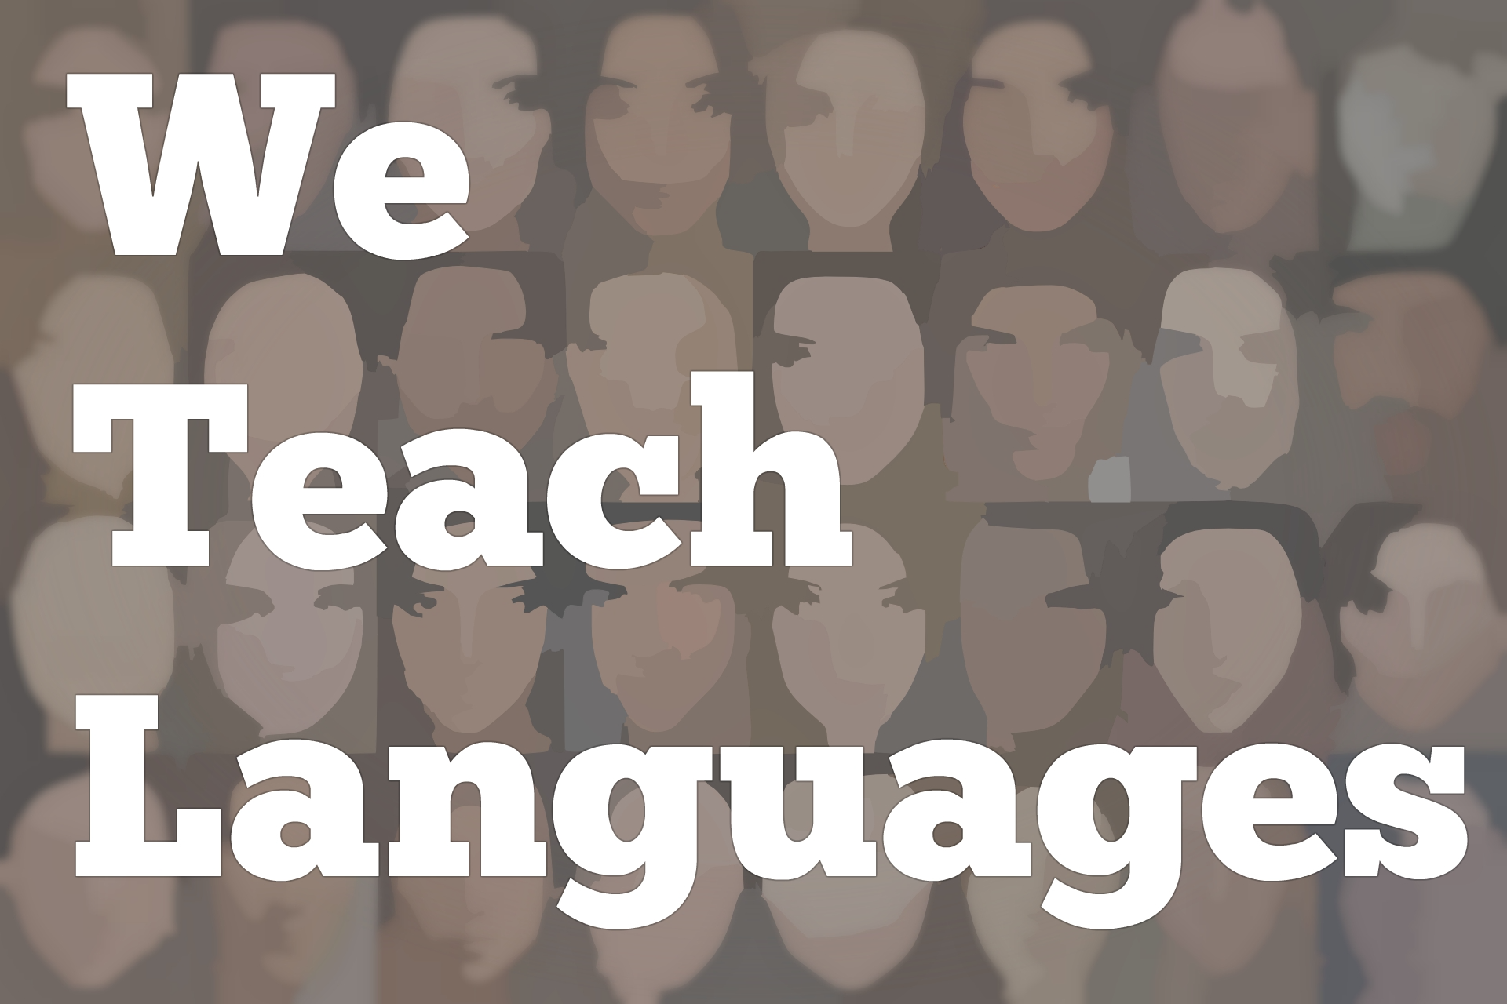
We Teach Languages Episode 117: The Language Center’s Role on Campus and in the Community with Angelika Kraemer
[0:00] [background music]
Announcer: [0:00] This is, "We Teach Languages," a podcast about language teaching from the diverse perspectives of teachers.
Stacey Johnson: [0:11] I'm Stacey Johnson. Today, on Episode 117, Melanie Forehand interviews Angelika Kraemer about the role of a modern language resource center.
Melanie Forehand: [0:27] Hello, my name is Melanie Forehand. I'm a PhD candidate in Spanish and Portuguese here at Vanderbilt University. Today, I'm joined by Angelika Kraemer.
[0:37] Angelika is the director of the language resource center at Cornell University, and she serves as the co-editor of the journal, "Teaching German." She is also the co-coordinator of the International Association of Language Learning Technology and was recently elected president-elect of the association.
[0:59] Thank you for taking time to chat with me today, here at the Center for Second Language Studies.
Angelika Kraemer: [1:05] It's my pleasure, Melanie. Thank you so much for having me.
Melanie: [1:08] You're welcome. Since we're here at the language center, I thought maybe that would be a good place to start our conversation. You work as the director of the language resource center at Cornell. That got me thinking about the language lab model.
[1:24] A lot of people in the field probably remember labs filled with students with the very bulky headsets or headphones. How do you think language centers differ from the language labs of your?
Angelika: [1:41] As a field, we have actually seen a transition from language lab to language center. A lot of institutions have realized that what language labs did is no longer in line with what we know about how languages are acquired, and that this individual, staring at the front in rows is not very communicative way of teaching or having students practice, that this is not what our students need in order to advance in their proficiency.
[2:17] A lot of language labs actually have morphed themselves into more social spaces, language centers. I enjoy the space here. It's such an open and welcoming space.
[2:31] Also, another thing, if you think about our student demographic, a lot of students have their own devices on them constantly. There's no longer much of a need for these traditional language labs with the bulky computers and the carols.
Melanie: [2:46] Tape recorders.
Angelika: [2:47] What is that?
Melanie: [2:48] Exactly.
Angelika: [2:49] [laughs]
Melanie: [2:49] One of the great things about language centers is that they serve a broader community. When it was the language lab model, it was serving the undergraduate language learner.
[3:07] Now, we have the opportunity to not only help those students develop cultural competencies and language communication skills, but also our upper-level students, offer professionalization opportunities for our graduate students, offer training for our faculty, allow for different events throughout the year, throughout the semester.
[3:33] It's interesting when you think about how different those are. It hasn't been that much time.
Angelika: [3:38] That's true. We can even expand the stakeholder list to include the community at large as well. Oftentimes, universities are located in a specific city. There might be pockets of different native speakers. They might be interested in sharing their cultural knowledge, their background, maybe practicing their English, and just engaging with the university community as well.
[4:06] Definitely, there's a lot that language centers can bring to the table and a lot of expertise.
Melanie: [4:13] Speaking of that, I know that when you were at Michigan State University, you all did a lot of outreach programs for children and for the community. Could you talk a little bit about how those programs originated?
Angelika: [4:26] It was actually an interesting story. When I was a graduate student at Michigan State, one of my professors, her son, was in elementary school. She wanted to expose his peers to his heritage. She was looking for graduate students to go into the school. We did what was called Fabulous Friday events.
Melanie: [4:46] I love that. Fabulous Friday.
Angelika: [4:48] Fab Friday. A friend of mine and I, she was also from Germany. We would go in, we would sing songs with the kids, do some arts and crafts, and teach very basic language. That was well-received. The school was interested in doing more.
[5:06] We did a more longer-term enrichment program during lunch. That was the lunchtime enrichment. From that parent's one, it's still more.
[5:17] Then we started a summer camp that was a half-day camp for two weeks. Then that morphed into weekly classes. Then from there, we built to include more languages. By the time I left, we had about 12 different languages that we would offer, depending on what the community need was.
[5:37] We had a lot of programs that ran on our campus, weekly classes, summer camps. Then also programs that ran at elementary schools, at middle schools in the community, to make sure that we share the expertise that we have at a university with the community at large.
Melanie: [5:58] I love one of the things that you were talking about is that the direction of your program was determined in part based on what the community needed. I know that in 2017, along with your colleagues at IALLT, you created a language center evaluation toolkit.
[6:11] Now that you're working on the new language center handbook for 2021, I was wondering, what do you think language center excellence looks like? What do you think makes a great language center?
Angelika: [6:36] Based on the survey data that we have from language centers, mostly across the States...We get a few international submissions. That's the I in IALLT, international. We definitely need to ramp that up. What we have seen is that successful language centers function as social hubs. They are a space where people can come join whenever they feel like it. They can hang out.
[7:09] It's a social space, but it's also a safe space to expand their repertoire of teaching expertise, of best practices for students for how to learn languages. As you mentioned earlier, too, combining or being open to a broader set of stakeholders. Taking what we can offer, all the expertise that our graduate students bring, that our undergraduate students bring, especially our international students too, and sharing that on a broader basis.
Melanie: [7:43] Do you notice any differences in the types of activities that the centers do in the United States versus abroad? Are they pretty similar?
Angelika: [7:52] That's an interesting question. I just returned from a conference in Japan. In Japan, language centers tend to focus on students exclusively. Oftentimes there are self-access centers, where students can go to practice their language.
[8:14] It's less of a social space, and not often utilized by instructors or graduate students. That's the Japanese model. There are different models in different countries. I think some reflect more the standard. I don't know if there's a standard, but the way that a lot of language centers function in the United States.
[8:39] I think it always depends on going back to the local need -- what is the local need, and how can you best support the individual people that you work with at your institution. I think there are certainly some differences.
Melanie: [8:55] That's interesting, to learn that there is a little bit of a difference. It is always an evolving process or an evolving status. Maybe it starts out with those headphones, but then over time it becomes a communal space. It's a transition.
[9:14] Do you have a favorite activity or a favorite event that you like to do at your language centers, something that you would recommend to others?
Angelika: [9:24] Something that we just started doing last year, and this was part of a bigger initiative. We had a Global Grand Challenges Symposium, where, as an institution, we were trying to figure out what are some of the challenges that we face globally and what can Cornell do to tackle those.
[9:41] As part of that, we wanted to engage students as well. From the international perspective, we decided to do a Lingua Mater Competition. We asked the students to take the Cornell Alma Mater, translate it into either a language that they speak at home or a language that they're learning, and perform that somewhere on one of the Cornell campuses, submit a video of that.
[10:06] Then we honored the top-three entries at the symposium, and there was a cash prize too, which always helps. That was such a fun event that we're now going to do every year during international education week, where we will release the top winners.
[10:24] It was amazing too to see the creativity that some of the students and the student groups brought to the table, and the time they spent creating the video, learn the song, translating the Alma Mater too. We all kept humming the Alma Mater for weeks after.
Melanie: [10:42] [laughs] I love that. That's such a great story. It makes me think about ways you can incorporate karaoke into your center or ways to do translatathons. There are so many different facets to be able to incorporate the community and to make it relevant to students on campus and to campus life.
Angelika: [11:02] Yeah. Absolutely. There was also one option for alumni to submit entries as well. [laughs]
Melanie: [11:07] Wow! Did you have alums that entered?
[11:10] [laughter]
Melanie: [11:11] That's great.
Angelika: [11:11] But it was a very sweet video too, very endearing.
Melanie: [11:17] I guess one last question that I would have for you is I know that you recently took over a language center, so you started at a new center. The question that I was wondering about, especially for graduate students that are thinking about entering into the profession, I think that, when you come to a new place, it can be difficult to learn what the institutional history is and what are everyone's favorite things.
[11:47] Could you talk a little bit about how you approach starting at a new center?
Angelika: [11:54] I was set up with a great onboarding team, so lots of people who are very familiar with the language learning landscape and who have been at Cornell for a very long time. Those were extremely important allies for me to have, because I could ask all the silly questions that I wouldn't really want to ask in public.
[12:16] They would be able to tell me some of the politics things that I would need to be careful about, and point me toward other people who would be good supporters of the work that that language resource center does.
[12:31] We ran surveys to hear from people, "What do you think?" We did strategic planning for the center. That was one of the first things that we did, trying to get a sense of what do people think we do and we are, what do they want us to do, what do they think we should be, and then just lots of conversations with people.
[12:52] That's the beauty of being new to a campus who can knock on people's doors, and it doesn't matter what relationships used to be beforehand, because you're new. You don't know any better.
[13:03] Just introducing myself to people and telling them, "This is what I'm here to do. I'm interested in hearing what you think what we can do to maybe collaborate or to support your students, your faculty."
[13:15] Just be open-minded. I think that has really helped. For me, it's been a very positive experience and a very welcoming experience. I'm still learning. [laughs] There is still a lot for me to figure out how to navigate such a big institution.
[13:36] I think being willing to ask questions and approach people, not being shy to knock on people's doors, being out there and being visible, I think that was a good way for me to get my foot in the door.
Melanie: [13:51] All right. Everyone needs to go knock on the doors and ask questions.
Angelika: [13:57] Yeah.
Melanie: [13:57] Thank you so much for taking time to talk to me. I really appreciate it.
Angelika: [14:01] Absolutely.
Melanie: [14:01] I hope you have enjoyed your time here in Nashville.
Angelika: [14:03] I have very much so. Yeah.
Melanie: [14:05] All right.
Angelika: [14:06] Thank you so much for having me.
Melanie: [14:07] You're welcome. Take care.
[14:09] [background music]
Stacey: [14:12] We would love to hear your feedback on this episode. You can find us on Twitter or Facebook @weteachlang, or you can leave a comment on the episode page on our website at weteachlang.com.
[14:27] We would like to say a special thank you to the Pearll Foreign Language Resource Center for partnering with us to provide transcripts and other professional development resources related to the episodes.
[14:40] You can learn more about Pearll by to pearll.nflc.umd.edu. Thanks so much for listening. Bye-bye.

Podcast transcripts are provided through a partnership with PEARLL (Professionals in Education Advancing Research and Language Learning), a Title VI Language Resource Center at the National Foreign Language Center at the University of Maryland. Find additional transcripts: www.pearll.nflc.umd.edu/podcast

Transcription by CastingWords

