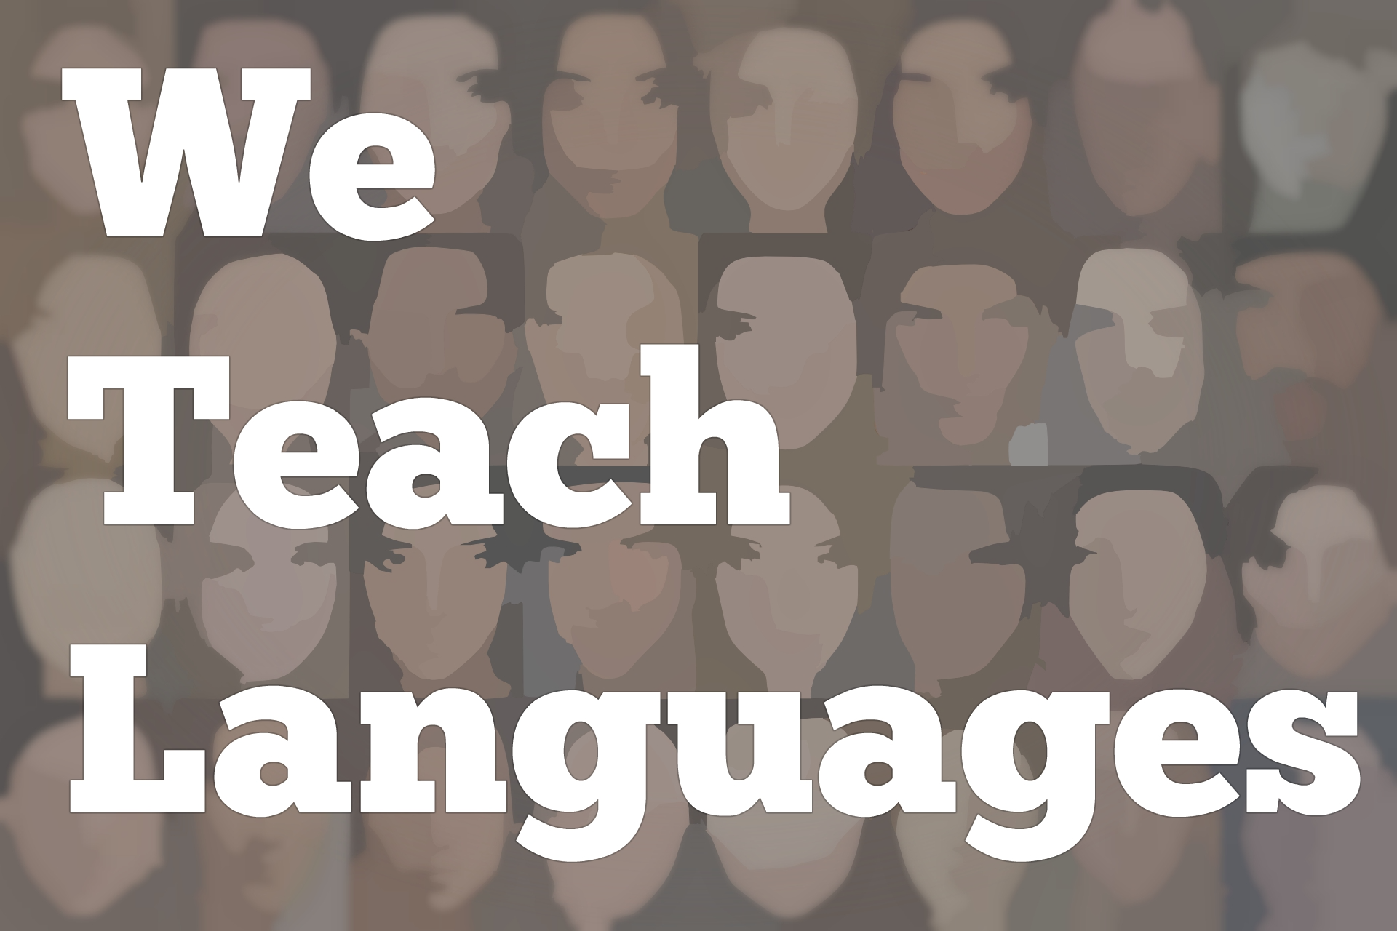
We Teach Languages Episode 119: Integrated Instruction in Pre-K through 8 and Inviting Colleagues into Change with Victoria Gilbert
[0:00] [background music]
Stacey Johnson: [0:00] This is "We Teach Languages", a podcast about language teaching from the diverse perspective of teachers. I'm Stacey Johnson. Today, on episode 119, Victoria Gilbert tells us about the journey she's been on as a teacher and how, as the department chair, she's helping her entire department move towards a more proficiency-oriented way of teaching.
[0:30] [music]
Stacey: [0:30] Thank you so much for making yourself available for this interview today. I really appreciate it.
Victoria Gilbert: [0:40] Of course. I'm happy to do it.
Stacey: [0:41] Would you mind if we start out with you introducing yourself and telling listeners a little bit about what you do and what your context is.
Victoria: [0:51] Sure. My name is Victoria Gilbert, and I teach in an all-boys Catholic school, where I've been [inaudible] . [laughs]
Stacey: [1:00] My goodness.
Victoria: [1:01] We're pre-K through eight school. There's a lot of energy in the building. Let's put it that way, and I've been there for about 30 years.
Stacey: [1:14] [laughs]
Victoria: [1:10] I began teaching both French and Science and then continued, switched at one point to Spanish because I grew up speaking Spanish, but my heritage, native/whatever you want to call it, [laughs] identity [indecipherable] speaker, but I have learned French in the traditional way.
[1:31] Then, I switched because my headmaster was kind enough to offer me the chance to do that. I said I'd love to do it, but I need to learn some grammar, so off I went to learn some grammar in the summer, which I'm yet to use in any class [laughs] I've ever taught.
Stacey: [1:46] [laughs]
Victoria: [1:46] It made me feel a little more secure at the time. We 10 years ago started a [indecipherable] program for pre-K through fifth grade. Up until that time, our only language options were French and Spanish six, seventh, and eighth grade.
[2:05] Sort of a new leadership situation that came in that was really as excited as I was about doing language for the little in a very serious way, not sort of as an experience, not as a one off, but as a seriously committed, consistent.
[2:25] We have a minimum of 90 minutes in every grade level and most have more like 100-120 every week. It is a serious commitment. It required taking some time away from some other content areas. In that vein, when we rolled out that program, I started learning so much about language instruction in preparation for that. Since we've begun that, my practice changed radically.
[2:54] I studied art history, and I got graduate degrees along the way as an in-service student. I got my masters in education, my doctorate in education, curriculum and teaching. I was always very interested in teaching anything as much as I could, in the sense of creating a learning environment, designing the architecture by which students could learn something.
[3:20] That brought me back to where students were, what their interests were, and how was I going to take some content, whatever that content might be, that was exciting and inspiring, and connect it to their passions and their interests. That in a larger framework is the educator I see as myself. I hope that's who I am in practice too.
[3:41] The most radical shift I made as a language educator, was really to let go of the textbook, and to have the freedom and support of my school to design these units, that would incorporate the best of culture in the target language, as well as the content, and using language as a vehicle to get there, and to understand and learn about those things, rather than simply the endpoint in and of itself.
Stacey: [4:10] That's fantastic. I have a couple of follow up things that I want to know about. I have three boy children of my own at home. Based on how much broken furniture we have here, [laughs] I'm just imagining that an all-boys school, the furniture budget has got to be crazy, right?
Victoria: [4:30] They do get very wobbly very quickly. [laughs] I don't know how it happens [indecipherable] .
Stacey: [4:39] I can't imagine. It sounds like my home experience, multiplied exponentially. I just can't imagine. [laughs]
Victoria: [4:46] I traveled with 25 seventh graders to [inaudible] for two weeks last year.
Stacey: [4:53] Abroad?
Victoria: [4:55] Yeah. The year before it was 31. [laughs] A couple of things fell off of the wall. Yes. In fact, it was a fantastic trip.
Stacey: [5:03] That's amazing. Good for you. One of my questions is, I know that you've also taught adults as a college-level instructor, and that's my wheelhouse. I typically teach adults. I'm wondering, what are some of the differences, if you can think off the top of your head, some of the differences you might have noticed between teaching language to your population, pre-K through eight, and what I do?
Victoria: [5:30] I can tell you that the number one difference between teaching say a 5-year-old, a 10-year-old, and a 15-year-old for me is the amount of physical energy it requires. Teaching little kids requires a tremendous amount of physical energy.
[5:45] I would say the older they get, it's more of an emotional, being able to maintain your sense of humor and perspective with adolescents, as we sort of all know the ones who love them dearly is who might.
[5:57] I think when I work with adults, they have so much life experience, they bring so much more to the table. It's really more of a partnership. As kids get older, I find that they're bringing more to whatever the lesson is and that my role becomes even more of a guide than I might otherwise be as they're exploring something.
[6:16] We're really kind of going back and forth with ideas of what a project might be. Part of me remains a science teacher in the sense that I want to investigate everything and use the five Es as a way of exploring whether it's a cultural artifact or an expression or a way of doing something or a story line.
[6:37] All those kinds of things to me are part of learning language, just as much as they're part of doing an investigation of the natural world. I appreciate it when adults can bring their own perspective, and it makes it that much richer for me as an educator, and obviously the longer you've been around, the more you have to bring to the table usually.
[6:59] That's exciting, but I would say that's one main difference. I do believe that all ages love to play [laughs] and you would be surprised I think to see adults as excited to play games and do the kinds of things that I might do with younger learners with just as much joy.
[7:16] I think that sometimes we forget that. I think it's important to remember and bring that into our classroom or our work areas as much as possible. Somehow people forget, but it's not always a part of the adult learning scenario.
Stacey: [7:29] I have often found when it comes to play with my adult students that I have to be really clear with them about the goals of the activity and how play will help us reach those goals because they're so crunched for time all the time.
[7:46] Both undergraduate and graduate students are so overwhelmed that if I ask them to play and it's not immediately clear what benefit the play has...
Victoria: [7:54] [laughs]
Stacey: [7:55] to them that it's a [inaudible] use of their time, that they won't buy in.
Victoria: [8:00] Right. It's sad, but true.
[8:01] [crosstalk]
Stacey: [8:01] I imagine that kindergarteners, you have much less explaining to do.
Victoria: [8:05] Lot less. [laughs]
Stacey: [8:06] [laughs]
Victoria: [8:06] They just jump right in, right on it.
Stacey: [8:09] Yeah. That's good. You mentioned earlier that one of the biggest changes that you've made is letting go of your textbook, I would love to explore that a little further. What made you decide to go textbook free? How did that process happen? What changes did you have to make in your teaching to sort of make sense of that?
Victoria: [8:32] I will definitely talk about that. Let me just say that, in some ways the textbook is still there. It's just not what it used to be to me. What it's still there for I think is to support families and what they feel is necessary in language learning rather than what I feel is absolutely important.
[8:50] In the sense of I let go, when we planned our curriculum units and program for the lower school for pre-K through fifth grade, we rolled out units that were connected to what was going on in the classroom.
[9:05] That was in part in response to the idea that we knew we were taking time away from things like science and language arts.
[9:13] We wanted the students to be able to continue to pursue some of those ideas and concepts even in the second language so that it wouldn't be completely removed from the program, but also because we felt that the emphasis should be on using the language rather than studying about the language.
[9:30] I would say that was perhaps the most pivotal aha moment in my career because I've always had an integrated perspective or lens in learning. I love learning about different parts of an issue or concept and not just one disciplinary viewpoint on it. That's been an easy passion of mine to bring to the classroom.
[9:52] For example, when we could talk about the Incas and the Inca diet and the healthy choices that were made for the nutrition of those peoples and how we can still count on things like quinoa today to bring in those wonderful nutrients to our own personal lives and...
[10:09] How to take something from long ago, make it relevant to today, and still work with it in the target language was I would just say a delicious opportunity quite frankly.
[10:21] Could not resist being able to do more of that kind of work. In some ways, as a new teacher, I really clung to a textbook because I hadn't had the formal training in education school. I thought that that was what I was supposed to do.
[10:39] As I grew in my career and grew more confident of my skills as an educator and started going to master's programs and everything else, I realized I didn't need a book to tell me what to do. I needed to think it through. I needed to consider a backwards design. What was the end goal? How was I going to get these students there?
[10:57] Through what processes, through what experiences, through what occasions? How might they be part of that story as well with their interests and their perspective being brought in? I thought that was really more and more important. I saw how kids reacted when they had some autonomy, some say in the classroom.
[11:18] Leaving a textbook behind meant, in a sense, it was no longer a crutch for me. It was certainly a tool if I wanted to look at a scope of sequence and see how somebody else taught the progression through a series of topics might make sense, but it wasn't what I had to use anymore. When we made up our units and combined art...
[11:40] For example, in the second grade, we did a Picasso unit where the boys at my school not only learned about art in art class, but they would also learn about line, and color, and fracturing in Spanish class. Being able to identify the different periods of his work and what made him so ingenious in very simplistic ways.
[12:02] I mean, we're talking about second/third-grade level, so we're talking about something they could do. When we did the Christmas pageant in first grade in English, we thought it was a great counterpoint to bring it back in third grade and have them do it in Spanish, and be able to tell the story, because we are a Catholic school, of Christmas.
[12:19] The main characters, and what they meant, and who they are. It's amazing when you get students able to talk about what a real gift is in that sense, in the sense of Christmas. Was it the gold? They can say it in very simple language, no, the gift is Jesus, because that is the main story behind the Christmas story if you're a Christian.
[12:40] That kind of language and deeper perceptual thinking was not necessarily part of any textbook. It was part of the experiences that we were creating for the boys and with the boys. I've also always tried to keep an authentic audience in mind for their work.
[12:57] I've found that students respond much better when they know somebody beyond their teacher is going to be looking, and seeing, and figuring out what they've been thinking about.
[13:05] For example, last year we had third graders who were writing about animals read their stories to dogs and cats in a shelter because it helps to de-stress the animals. The dogs and cats, they don't care what you read to them. [laughs]
Stacey: [13:22] That's the cutest thing I've ever heard. What an adorable picture I have in my head of children having a non-judgmental audience for their work.
[13:31] [laughter]
Victoria: [13:32] We even have a little video of a little dog that was towards the front of the cage peering out as the boy started reading, and then slowly sitting down, and then finally putting his head down almost to go to sleep at the end of it. [laughs]
Stacey: [13:45] Oh my gosh.
Victoria: [13:47] It was very sweet.
Stacey: [13:48] That is lovely.
Victoria: [13:48] Things like that. Pen pals will work. Anything will work, as long as it's not just you the teacher. Could be another class in the same school. That works too.
Stacey: [14:00] That's such a good idea.
Victoria: [14:03] I guess the most recent changes for me in terms of my practice has been when I've been learning about integrated performance assessments, and how those unify the three modes with the tasks.
[14:16] That also to me takes you away from the textbook in the sense that, unless you have cutting-edge textbooks which have authentic resources that are available to you and they're updated all the time, what better encounter for a student to have [inaudible] some authentic text, be it video, be it print, of any sort, as a way of engaging them with the target language.
[14:40] The target language culture, the target language way of thinking, and saying, and expressing. Using what you know to figure out what you don't, so key not only to language learning, but also to any kind of learning, frankly any kind of problem-solving. You have to know how to bring to bear what you have on what you're trying to solve.
[15:02] In fact, that's one of the reasons we see research studies like the, I think it's Diana Taylor, where they found that children who had foreign language instruction every week, maybe three times I think it was a week, compared to additional instruction in math actually did better on the math state test than the kids who did the additional instruction in math.
[15:23] Nobody was able to say exactly why, it was just a correlational finding, but my guess is that if you are working in a foreign language class, you're working to understand, you're working to learn, you're working to figure things out.
[15:36] If the scaffolding is there, the teachers provide you with successful experiences with that and boosting your idea, you can sit down and figure something you don't know out. That might be a math problem, it might be a part of the language piece of literature.
[15:52] The more that we can take students beyond what might be stuck on a page in a text that was determined years ahead of when they're actually studying it, the better. Because they're going to encounter that kind of thing again very soon, especially if they continue studying in the target language, which is what we want them to do.
Stacey: [16:09] That's fantastic. Listening to you describe some of the changes that you've made over your career and some of the big picture things that you have in place now, like not centering the textbook and finding authentic audiences for your students, and using IPAs to create authentic assessment, helping students focus on what they do know.
[16:36] I relate to that a lot. This is very similar to the trajectory I've been on, and so many teachers that I've talked to say it's been a difficult journey to figure out how to do better. I know that you're also a department chair. I'm wondering, how does that work when you're at a different place in your journey that maybe that your colleagues in your department are?
[17:00] How do you help individuals and how do you help the team as a whole move forward from wherever they're at?
Victoria: [17:07] Well, the first steps are to share. Share resources that you come across and plant the seed for something in a way that's not threatening, in a way that's invitational, is really how I start.
[17:25] Then you have to be listening, and I mean listening for a time when that teacher is in need of some support, in need of some ideas, in need of some resources to help solve a problem that they're struggling with in the classroom.
[17:41] Whether it's classroom management, or a lower level topic lesson rather than a central question with a theme that grabs you, or just frankly they're bored with what they're doing.
[17:58] When you hear or see those kinds of things starting to happen, it's a moment when inserting a new process might work, and people are open, because they're struggling with something, to hearing another option. It's important not to overwhelm people. It's important not to give them too much to chew on at once.
[18:22] The better job you do of listening, the better you can hear where they are and what a next step might look like. In a sense, it's very much what we do with our students. You can't push a student too far too quickly, or they will get frustrated, and so will teachers.
[18:37] I think it's part of, particularly as adult learners, people are very much on their own pathways, and if you can be there at the right moment with the right support lending a hand, or whether it's giving them an example of a lesson plan, or showing them a tool that helps them to organize and segment their lesson, or just brainstorming with them.
[19:01] Sometimes it's important people come up with their own ideas, and they want to be in charge of that. If it's coming from you, it's not OK. It needs to come from them. Then you have to have the conversation that helps to elicit and draw out their ideas in a way it's going to work for them.
[19:17] People say, "Oh, well, you have such great ideas." Then they have the hard work of putting ideas into practice. It's not just enough to have an idea. You have to be able to help somebody figure out how they're going to get there, how they're going to use that idea. What is that going to look like in their environment, in their classroom?
[19:36] That really requires you being open to reformulating, maybe, what you originally had suggested, or changing it up, or going in a different direction from where you thought the conversation started off.
[19:51] Actually that's kind of exciting to me, because the element of not knowing exactly where the ending might be -- that you're there along for the hike -- is fun.
Stacey: [20:01] Yeah. I love that also, just thinking of someone...I am not the chair of my department. I am a member of my department, and so just thinking from a faculty perspective, a teacher perspective, it is so much more empowering to believe that my chair wants to partner with me and is inviting me into a conversation, and is really listening to what I need and is helping me find my own solutions.
[20:29] That is so much more empowering for me than believing you have some agenda in mind for me and you're just secretly waiting for your opportunity to tell me [laughs] what I should be working on. I really appreciate that.
Victoria: [20:41] It takes some patience. It takes, I think, real generosity. You cannot be selfish and work with other colleagues well. You just can't. It's not about you.
Stacey: [20:52] Maybe that's why I'm not the chair of my department then.
[20:48] [laughter]
Victoria: [20:48] Well, that may be. I don't know.
[20:51] [laughter]
Victoria: [20:46] I don't know your exact situation, but I doubt it. You'd probably be a good partner to a lot of people. You are doing an interesting podcast. You really are.
Stacey: [21:20] [laughs] I like to think I am. I think I also really gravitated to the word "invitational." It's a word that I haven't really used in the past, but it just describes so many of the ways that I personally have learned to be a better teacher, when people really invited me in.
[21:39] One thing that I'm doing this semester that is going super-well -- one of my roles on campus where I work is to consult with language faculty on campus about how things are going, but not from a supervisory perspective -- really from a partnership perspective.
[21:56] One of the things I'm doing this semester that's been amazing is instead of asking people how I could help them, or how I could help them solve their problems, or if there's any research I can look at for them, I'm just simply inviting people to come watch me teach.
[22:13] When I just invite them to come watch me teach, maybe give me some feedback, and talk about how we are similar, how we're different, and just open up my classroom in an invitational way, I have found it incredibly powerful and in fact have had some of the most fruitful discussions about language teaching, so I like that part. [laughs]
Victoria: [22:34] That's wonderful. I think it makes you the vulnerable one first, and if you're willing to be vulnerable first, that means a lot to people.
Stacey: [22:40] That's an excellent point. Well, this has been fantastic.
[22:44] [background music]
Stacey: [22:44] Thank you so much for sharing your wisdom.
Victoria: [22:47] You're welcome. Thank you. Take care.
Stacey: [22:50] Buh-bye.
[22:51] If you have questions or comments related to today's episode, we would love to hear from you. You can reach out to us multiple ways. All of them are available at our website, weteachlang.com/contact. You can also find us on Facebook and Twitter at @weteachlang.
[23:14] We would like to say a very special thank you to the PEARLL Foreign Language Resource Center for partnering with us to provide transcripts and other professional development resources related to the episodes. You can learn more about PEARLL by going to pearl, P-E-A-R-L-L.nflc.umd.edu.
[23:40] Thanks so much for listening. Buh-bye.

Podcast transcripts are provided through a partnership with PEARLL (Professionals in Education Advancing Research and Language Learning), a Title VI Language Resource Center at the National Foreign Language Center at the University of Maryland. Find additional transcripts: www.pearll.nflc.umd.edu/podcast
Transcription by CastingWords

