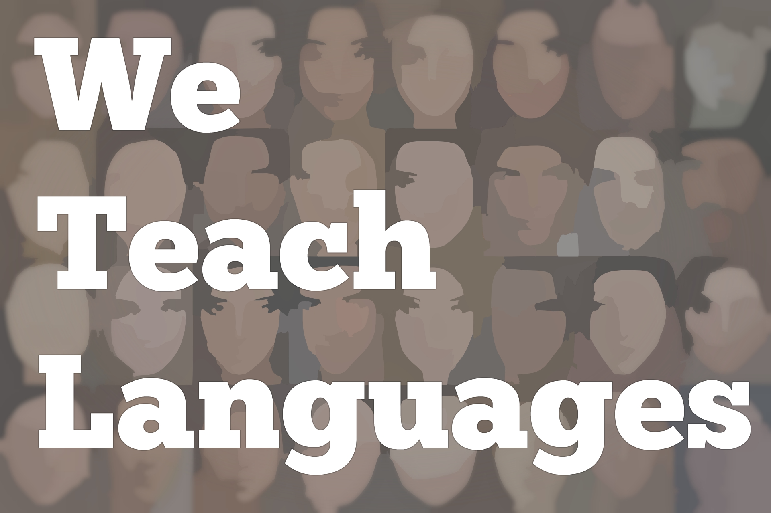
We Teach Languages Episode 123: Steady, Collaborative Change at an Independent School with Sarah Aguilar-Francis

Carolyn Siegel: [00:00] This is "We Teach Languages," a podcast about language teaching from the diverse perspectives of teachers.
[00:07] [music]
Carolyn: [00:11] My name is Carolyn Siegel. I'm the Resources Developer here at We Teach Languages. Today, on "Episode 123," I'll be interviewing Sarah Aguilar-Francis, the Foreign Language Department Chair at William Penn Charter School in Philadelphia, Pennsylvania.
[00:26] We'll be discussing her department's path to proficiency and how their multi-year transition has been going.
[00:31] [music]
Carolyn: [00:36] Hi, Sarah, welcome.
Sarah Aguilar-Francis: [00:37] Hi, thank you.
Carolyn: [00:38] Please, can you tell us a little bit about your background and teaching context?
Sarah: [00:44] Sure, I grew up bilingual, speaking Spanish and English, and traveling throughout Barcelona to Mexico.
[00:53] Both my mom, my stepdad, my aunt, most people in my family actually have an education degree. I was in and out of classrooms helping, and it seemed like a natural progression to go from there into the classroom myself, and then to also share my language and my culture as well.
Carolyn: [01:12] Absolutely, how did you make your way to Penn Charter?
Sarah: [01:17] After graduating from college, I wanted to leave Pennsylvania. I wanted to try to see a different part of the country. I moved to Colorado. I was there for a couple of years before I realized I was too far from family.
[01:29] I moved back to get my master's, and then started looking closer to Pittsburgh, closer to the area, for my next position, and ended up here in Philadelphia at Penn Charter.
Carolyn: [01:40] Can you tell us a little bit about Penn Charter?
Sarah: [01:43] Sure, Penn Charter is a Quaker school. It has a longer than 325-year history. It started in 1689 by William Penn. It has a rich Quaker tradition, private school for boys and girls.
Carolyn: [02:03] Could you tell us a little about how the fact that it's a Quaker school how that manifests itself in the foreign language classroom?
Sarah: [02:10] Absolutely, one of the things that we talk a lot about, and talk a lot about with our students and with the faculty, is that we're educating students to live lives that make a difference. That manifests itself in our curriculum across all subjects.
[02:26] Particularly in the foreign language classroom, it manifests itself in the way we've designed the curriculum towards proficiency-based and communicative-based, task-based learning and also providing students with real-life context with authentic materials.
[02:43] They can truly engage with the different communities both that are here in the United States but also abroad, have that tolerance for ambiguity and that willingness to engage with communities of people who might have different experience than their own, whether it be in English or in the language of our classroom.
Carolyn: [03:06] Awesome. Can you tell us a little bit about what your department's pedagogical approach has been and what the journey has been to today?
Sarah: [03:17] Absolutely, we are mostly based on integrated performance assessments, on the three modes of communication, the ACTFL five Cs, and the standards.
[03:29] It started roughly seven or eight years ago with our previous department chair who, during his supervision here, really researched and looked into changing our curriculum and moving towards integrated performance assessments as our evaluation tool, and then having this idea of backwards planning.
[03:50] If we're starting with those as how we're going to evaluate our students, how do we get them throughout the units to that point?
[03:57] It started with one unit in Level 3 during the environment unit. Now, here we here six, seven, eight years later. All of our Level 2, Level 3, Level 4 units are based around authentic materials or based around the three modes of communication with IPA-type activities or evaluations at the end.
Carolyn: [04:27] One of the components of many departments' conversations around the path to proficiency is not everybody feels a strong conviction about this particular pedagogical approach. Can you talk a little bit about what that's looked like in your department?
Sarah: [04:44] Yes, it started back then, close to a decade ago, seven, eight years, with one or two teachers that really embraced it and really started with one unit. David Brightbill, who was our previous department chair who started this change, started working with a few different colleagues who were around at that time who also had interest in moving the curriculum forward in this way.
[05:12] Then, the following year, I was hired. It became this progression of, as we had turnover, finding ways to hire people and to build the department around this collaborative environment with people who had similar ideas and thoughts on proficiency-based education and task-based learning, had knowledge of the three modes of communication, and were interested in moving this work forward as well.
Carolyn: [05:44] One thing that I've found listening to different guests on our podcast, going to conferences, and everything is that independent schools have idiosyncrasies that are particular and do not necessarily mean that they're experiencing this path in the same way as in public schools. What do you think about that?
Sarah: [06:09] One of the things that I love about independent school education is that there is this autonomy. I feel that I am able to build my classroom and my classroom environment around what my strengths are, what the strengths are of my students, what their interests are, what my interests are.
[06:30] One of the things that has been great about my work, or our work really, our department's work here at Penn Charter, is that we all also recognize that, in addition to that, there's also the department and there is our departmental goal for our students in moving them through. We also have to be held accountable to each other and to the proficiency of our students.
[06:54] We say that we want to, by the time students leave Level 3, which is our graduation requirement, that students should be solidly in the intermediate-mid range of proficiency.
[07:06] They don't all get there, but I would like to say that most of them definitely at least started in the intermediate range. In order to meet that goal, we all have to work with each other, and we have to collaborate with each other.
[07:19] What's really helped is that there isn't any one person who teaches just one level. There's not a Level 3 teacher or a Level 2 teacher. All of us are teaching multiple levels, which has been necessary, one, to see the students growth over levels, but also so that we are continuously having to talk to each other and collaborate with each other to build our curriculum.
Carolyn: [07:43] In terms of how IPs and the ACTFL standards play in, you say that you faithfully try to match up those standards, or do you feel like you can interpret it in a more flexible way?
Sarah: [07:56] We use them as a base, but that we interpret them depending on what it is that our students need. We are constantly looking for new materials. We're constantly changing our units. We're constantly rearranging them to fit the order that we feel is best, and keeping those ACTFL standards always at the back of our minds.
Carolyn: [08:26] I definitely can understand that. Thinking about the individuals and departments that are listening to this conversation, what advice do you have for those that at are independent schools seeking to make a similar shift and approach?
Sarah: [08:43] The best advice I can give is really to start small. We didn't change overnight. We're still in the process of changing. Starting with one unit in one level was a big task. It was maybe a year or two before we started adding other units and other materials.
[09:07] We designed this one unit, and then had to do it again the second year to make it's how we wanted it and this is what we wanted to continue doing, and then we started adding in different units, different levels, and slowly getting other people on board until we felt good, the department that we have now.
[09:25] We're still constantly changing things, testing things out, and realizing, "Oh, that didn't work. We need to do this." Our Level 1 class is still very textbook based and textbook driven, for many reasons, mostly speed.
[09:45] We have to get through a lot more material in a little bit of time. This summer, we're going to start working on trying to change Level 1 to match the rest of our units.
[09:57] It has not been fast. It's been a very slow process over the course of many, many years and starting small, starting with one unit and then adding more.
[10:08] I also think getting administration and parents on board was helpful.
[10:16] There were several years during our back-to-school nights that we had to lead our conversation about our class, talking about what integrated performance assessments are, what the three modes of communication were, why we were using them in class, why we weren't just giving verb conjugation tests and vocabulary tests, and why we had moved to this.
[10:38] It was a radical shift from what we were doing before, and trying to get parents on board as well as the administration was key also to making this change.
Carolyn: [10:49] I have a question about that. In terms of evaluation, one thing that I've heard in different schools and different departments is this idea that, "Well, but students need to have a traditional sit-down assessment because, when they go to college, that's what they're going to be asked to do."
Sarah: [11:05] True.
Carolyn: [11:05] What's your answer to that question?
Sarah: [11:08] That's one of the reasons why we still give finals the way we do. We have that reasoning and that even the students will say that back to us, "We hate finals, but we understand because this is what we have to do in college." That's across the board. That's not just in our language classes.
[11:26] We still do test the students on vocabulary and grammar, but those are more quizzes leading up to the IPA, which is the final evaluation or test for a unit. Leading up to that, we'll have shorter verb conjugation quizzes and vocabulary quizzes.
[11:49] At this point, we've seen that we've had enough success with students coming back to tell us that they were placed in higher levels in college. One student, who comes to mind last year, took her language placement exam at school and was placed into a heritage level class.
Carolyn: [12:12] That's fantastic.
Sarah: [12:12] She's not a heritage speaker. We haven't moved completely away from grammar and vocab. We still find that it's necessary to teach aspects of vocabulary and grammar because we have to prepare them to do the tasks that we're asking them to do. They're not part of the evaluation, the end summative evaluations.
Carolyn: [12:34] I see. Could you go into that a little bit more, how vocabulary and grammar enter in not just in the final evaluations but throughout the trajectory? Because I know that a lot of programs are on that path to proficiency toss grammar and vocab out the window and say, "None of that. No, it's just going to be this natural acquisition of language through input."
[12:54] What do you have to say that? How do you reckon with that?
Sarah: [12:58] We try to do it in terms of backwards design, backwards planning, what it is that we want students to be able to do at the end of the unit, and then how we're going to evaluate them and show that they can do that, but then designing the activities and finding the grammar and the vocab that they need in order to be able to.
[13:17] For example, one of our units in Level 3 is the environment. We wanted them at the end of the unit to be able to talk about existing environmental issues, talk about what they do in their lives to fight these, or tackle these different environmental issues, be able to give recommendations to others to also help other people make changes in their lives to tackle these environmental issues, and to be able to talk about what's going to happen in the future if we don't make these changes.
[13:48] That was our can-dos, our students will be able to by the end of the unit. We designed our Integrated Performance Assessment, or IPA, around that task.
[14:00] Then, from there, we realized, "Well, if we're going to ask them to give recommendations, they're going to need to know the subjective. If we're going to ask them to talk about what's going to happen in the future, they're going to need to know some of the future tense. In terms of vocabulary, they're going to need to know all these different environmental terms."
[14:20] From there, we worked with different authentic resources. We don't spend a ton of time on the grammar and the vocabulary. We really use the grammar and the vocabulary intentionally so that they can read the articles that we're asking them to read or listen to the audio that we're asking them to listen to and to be able to do the things that we're asking them to do.
Carolyn: [14:43] Thinking about that transition, I'm trying to imagine what a class looks like when you have grammar enter into it. Generally, I imagine that your classes is very communicative based, task oriented. How does the grammar float into the classroom scene?
Sarah: [15:01] Trying to introduce it in context, we've tried many different things. I don't know if we've really found the perfect way. Every year, actually, we tackle our vocab lists. We tackle how it is that we're going to introduce vocabulary.
[15:17] We have intentionally tried to introduce vocabulary and grammar in context, having them describe pictures that have to do with the environment. For example, going along with this unit.
[15:31] Also, we've tried other things. We've tried the flipped classroom where they read about it at home, and then they come into class ready to use it.
[15:39] I don't know if we've found the ideal way of introducing the vocab and the grammar. We do try to organize our classes so that they are using the vocab and the grammar consistently in communicative-based tasks and formative activities.
[15:56] One of the things that is important is that, every class, we try to...Not even try, we do get interpretative, interpersonal, and presentational practice into every one of our classes and finding ways to also have them be practicing the grammar and the vocabulary.
[16:16] It has come at times with very explicit grammar instruction to practice the conjugations and sentence structures. Those are more like pop-up grammar type activities, and then the majority of the classes using them in real context.
Carolyn: [16:33] Thinking, on two sides of this journey, if you had to go back and whisper into your teacher ear eight years ago and say, "Guess what your classroom is going to look like in eight years," I guess on that side, what would be the most surprising to you?
[16:47] Then, on the flip side, if you had to go to whisper in your teacher ear in eight years from now, in the future, what do you think would be the conversation in that moment?
Sarah: [16:58] The conversation I would have with my past self is mostly around classroom management. The way my classroom looks now, there might be some people who don't think I have much control of my classroom, but it's very intentional. I have them constantly moving and constantly talking.
[17:17] They're doing many different things, and I'm switching it up constantly. I do that intentionally to maintain control of my classroom because, as a new teacher, classroom control is not my forte.
[17:29] It still isn't my forte, but one way I've managed that and made sure that they're speaking in language and staying on task is by constantly changing it up and having all these different activities playing out in my classroom at different times, all with the same end goal of getting to this task that they're completing.
[17:49] There's a whole bunch of stuff going on. In the future, there's still a lot for me to learn. I'm still learning a lot from my colleagues. I'm still learning a lot from other teachers, from going to professional conferences, and being a member of professional organizations and from having conversations about language learning.
[18:08] I'm not sure what my classroom would look like in eight years. I know that it's not going to look the same as it does right now.
Carolyn: [18:15] I love that answer. It's a wonderful one and a wonderful note to end this conversation on.
[18:20] Sarah, thank you so much for your time today. I look forward to hearing from you and from your colleagues at Penn Charter at future professional conferences. You'll definitely be on my radar.
Sarah: [18:30] Absolutely, thank you so much.
[18:32] [music]
Carolyn: [18:35] We would love to hear your feedback on this episode. You can find us on Twitter or Facebook, @weteachlang, or you can leave a comment on this episode page on our website at weteachlang.com.
[18:50] We would like to say a special thank you to the PEARLL Foreign Language Resource Center for partnering with us to provide transcripts and other professional development resources related to the episodes. You can learn more about PEARLL by going to pearll.nflc.umd.edu.
[19:15] Thanks so much for listening. Bye-bye.

Podcast transcripts are provided through a partnership with PEARLL (Professionals in Education Advancing Research and Language Learning), a Title VI Language Resource Center at the National Foreign Language Center at the University of Maryland. Find additional transcripts: www.pearll.nflc.umd.edu/podcast

Transcription by CastingWords

