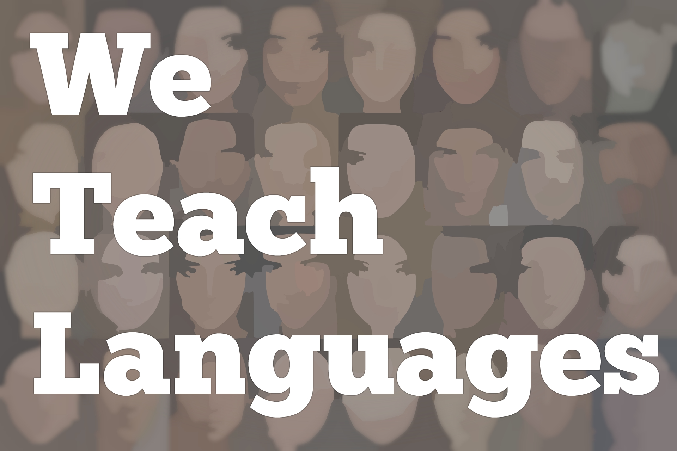
We Teach Languages Episode 127: Diverse Images of Spanish-Speakers and Reaching “Reluctant” Learners with Rhoda Nunez-Donnelly

Stacey Margarita Johnson: [0:00] This is "We Teach Languages," a podcast about language teaching from the diverse perspectives of teachers.
[0:06] [music]
Stacey: [0:06] I'm Stacey Margarita Johnson. Today, on Episode 127, I get to interview Dr. Rhoda Núñez-Donnelly who I recently met at ACTFL in Washington DC. We got to sit down and talk about some of our thoughts from a particularly meaningful session that we were both in. Rhoda also gives us her best advice on how to reach reluctant learners in our classrooms.
[0:41] [music]
Stacey: [0:41] The session that we were in was called...I don't remember the entire title. I'm going to mention it was with April Broussard and Rhashida Hilliard. I hope I'm pronouncing it correctly. Their talk was about de-centering whiteness.
[0:59] We got into a conversation about the vocabulary, the accent, the media images that we portray of the target culture and language and what message that sends to our students. I'm sure I'll ask you follow-up questions when we'll get into a whole conversation.
[1:16] I want to start there. Tell me about the vocabulary, the accent, and the media images that we show our students in class and what our students get from that, what they learn from it.
Dr. Rhoda Núñez-Donnelly: [1:29] Oftentimes, we get comfortable in our language classroom presenting the images that are part of our normative society. We do a Google search on certain images. For example, if we're looking for a Latina woman and we want to put that as part of our image, we don't always, what does that mean? What does that look like?
[1:52] As a woman who is both Black and Latina, I've always been very cognizant of the absence of the definition of what Afro-Latina means in Latin American society or even the American definition of what Latinaness or the Latino image is.
[2:13] When we're thinking about, "What image am I going to present to my students?" we need to be inclusive in what that looks like in the world of Latin America.
[2:24] We have a rich culture of indigenous images of women, African images of women, and also, more European-centric images of women. However, the European-centric images of women, men, and Latinos are the ones that dominate our media consumption.
[2:44] It's really important that when we're looking at vocabulary, we're looking at images, we are inclusive of all of the vernacular that make up who Latinos are, how Latinos communicate, and that we're careful in not excluding this narrative from our instruction.
Stacey: [3:03] I'm going to ask you a question that a graduate student asked me the other day. In the textbook, when it's describing people, it says, "Ella es morena." It's describing the white woman with brown hair. What do you do with that? How do you handle the word negro? How do you handle the word moreno?
[3:22] For people who aren't Spanish speakers, those are different ways to describe someone's physical appearance of being dark-skinned or dark-haired. What do you do with the terminology that has regional variation, has deep cultural and historical connotations? Do you have any insight on that?
Dr. Núñez-Donnelly: [3:39] I'm not sure how insightful it is. I can definitely share how I attacked exactly that description of what negra or morena is. For me, it was a shock when I went to Spain to hear women being described as morena and just seeing them as brunettes. For us in the Caribbean Spanish-speaking countries, morena is a Black woman.
[4:07] Then the word negra, depending on where you come from also in Latin America, could have negative connotations where people don't identify themselves as Black even though we are Black. We have different degrees of colonized mentalities. Unfortunately, it's a hot topic.
[4:27] Colorism and how we identify ourselves. I can tell you that in the Dominican Republic where my family's from, we have so many different variations of the word black. Negra is not one that we necessarily identify as. I grew up in a family where that word was absolutely OK.
[4:51] I had friends who also grew up Dominican where if they were Black and they said negra, it was almost like, "Ew. Don't say that, Honey. You're coffee and milk. You're the color of wheat." All of these other things except for black.
[5:04] In the classroom, I surfaced those for my students and defined the word, and had my students choose how they would like to define themselves within that structure. I felt that having the students define but having the context to be able to choose a definition was way more powerful than telling them how people should identify.
Stacey: [5:28] Another thing that I have heard is, "OK, so we're going to surface all of those potential definitions. This is Spanish 101. We don't have time for that. I have to cover all the words to describe someone's skin and hair today." How would you respond to that teacher?
Dr. Núñez-Donnelly: [5:44] I would say that we have to make time to include our student voices, and identities, and images and provide that alternate narrative. If we don't do that, it doesn't matter what we teach them, we're not connecting with our students.
[6:01] There is time to include these definitions, especially if we make the students part of what our vocabulary looks like.
[6:09] If we include them in that conversation before we give them the vocab list, before we enter into a conversation about the images that we see in the media...If we are taking and having a discussion with them to see what interests them in the discussion, then that vocabulary is part of what you are doing in your classroom.
[6:30] It's inclusive. It's thoughtful. It connects to what the students want to learn about and what our society needs to hear right now, which is there is more than one story. You are part of that story. As a teacher, it is my absolute responsibility to include you in the story or I'm not servicing the needs of my students in the classroom.
Stacey: [6:53] That's amazing. I can't help but hear echoes of what you're saying in the closing speech that we just listened to, which was intensely moving. I'm letting people know, I'm going to put a link to that if it's available on the ACTFL website. I'm going to put a link to it in the show notes. All of us caught fire a little bit in that session.
Dr. Núñez-Donnelly: [7:14] Oh my gosh, yes.
Stacey: [7:14] Honestly, it's been that kind of ACTFL. I've gone to a lot of sessions about social justice and representation. It's been good.
Dr. Núñez-Donnelly: [7:21] It has been good.
Stacey: [7:23] I'm very interested in what your dissertation was about.
Dr. Núñez-Donnelly: [7:26] Oh, my goodness. OK. My dissertation was about understanding how teacher belief systems impact the outcomes of students in the classroom. I focus on how the transformation of perspective happens for teachers. Then, once that transformation happens, how it changes the way they behave in our society.
[7:50] It becomes almost as if they are wearing new lenses in the world. The way they interact with everybody changes because of this new understanding of how their life experiences impact their interactions with students in the classroom, other people, their families, the world around us.
[8:09] It was really, really cool to hear from teachers. The coolest thing about it was that every teacher went through their own perspective transformation.
[8:18] I had teacher who had experience of perspective transformation that said, "You know what? I understand now when my colleagues say something that was offensive. I understand to look that that may not have been their intent. That might not have been their intent because their life experiences were different from mine and they may not have the same lens into understanding the impact of that intent."
[8:47] Now, this teacher that I interviewed said that the intent is different than the impact. Now, his job is to help teachers understand that impact via conversation that acknowledges the differences in perspectives.
Stacey: [9:05] Are you teaching? You're a resource teacher. You teach and support, right?
Dr. Núñez-Donnelly: [9:13] No. I'm out of the classroom.
Stacey: [9:16] Completely.
Dr. Núñez-Donnelly: [9:17] This is my first year out of the classroom. It was difficult to decide to leave the classroom. That's where I feel the most connected and the most impassioned is being in the classroom. For me, the decision to leave the classroom was very difficult.
[9:42] Now, being out of the classroom, and getting to work with teachers, and getting to put this social justice frame on the table for the teachers that I work with and also seeing the impact that that can have on a wider scale to the students that we service in the county, that is really powerful. It has been surprising to me how rewarding that can be.
[10:06] I'm enjoying what I'm doing. I still get to see my babies every time I go into a classroom. They're not mine but they are mine. You know what I mean? I still get to interact with them and get to see the great things teachers are doing and impact the lens of teachers.
[10:22] Sometimes it's not our intention but we don't know what we don't know. Surfacing that some of the beliefs and some of the practices that we're not doing and providing teachers with the tools to provide students with different access to the content and the curriculum, and the language, and the culture has been a pretty cool thing.
Stacey: [10:45] Real quick, my question for you is if we have teachers listening who say, "I don't want to be doing the same thing in 20 years that my teachers 20 years ago did to me. I just don't know how to move forward from here." As a resource teacher, what would you say is their way forward?
Dr. Núñez-Donnelly: [11:05] Right now, you're listening to a podcast. That's a great way to start is to educate yourself by listening to people who are already doing the work that you look to be doing. Also, be kind to yourself. You don't know what you don't know.
[11:18] That perspective and learning, and awareness can only happen by exposing yourself to the new perspectives that you're looking to incorporate into your curriculum or into your lens, into your perspective.
[11:32] The first thing I would do is look to see who's already doing this work. I would read up on it. I would listen up on it.
[11:39] I would try and surround yourself with as many examples of teachers that are doing this successfully in the classroom. Then, start thinking about your students, and your population of your students, and what you see the need is.
[11:56] Get to know your community. Get to know who's in your classroom. Get to know who's been successful teaching the students that you teach.
[12:05] Talk to those teachers and find out what is it about them and what they're doing that's connecting to the students. We all have those teachers in our schools that are doing amazing things for the kids. The kids absolutely love them and they feel supported. If you're not there yet, let's talk to our colleagues.
[12:22] Let's find out, what are you doing that is connecting to the student that I'm having a difficult time connecting with? That's the smallest step to take. Then you can open it up and start seeing how other successful teachers of students are doing it.
Stacey: [12:41] I love that. For most of my career, I felt like my classroom was a closed space and other people's classrooms were closed spaces. I didn't get to observe many people. I didn't understand what I was doing because I didn't have any points of comparison for other ways people might do it.
[12:59] In the last five years or so I'm in a position where I'm part consultant at my institution. I get to see mostly language teachers but teachers in other disciplines too every semester. It's amazing. I don't think I've ever understood my own teaching as well as I do now.
[13:17] I've got what you said completely. I hope that we get some insight into each other's practice through the podcast. Also, go visit the person who teaches next to you and invite them into your space. Know that we're all doing the best we can. Love each other through the experience.
Dr. Núñez-Donnelly: [13:34] Yeah. It's part of our growth.
Stacey: [13:37] I know from our previous conversation that in your classroom you had a lot of success with students who maybe weren't excited about learning a language who were labeled reluctant students or reluctant learners. I would love to get some insight into how to connect with those students, how to reach them.
Dr. Núñez-Donnelly: [13:53] The label reluctant learners is a mask. We only have reluctant learners because we haven't tapped into why they're not comfortable in our classrooms. They're only reluctant because there's a root cause there.
[14:07] The root cause can be deep. It can be trauma. It can be you don't know what's going on at home. It can be bullying in school. You don't know what the root cause of the student disconnect is.
[14:24] However, when a student is disconnected in your classroom and they're not engaged in your classroom, if you don't take the steps to actually understand why and talk to the student, and dig in, and saying, "How is your day?" Greeting students at the door, and really finding out what makes your students -- all of them -- tick and what they're going through.
[14:48] I've done that by asking other teachers, looking up their files, asking the guidance counselors. Really getting an insight as to, this student is disconnected in my classroom. It is my responsibility to find out as much information as I can about the student, and then to tap into how I can support that student.
[15:08] The support looks different for every different student who's not engaged in my classroom. It might be you give them handouts and they leave them all over the table every time you give it to them, and you're like, "OK. What do I do there?"
[15:21] Well, I have to develop a lending library where I have these materials available to the student so the next time they come in, they actually are still able to function in the class without those papers that I gave them because that's not their strength.
[15:34] If I penalize the student for just being absentminded or leaving his papers behind, and then tell him he can't, or she can't, do this work because they left their papers behind, then I'm doing them a disservice and I'm not looking at what they really need. If my purpose in the classroom is to actually teach the student, then why can't I give them the resources again in the classroom?
[15:58] Now, I don't want to have to give it to them every day, so I have a lending library. I put it in protective sheets, and I said, "Here is what you need to be successful today." Some students are reluctant because they feel that they don't have the capacity yet to do what you're asking them to do.
[16:12] Why not provide the students with the scaffold and the support for them to be able to produce the way that other students who are already there can do without supports. Supporting students where they need to be supported and not penalize them for needing support. Seeing students for the strengths that they have and not only telling them about their weaknesses.
[16:35] Because if we continue to look at students with their deficits when they come into the classroom, they will feel deficient. We must address the needs of the students without making them feel that they have these deficiencies that make them incapable of participating in a classroom and being successful there.
[16:55] If we can support and scaffold all of the materials in our class to really extend for some students who are just disengaged because they're bored or support.
[17:07] For example, if I'm doing an activity where I'm asking a student a question in Spanish, and I want them to produce in Spanish and I know that the student doesn't have the proficiency level, why can't I give this student a word bank of expressions already there that that student can choose from so that that student can say, "I know how to answer this question. Here it is. I just can't produce it myself"?
[17:30] That student, instead of putting their head down and pushing the paper to the side, would get up, take their hood off, and look at the piece of paper because now they're supported. It's just a matter of what do you want in your classroom? Do you want all your kids to be successful?
[17:46] Then if we want them to be successful, we have to take punitive punishments for them not being there yet out of the equation.
Stacey: [17:54] I love that. I hope that we can figure out how to apply that message to the students we teach, to our children at home, to our colleagues who disappoint us, to the driver who cuts us off.
[18:05] [laughter]
Stacey: [18:06] What if we saw what people needed and tried to help them get it, instead of punishing them every time they didn't meet our expectations? What kind of a world would this be? Can you imagine how beautiful that would be?
Dr. Núñez-Donnelly: [18:18] Yes. It would be great.
Stacey: [18:20] What an amazing message. Thank you so much for taking time to talk to me today.
Dr. Núñez-Donnelly: [18:22] Thank you so much for having me.
[18:25] [background music]
Stacey: [18:25] If you have questions or comments related to today's episode, we would love to hear from you. You can reach out to us multiple ways. All of them are available at our website, weteachlang.com/contact. You can also find us on Facebook and Twitter @weteachlang.
[18:47] We would like to say a very special thank you to the PEARLL Foreign Language Resource Center for partnering with us to provide transcripts and other professional development resources related to the episodes. You can learn more about PEARLL by going to pearll.nflc.umd.edu. Thanks so much for listening. Bye-bye.

Podcast transcripts are provided through a partnership with PEARLL (Professionals in Education Advancing Research and Language Learning), a Title VI Language Resource Center at the National Foreign Language Center at the University of Maryland. Find additional transcripts: www.pearll.nflc.umd.edu/podcast

Transcription by CastingWords

