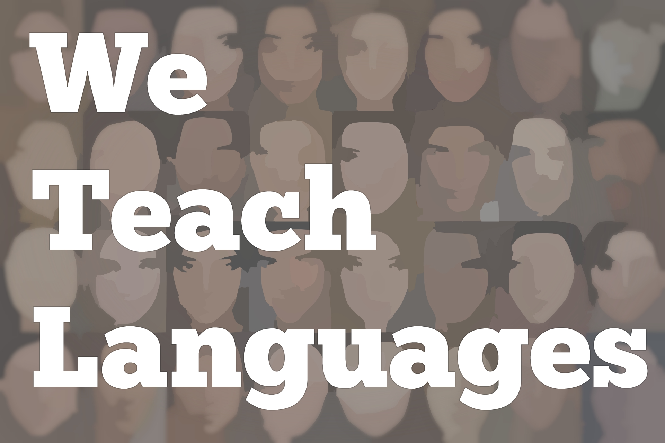
We Teach Languages Episode 129: Language Policy and Innovation in Scotland with Lynne Jones and Louise Whyte

Stacey Margarita Johnson: [0:00] This is "We Teach Languages," a podcast about language teaching from the diverse perspectives of teachers.
[0:09] [background music]
Stacey: [0:13] I'm Stacey Margarita Johnson. Today, on Episode 129, I speak with Lynn Jones and Louise Whyte who both work to support language teaching in Scotland. Lynne is a professional development officer at SCILT, Scotland's National Centre for Languages, where she supports pre- and in-service teachers across Scotland to develop their language's pedagogy.
[0:40] Louise also used to work at SCILT, but now has returned to teaching as principal teacher and the chair of the Scottish Association of Language Teaching. Let's jump in and hear about some of the innovative programming Lynne and Louise are working on to motivate students to continue their language studies beyond what is required.
[1:03] [music]
Louise Whyte: [1:05] My name is Louise Whyte. I've been teaching for 14 years. I have led a department in Glasgow in a Glasgow school where we teach both French and Spanish.
Lynne Jones: [1:17] I'm Lynne Jones. I work at SCILT, Scotland's National Centre for Languages. I'm not secondary. My background is primary.
[1:25] During my career as a primary teacher, before joining SCILT, I was teaching across the whole curriculum, but the languages element then would be usually French, sometimes Spanish, on occasion, German. For one very memorable time, a short time, it was a bit of Mandarin as well.
[1:44] In SCILT, we're doing a lot of work with in-service and pre-service teachers, teacher education.
Stacey: [1:51] Mostly with in-service teachers, right?
Lynne: [1:55] Yep, mostly.
Louise: [1:55] Yes.
Stacey: [1:55] Something I'm really interested in is helping teachers who already feel like they have a certain level of ability to improve and learn new things. Is that something you guys face, how to help teachers that maybe already know how to do things to learn new skills?
Louise: [2:12] Absolutely. You have provisional workshops [inaudible] . There are different aspects to those workshops, but we have both primary and secondary. I do a lot in secondary, specifically looking at learners from 11 to 14. The workshops are designed for all teachers.
[2:31] Whether you're a classroom teacher or whether you are a principal teacher, you're bringing in new ideas and new opportunities for teachers through those workshops.
[2:40] We have a workshop on the secondary menu. The workshop is looking at inspiring contexts and motivating learners.
Stacey: [2:47] Inspiring contexts?
Louise: [2:48] Inspiring contexts because one of the issues in Scotland is we do have an entitlement to language learning all the way through to age 14. Lynne's already explained that that starts at age five in primary school and sometimes earlier, all the way to age 14. It's an entitlement there.
[3:05] Once learners move into the senior phase of their education, we're talking about 15 to 18, then just like the American context, we have to look at motivating learners to continue with their language into the senior phase.
[3:18] We try to develop workshops that will enhance learning and teaching and encourage learners to make choices and to continue with languages beyond the broad, general education, which is first year to third year.
[3:33] I'm running a project with five schools in Scotland in what we call challenge authorities. Challenge authorities are where they have a higher number of learners coming from deprived areas in Scotland. The project is looking at [inaudible] learners' pathways and further education where languages might be useful.
[3:54] Quite often, learners think they're not going to study...not all learners will go on to study languages at university, but there are other pathways that learners can choose where they can study languages alongside a degree program. Through the projects that we are doing, which is Espacios Increíbles...
Stacey: [4:09] Ah!
Louise: [4:10] Amazing Spaces, we are working with the faculty of architecture at the University of Strathclyde, who have links with Bolivia and Chile.
[4:21] What the children are going to be doing is an interdisciplinary project. It involves language departments in the five schools who are involved, and design and technology departments, too. We're all working together on the project.
[4:39] Amazing Spaces is a program in the UK. It's where we look at small spaces in countries where you design a house. It might have a sort of ecological slant to it. When we're looking at Bolivia and Chile, we want our learners to design these houses.
[4:59] What they're actually going to be doing is they're going to be presenting their project, the marketing side, they're going to do that in Spanish. All the learners involved are going to design an amazing space for Espacios Increíbles in Bolivia or Chile, and then they're going to present their projects, in Spanish, to their classmates.
[5:20] From each school, we are going to get a winning team who will then come up to the university. They're going to present, in a lecture theater, the project that they've designed in school. We're going to have an audience from each school, perhaps about 30 children from each school.
Stacey: [5:36] In addition to the programs and professional development that Lynne and Louise help to provide, Scotland also has a really innovative languages policy that supports all of this work. In our next segment, Lynne tells us a bit more about that.
[5:52] [music]
Lynne: [5:52] Scotland is part of the United Kingdom. The government of the United Kingdom based in London, but Scotland has its own government which is in charge of certain aspects. Education is one of those things. Scottish education is very different to education in England and in Wales.
[6:15] In 2012, Scottish government committed to a new languages education policy. They called it the 1+2 policy. It was influenced by European Union policy. The idea is that every child in Scotland is entitled to their L1, their mother tongue, to be respected, celebrated.
Stacey: [6:38] Does that include indigenous languages like Scottish?
Lynne: [6:41] Gaelic, all of that, yep. That is respected, all of that. It could be Polish, it could be Urdu, it could be anything at all. That's respected, though not necessarily taught in the school, but there you go. That's that.
[6:56] The further entitlement is that any child from the age of five, when they first start primary school, they are entitled to start learning their first additional language, their L2.
[7:10] The expectation is that that L2 learning will continue until age 14, 15 in the secondary school. They've had such a great time learning that language that, hopefully, a lot of them will then go on to get qualifications in that L2.
[7:26] Then there's an additional entitlement to learn an L3 beginning no later than age nine. There's not the same expectation around progression towards national qualifications, necessarily. For example, things like British sign language are coming in some places as an L3. Less-spoken community languages are coming in as L3 in some places.
[7:54] The idea is that there's bigger diversification, and there's encouragement for exactly that. The Scottish government committed to 10 years of funding for this policy. We're kind of at the far end. We're getting towards the end of the solid commitment.
[8:12] There may be further commitment, we don't know, but certainly there's been an awful lot of investment in terms of money, in terms of professional learning for teachers, in terms of resources, and all those things. It's a big aspiration for a little country. We're only five and a half million.
[8:32] This kind of welcoming, inclusive idea around languages and people stems from the history of Scotland whereby there was something called the Highland Clearances. The big landowners basically kicked off their tenant farmers and all this kind of thing.
[8:54] There was a massive emigration to places like Canada, New Zealand, and Australia because people had no longer anywhere to live and no land to farm or cultivate. Now, in the 21st century, Scotland is delighted that people want to come and live in Scotland and contribute to our economy.
Stacey: [9:19] I didn't realize.
Lynne: [9:20] Having come from England myself -- I'm not Scottish, I live there now, I work there now -- I didn't realize quite how the mindset in Scotland has been so shaped by this historical event. The mindset around this whole idea is very different to, what we say, south of the border in England. It is remarkable, incredibly ambitious.
[9:45] As I say, there's been a lot of work towards making a difference and making it happen. We'll see how that all pans out and how sustainable it eventually becomes. We're hopeful. Having been able to come ACTFL Conference this week has opened our eyes.
[10:04] I was particularly interested in attending some of the sessions around social justice and inclusion around LGBT and things. I've not seen that in conferences that I've attended in the UK prior. It was like, "I need to know about this stuff."
[10:22] We could be cutting-edge here. We're already doing amazing things with this long-term policy commitment. This will hopefully bring something to that also.
[10:34] My work, I am a primary teacher trained, so working with youngsters from 5 till 12 back in the day. Since 2012, I've taken all that experience and taken it to a place called SCILT, S-C-I-L-T, which is Scotland's National Centre for Languages.
[10:53] We're based in the University of Strathclyde in Glasgow, but we're not funded by them. We're fully funded by Scottish government. When they brought in this fantastic policy that I was telling you about, then they grew their team.
[11:09] They realized there would have to be a lot of engagement with in-service teachers who hadn't had to teach languages before, but also teachers coming through the universities, so that they were ready to do it when they finished their training and their teacher education at the end.
Stacey: [11:26] I am really impressed with your government. The way we speak represents who we are. Including community languages includes people. It feels so progressive.
[11:36] You were saying you want to move forward with social justice, but one of the things we're trying to get our policymakers to understand is that we don't teach an elective. We actually teach identity, community participation, inclusion, and citizenship. They're essential to the policies.
[11:53] Most students in the United States only get two years of language by the time the graduate high school, any language besides English. They often don't even get their own native language opportunity. [laughs]
[12:05] I'm so impressed. It sounds like you guys are further along than we are even though we might be talking about some kinds of inclusion more. Thanks for sharing that.
[12:14] That was a really tremendous interview. It was so inspiring to hear about Scotland's languages policy and really made me think about what a comparable US policy might look like. For a second, I want to take a moment to talk about some correlations that I see to events and policies in my country, the US.
[12:36] Lynne mentioned that, in Scotland, a student's first language is to be respected as part of the 1+2 policy. That language may not be taught, but it should be respected. This has not traditionally been the case in Scotland or in other places in the world, definitely hasn't been the case in the United States.
[12:56] I can't help but believe that legislation that mandates this would be hugely beneficial in the US. Many of you might know, but in case you want to do a little bit more reading, in the US, indigenous students and students who speak languages other than English at home have traditionally been punished for using their own language at school.
[13:19] If you want to learn more, I've put some links in the show notes so you can go check that out. There's so many horrifying examples of language suppression in the US, indigenous students sent to residential schools where they were violently separated from their own languages or students who speak Spanish at home having their mouths washed out with borax or being physically beaten for speaking Spanish.
[13:45] I don't want to give you the impression that this insistence is completely in the past. I've also included a few links in the show notes about the English-only movement and how it's alive and well in schools and in other public spaces.
[14:02] As language teachers, we obviously combat the English-only mindset with our teaching every day, but it would be an incredible step forward if our government were to formally assert every student's right to their own native language the way Scotland's 1+2 language policy does.
[14:23] The idea that students' second and third languages would be taught throughout their schooling would be absolutely revolutionary for language education in the US. Can you imagine what it would be like if our students got at least two different languages in school for most of their primary and secondary years?
[14:45] Obviously, this was a wonderful conversation. I was so grateful to meet Lynne and Louise through ACTFL and to learn about the system they work in and the work they do there.
[14:57] [background music]
Stacey: [14:58] I would also love to hear your feedback on this episode. You can find us on Twitter or Facebook @weteachlang, or you can leave a comment on the episode page on our website, weteachlang.com.
[15:11] I would like to say a special thank you to the PEARLL Foreign Language Resource Center for partnering with us to provide transcripts and other professional development resources related to our episodes. You can learn more about PEARLL by going to pearll.nflc.umd.edu.
[15:27] Thanks so much for listening. Bye-bye.

Podcast transcripts are provided through a partnership with PEARLL (Professionals in Education Advancing Research and Language Learning), a Title VI Language Resource Center at the National Foreign Language Center at the University of Maryland. Find additional transcripts: www.pearll.nflc.umd.edu/podcast

Transcription by CastingWords

