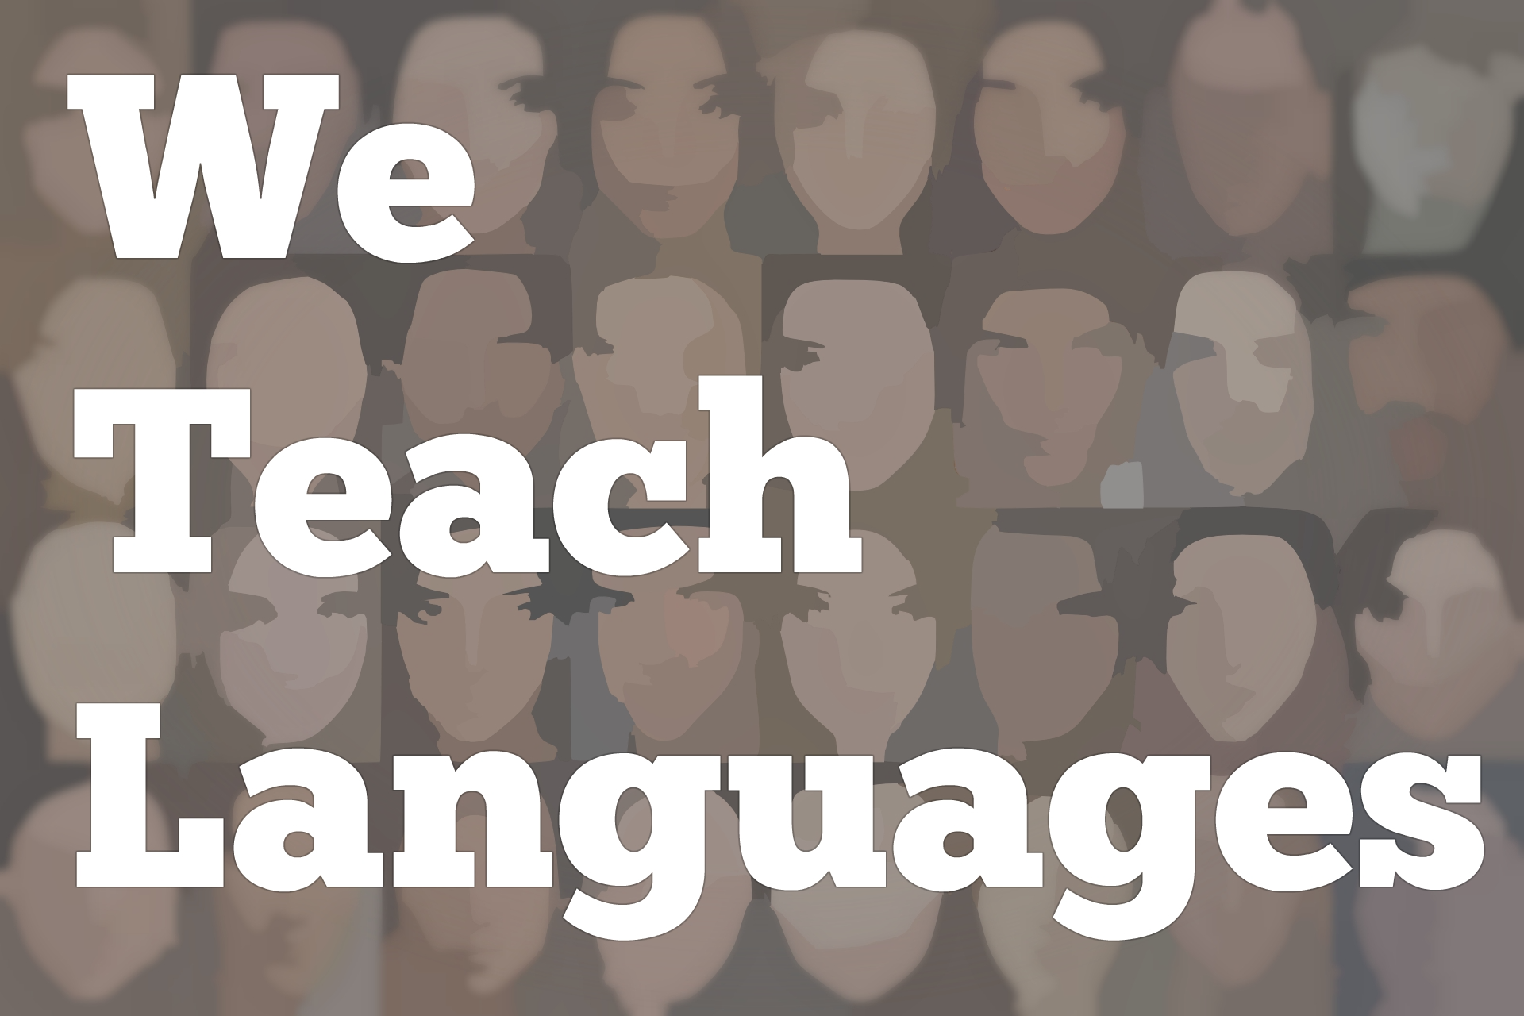

Episode 92: Elena Mangione-Lora
[00:00] [music]
Stacey Margarita Johnson: [00:10] I'm Stacey Margarita Johnson. Today, on Episode 92, Elena Mangione-Lora joins us to talk about student reflection, assessments, and ePortfolios in her language classroom.
[00:25] [music]
Stacey: [00:28] Thank you so much for being here.
Elena Mangione-Lora: [00:30] Thank you. It's my pleasure. Thank you for inviting me.
Stacey: [00:33] Of course. Would you mind telling us a little bit about who you are and where you teach?
Elena: [00:39] My name is Elena Mangione-Lora. I'm an associate teaching professor at the University of Notre Dame in Indiana. I've been here 20-plus years. I've made tons of mistakes along the way, and I think I'm better for it.
Stacey: [00:57] I love it when people start out with that. We are all in the same boat. None of us have to feel shame. We're just all improving. As we know better, we do better.
Elena: [01:09] I think that as language learners, we probably are the most important lesson or the foundation on which we learn language, is the ability to laugh at and make use of our mistakes. Having that attitude about language transfer to my teaching has made me a better teacher.
[01:33] I'm modest because I have to be. I'm more self-aware because I know that that's been valuable in language learning. It's equally as valuable in teaching learning. I have developed a great ability to laugh. [laughs] I need it.
Stacey: [01:55] I can vouch for that. In most of our conversations, I think the meeting takes about half again, as long as it would if we weren't laughing so much in between. [laughs]
Elena: [02:07] Absolutely. I know there are lots of different approaches and lots of different attitudes that fit different people, but this one has worked for me.
Stacey: [02:18] I also just thought I would mention that you and I met for the first time at an AATSP Conference, like three years ago maybe?
Elena: [02:30] I think so. I think so.
Stacey: [02:34] The reason why you're here today is actually to tell us a little bit about your work, using ePortfolios as a form of summative language assessment.
Elena: [02:46] It is the use of ePortfolios as one possible alternative to final assessment, but I wouldn't use the word summative. The beauty of the ePortfolios is that it's summative and formative at the same time. I'll talk a little bit. It's not an evaluation of learning, it's assessment as learning. I'll talk a little bit about that as I go.
[03:14] I'll begin by telling you that part of this work that I've done with ePortfolios was made possible by a grant I received at the University of Notre Dame for language teachers. It's the Ursula Williams grant. It's offered by our Center for the Study of Languages and Cultures.
[03:33] That frees us up for one semester of course relief, just a course, and a lot of support, a lot of resources that allow us to play. In playing, you make discoveries. I played with the idea of alternative assessment.
[03:55] The reason I did that is because, after years of giving final exams, having students absolutely stressed to the max, having to, with the changing culture, put together study guides and things that naturally cut out sometimes half of the course material of the semester to fit into those two hours, it was clear to me that there was some work to be done in final assessment.
[04:24] That, on the very practical side. On the very personal side, knowing that the technical and the emotional are so key to deep learning, and knowing that when students were leaving my exam, their reaction was, "What a relief. Thank God that's over," [laughs] my heart just about broke.
[04:50] I said, "Over? What do you mean? We've just begun." I don't want that semester experience to be encapsulated. I don't want them to think that there's an opening and a closing. That's totally not how language works. It's working and building, tearing down and building again, and transferring and using in different contexts and formats.
[05:16] I was really distressed. I was distressed by the sense of stress that they felt and the sense of relief and closure that they felt with an exam.
[05:28] Those two things feeding into a way of studying that is terminal. I cram for this many hours, strategize for this exam. I cram for this many hours for that exam, and then I move on to the next thing. I really didn't want that.
[05:48] In this sandbox, in this course relief space of play, I worked with some of my wonderful colleagues at Notre Dame. Alex Ambrose, he's my number one partner in crime, and Joachim Castellano, my number two partner in crime, I said to them, "Look, this is how my students feel. I don't want them to feel that way.
"[06:14] I want them not just to be life-long learners and all of those buzzwords that we say. I want them to love it, I want them to struggle with it, and I want them to see it as valuable in other places. How can I not make their last experience with me not be about closure, but to be about opening a new door, seeing a new space?"
[06:40] Thanks to my collaboration with them, we came up with an ePortfolio platform and a template that really works for us that's been adopted by other colleagues and made better by other colleagues. The more people who are using things, the more perspectives you have and the more things evolve to be useful, helpful, and wonderful.
Stacey: [07:03] That's a wonderful start [laughs] to the interview.
Elena: [07:06] [laughs]
Stacey: [07:06] There's a couple of things that really struck me from your description that I just want to make some connections to my own work.
[07:13] One of the things that maybe some people don't realize about learning and especially about deep learning that has lasting impact which I think I identify so strongly with what you said about your goals for your students. You don't just want them to get through it, but you want them to love it and really struggle with it.
Elena: [07:33] Yeah.
Stacey: [07:33] I feel the same way. It was so smart of you to be attentive to not just what they were thinking and how they were rationally moving through your class, but how they were feeling and how you were feeling, reacting to those negative emotions as indicators that there might be a problem with something.
[07:55] That's a really good way for us to pay close attention to what's happening in our classrooms. How do your students feel about your class? How do you feel about your class? Those are important questions. I'm really glad that you asked them.
Elena: [08:08] What's really curious about it is Alex Ambrose, who's in our Kaneb Teaching & Learning Center, who helped me, he said, "Why don't we apply scholarship of teaching and learning tools" which begins with a literature review.
[08:25] When we looked at the literature on the efficacy of traditional, to the blue book or bubble sheet final exam, there's not a whole lot out there, to tell you the truth. It's just the way it's always been done. What's really interesting about it is that a lot of the research that we looked at was about coping mechanisms for lessening stress for a traditional final exam.
[08:59] We thought, [laughs] "If the big question about these traditional finals is lessening stress, is there a way to just use an alternative form that doesn't even cause the kind of stress that you would have to strategize to lessen?" That's where the idea of the ePortfolio platform came from.
[09:22] One thing that I think is important to mention is that a lot of the components that we incorporated into the template were things that I was already doing in class. I realized that in order for the class to be enjoyable and effective, I really had to think about how each component was integrated into the whole.
[09:52] I thought about things like writing. What kind of writing do my students do? Free writes, reflections on experiential learning, writing discussion questions, exam questions, thinking about each of those pieces. Every bit of writing is intentional. It has a purpose. It's not always the purpose that I think it is, but at least to have an intended purpose in mind.
[10:17] I'll tell you about the discoveries I made because my students are also fabulous teachers in the work that they do.
[10:26] I thought about the kinds of writing that they did and the kind of feedback they get and how that links to the kind of speaking they do and the kind of feedback they get, which is not always for me, so thinking about all of these individual pieces and how they are integrated with each other.
[10:47] I had already incorporated something at the end of my course called a meta-reflection. I'll tell you a little bit about that. About 11 or 12 years ago, I had course evaluations that were meh. Although I understand course evaluations to be a piece of feedback of my teaching, it's something I wanted to think about because it reflects student attitudes.
[11:12] I thought, gosh, they're saying that the feedback is subpar or they said, "I wish I had had more speaking." I'm thinking, oh my gosh, we speak for the first six minutes of every single class or they wanted more grammar. They were contradicting each other. I thought, holy cow, what on earth is going on? Did you forget that we did this activity or that activity?
[11:41] I used the meta-reflection for two purposes. The first was to gather honest, qualitative feedback about the course and about my teaching. Yeah, the students sometimes blow a little smoke. "This is the best thing since sliced bread. I really enjoyed this course or I really learned this and that."
[12:04] You can also read between the lines if you're looking for it. "I think that my progress would have been more dramatic if I had had articles that dealt with the disciplines I'm studying outside of class." That's really valuable feedback, something that's concrete and that I can incorporate. That's the one thing, is to get the feedback to the instructor.
[12:32] The second motivation was to remind students of the things that they did over the course of the semester. In the instructions, which I can send you if you'd like to include them with the podcast, I'd be happy to share those with you.
Stacey: [12:47] That would be really great, actually. Thank you. Any materials you can send to put to practice with what we talked about here would be great.
Elena: [12:54] Absolutely. Take it, use it, and make it better so that I can learn from you. That's what it's about. That second piece was to say we went to this Night Museum of Art and talked about ways of seeing.
[13:11] We read this particular reading and talked about these themes. We spoke at the beginning of every class, we listened to music in every class. I reminded them about things that we had done, and then asked them to comment, of course, on what was most fun, most enjoyable, what they might have changed.
[13:33] I teach a fourth semester and fifth-semester language courses and so the prompts are designed to organically elicit certain types of grammar. I asked them what they would have done differently to get to the... [laughs] contrary to facts, the Si clauses and imperfect or pluperfect subjunctive and conditional and conditional perfect.
[13:56] The prompts are designed to elicit certain...They can be modified depending on the level of the students. I wanted it to be a reflection on the course and a reflection on their own performance, progress, and insights to what they learned about the way they learn. That's what the meta-reflection does.
[14:19] I had that before I did the ePortfolio. I didn't change anything else about my course. I started incorporating the meta-reflection and my course evaluations went through the roof in part because I used the language of the evaluation, words like feedback and organization and inviting students to think about that.
[14:43] I got some real reality checks, which I appreciate because the most flavorful sweets are the ones that have a pinch of salt because they give depth and dimension to the feedback. I really appreciate that. Anyway, I've learned, they've learned, and we have learned together to value our time and experience together. I've made real changes based on their feedback.
[15:12] What does this have to do with ePortfolio? The ePortfolio, the template that we developed for mine...Some of my colleagues have taken and adapted and used other language to talk about how the ePortfolio is structured.
[15:28] My friend, Rachel Parroquín, amazing teacher, and scholar especially in community-based learning who teaches a youth literature class, talks about the ePortfolio as a bookshelf or a library. I have another colleague who talks about the ePortfolio as a story, as a book, which it really is. It's a story of learning.
[15:50] For me, in the original template, I used an art metaphor. Why an art metaphor? Because art has technical component. The greats all studied classical techniques and learned from people before them, learned from the masters. They have a good solid technical aspect.
[16:16] Then, there is an imperfect bend or break the rules once you know them creative aspects. You create with these instruments and with this knowledge and with these materials of people before you and you bring something of your own into it.
[16:35] We have a gallery in the ePortfolio. The gallery contains all of the artifacts. They upload the essays that they've written, the tests and test corrections that they...reflections, really, where they reflect on what they've done and they offer corrections and think about strategies to tackle the next test.
[17:01] There is some room for some traditional assessment as well, but as a tool to bring insights into how we learn and what we need to work on.
Stacey: [17:13] Do you give feedback on the student work immediately, then they make the corrections immediately, and upload it to the ePortfolio immediately or do you give the feedback, then they make the corrections, and upload it at the end of the semester? How does that work?
Elena: [17:26] No. End of the semester. We tried it both ways and we use the [inaudible] tools, our data points where surveys that students did after the semester and after they've got their grade.
Stacey: [17:39] Do they do this in the L1 or in the target language?
Elena: [17:45] In the target language.
Stacey: [17:47] Very interesting. I don't normally teach fourth and fifth semester. These are things that I might have my novice students do in English because they don't have enough language to do it. It's really cool that in fifth semester, you can have them do it in the target language.
Elena: [18:01] Since we teach it in Spanish and they have the vocabulary for it in Spanish, it might even be easier for them to talk about it in Spanish. I don't mind that they struggle with putting those concepts into words because I think that struggle helps the learning to be deeper and more permanent.
Stacey: [18:21] That's great. This is a really interesting overview of what you've done and how you've gotten there.
[18:28] I wonder for people listening, especially people who are teaching the same level as you are, if they would like to move more towards an ePortfolio assessment process where students are taking their work and the corrections to their work and using them as artifacts and doing this meta-reflection over what it means in the course of their learning.
[18:55] What would your advice be for people who might be just thinking about how to do this?
Elena: [19:00] There is one really important thing that I have not mentioned yet. Two actually, that I'll mention really quickly so that you'll have all of the moving parts. Then I'll tell you a suggestion, one of many different ways to approach it, but something that I think would make it feel less scary.
[19:21] In addition to the gallery where they upload all of their work, there is an additional page called the Índice de artefactos, so it's the index of artifacts. Here I uploaded a matrix, a box basically, and in one column I have filled in the learning goals course outcomes that we have defined in our syllabus. In the second column, they link that learning goal, to one of their artifacts on the gallery.
[19:53] Then underneath the learning goal, they write four to six sentence reflection explaining why the artifact that they chose is evidence towards progress in that learning goal. We have the usual suspects, reading, writing, speaking, listening. We have cultural awareness and reflectivity as our stated learning goals. Then I leave a box, one box, one row, at the bottom of that matrix.
[20:31] I ask them to fill in an unexpected learning goal and to give evidence for that and then to reflect on why the link to that particular artifact is evidence towards that self-stated learning goal. That has given me more insight into what my students are getting out of my class than any of the other instruments I have, and some of them are so incredibly moving.
[20:59] 70 percent of my students that have measured this have indicated that confidence and the enjoyment of learning are their unexpected learning goals.
Stacey: [21:10] That must be so gratifying for you. [laughs]
Elena: [21:12] You know, it really is. It's so affirming, and Lord knows, we don't get enough of that in our profession. [laughs] Other really magical things like, "I have discovered my identity as a Latina," which is incredible because they do experiential learning outside of class.
[21:34] Really the point of the ePortfolio is to make all these connections with their course material, their experiences outside of class, and their own insights, link all of those together. Honestly, I used to feel bad when I was a young instructor I'd have students say, "Well, I learned a lot in this course. Not so much about Spanish, but about life or about making mistakes or whatever."
[21:59] I used to feel really inadequate because of that because I'm like, hey, I'm a Spanish teacher and they're not learning about Spanish. Now, I recognize that as a fundamental, integral, valuable part of that process. I'm still learning too, but it gives me incredible satisfaction and it makes me feel like I'm where I belong.
[22:21] There is something to be said about what it does for the teacher as well as the student. Because this is our life. I have 150 minutes of their life every week. I'm not going to take that for granted. They have 150 minutes of my life every week. We're not going to waste it. We're going to enjoy it.
[22:45] It can be silly, it can be crazy, it can be sad, it can be whatever, but we have to recognize its value, even if we don't take it too seriously.
Stacey: [22:55] Oh, my goodness.
Elena: [22:56] The meta-reflection, it's a gift. You are providing a gift to your students by allowing them this platform to self-reflect and to think about all of the effort and work. You're valuing their work. Then they are providing a gift to you by showing you...It's like enjoying a meal. I worked for five days to prepare this lunch, and you are enjoying that meal.
[23:23] Even if something is not your cup of tea, you appreciate it. That mutual affirmation, that mutual valuing, and then the evidence of real technical progress is very satisfying. That's the motivator in itself. It's a mutual gift that you make to each other. Let's call it a going away, a parting gift, a bon voyage gift.
Stacey: [23:53] Do you need to wrap it up now? Is there anything else that you wanted to make sure to include?
Elena: [23:58] Well, you can definitely put my email address, mangione, M-A-N-G-I-O-N-E, .5@nd.edu. I'll be glad to answer any questions and help you get started in any way that I can. Again, any criticisms or raised eyebrows, that will help me to make my teaching better. I wanted to add that.
[24:25] Then just a really big thank you, not just for the podcast, which I think is such a treasure, but for your willingness to value different voices and just for being you. I'm a big fan.
[24:41] [laughter]
Stacey: [24:41] I'm a big fan of you too, Elena.
Elena: [24:44] Thank you.
Stacey: [24:45] I also want to mention that, as you said several times, we're going to link as many resources as we can into the show notes for this episode. We often have teachers who interact with the episodes on social media, on Facebook or on Twitter, @weteachlang. Then also, there is a comment section where the episode is online.
[25:10] I just want to invite anyone who's listening who wants to interact, you can email directly, or you can interact with the larger teacher community in the comments section or on social media. I will take it upon myself to make sure that Elena gets all of your messages. [laughs]
[25:26] [background music]
Elena: [25:26] Thank you. That's right. See, it's opening the door. It's not closure, it's opening the door.
Stacey: [25:31] Thank you so much for taking the time to speak with me. I'm really grateful.
Elena: [25:35] Thank you too very much.
Stacey: [25:35] Don't forget to check the show notes for all of the resources that Elena shared with us and to share your own ideas about how to encourage student reflection, and how you're incorporating portfolios into your classroom practice. Thanks for much for listening. Bye-bye.

Podcast transcripts are provided through a partnership with PEARLL (Professionals in Education Advancing Research and Language Learning), a Title VI Language Resource Center at the National Foreign Language Center at the University of Maryland. Find additional transcripts: www.pearll.nflc.umd.edu/podcast

Transcription by CastingWords

